Meiruike instrument
MEIRU IKEINSTRUMENT
Manual

RK83XX series
Instructions for use of high-power DC power supply

Shenzhen meiruike electronic technology co., ltd

Meiruike instrument 1
foreword 3
copyright statement 3
version 3
Safety precautions 1
1.1 Safe operation 1
1.2 electrical safety 1
1.3 Please pay attention to the safety of operation wiring! 1
1.4 Use and maintenance 1
1.5 Regular maintenance 2
Product introduction 2
2.3 Performance characteristics 7
2.4 Product size information 8
2.5 front panel 9
2.6 Introduction of Function Keys 10
2.7 rear panel 10
2.8 DB9 12
2.9 voltage compensation 12
2.10 local measurement 13
2.11 Remote measurement 13
Installation connection 14
3.1 Initial power on 14
3.2 Use operation 15
3.3 Operating Instructions for Rotary Encoder 15
Power setting operation 15
4.1 buzzer on 16
4.2 Boot settings again 16
4.3 Communication Port Settings 16
4.4 Baud rate setting 16
4.5 Address setting 17
4.6 Communication Protocol Settings 17
4.7 reset settings 17
4.8 View version 17
4.9 voltage setting 18
4.10 Current setting 18
4.11 Overvoltage setting 18
4.12 overcurrent setting 18
protocol 20
Instruction list 24
Appendix A: CRC-16 Calculation Code C Language Version 28
Appendix B: Reference Table for Power Specifications and Conductors 29
Product warranty, after-sales, maintenance and service commitment 30

foreword
Thank you for using our power products!
Please strictly abide by this manual and all warnings and operating instructions on the machine, and keep this manual properly. Please do not operate this machine until you have read all the safety instructions and operating instructions.
Pre-receipt inspection
- Before receiving the goods, customers need to check whether the package is complete, whether there is leakage, crack, pollution, wet and other conditions.
- Check whether the received products are consistent with the model and quantity of the goods signed in the contract. If there is any mistake, please don't open the box.
- In case of the above situation, please fill in the product model, contact name and contact information with a brief description of the problem and contact our company or agent in time.

copyright statement
The proprietary information contained in this manual is protected by copyright. Copyright belongs to our company. Any chapter of the manual shall not be copied, reorganized or translated into other languages without the authorization of our company.
All the information in this manual has been completely corrected before printing. However, due to the continuous improvement of product quality, the company has the right to modify product specifications, features and maintenance steps in the future without prior notice.

version
V1.0, released on xx, 2025.

Safety precautions

1.1 Safe operation
- Before using this product, please read the "Safety Precautions" carefully to ensure correct and safe use, and please keep the instructions properly.
- When operating, please pay attention to all warning signs and operate as required.
- Avoid using this equipment in direct sunlight, rain or wet environment.
- This product cannot be installed near the heat source.
- When placing this product, keep a safe distance to ensure ventilation. Please refer to the instruction manual when installing.
- When cleaning, this machine is a sander surface, please wipe it with dry items.

1.2 electrical safety
Non-professionals should not open the casing, please have authorized maintenance personnel to operate it.
- Before powering on, please confirm that it is properly grounded and check that the wiring is connected correctly.
- When the power supply needs to be moved or reconnected, all electrical connections of the power supply should be disconnected to ensure that the power supply is completely shut down, otherwise there may still be electricity at the output end, which is in danger of electric shock.
- Please use the additional devices and accessories specified by our company.
- Be careful of electric shock.
- It is forbidden to shut down directly under load.

1.3 Please pay attention to the safety of operation wiring!
When maintaining equipment powered by power supply, please disconnect the equipment from this power supply.
When maintaining and installing the power input and output terminals, please turn off the power supply and disconnect all connections of the power supply.

1.4 Use and maintenance
- The service environment and storage method have certain influence on the service life and reliability of this product. Please do not use it in the following working environments:
- Exceeding the technical indicators;
- Places with high, low temperature and humid environment exceeding (temperature 0℃~40℃, relative humidity 20%~90%);

- Places that are subject to vibration and collision;
- Places with metallic dust, corrosive substances, salt and flammable gases;
If it is not used for a long time, please store the power supply in a dry environment, and the storage temperature range is -25℃~+55℃. Before the power is turned on, the ambient temperature must be warmed up to above 0℃ for more than 2 hours.
Please do not put liquid substances on the machine, so as not to accidentally pour them into the machine and cause damage to the machine.
If the machine is placed (used) in a harsh environment, such as in a factory or in a dusty and windy place, please take special care to maintain it.

1.5 Regular maintenance
It is very important to check, clean and maintain the machine regularly, because it can prolong the life of the machine. The frequency of cleaning depends on the environmental conditions, and the simple operation steps are as follows:
- Turn off the power switch.
- Gently wipe the casing, upper cover and ventilation holes with a soft cloth and mild cleaning agent.
- Visually inspect all power cables and terminals for collision, looseness, thermal erosion, moisture and insect bite. If there is any damage, please replace the power cord or terminal with the same size in time.

Caution: Do not do maintenance work during machine operation.

Product introduction
2.1 Product introduction
High-power DC power supply is a high-performance power supply independently developed and produced by our company for scientific research and industrial application. Adopting high-frequency switching power supply technology can greatly reduce the calorific value, reduce the machine loss, improve the power efficiency and prolong the service life of the machine. The transformer is made of copper wire to reduce heating loss. The radiator adopts customized high-density tooth radiator to improve the heat dissipation efficiency, and the fan adopts speed-regulating fan to automatically adjust the speed according to the output power, so as to reduce the noise of the fan and prolong the service life of the fan. Other components are made of high-quality components at home and abroad, which greatly improves the overall performance of the power supply.
This series of products are simple to operate, small in size, high in efficiency, high in precision and high in stability, equipped with high-brightness digital tubes, and have perfect protection functions such as overvoltage, overcurrent, overtemperature and short circuit, which makes users feel more at ease, more stable and more reliable when using the products. It is the best choice for research units, laboratory testing, product testing of production lines and industrial application power supply.

2.2 Description of model parameters

8315 series |  | 8309 series |  | 8360 series
RK8315-1500-1 | 1500W 1500V/1A | RK8309-30-30 | 900W 30V/30A | RK8360-30-200 | 6000W 30V/200A
8318 series |  | 8336 series |  | RK8360-60-100 | 6000W 60V/100A
RK8318-30-60 | 1800W 30V/60A | RK8336-30-120 | 3600W 30V/120A | RK8360-100-60 | 6000W 100V/60A
RK8318-60-30 | 1800W 60V/30A | RK8336-60-60 | 3600W 60V/60A | RK8360-150-40 | 6000W 150V/40A
RK8318-100-18 | 1800W 100V/18A | RK8336-100-36 | 3600W 100V/36A | RK8360-200-30 | 6000W 200V/30A
RK8318-150-12 | 1800W 150V/12A | RK8336-150-24 | 3600W 150V/24A | RK8360-300-20 | 6000W 300V/20A
RK8318-200-9 | 1800W 200V/9A | RK8336-200-18 | 3600W 200V/18A | RK8360-600-10 | 6000W 600V/10A
RK8318-300-6 | 1800W 300V/6A | RK8336-300-12 | 3600W 300V/12A | RK8360-1200-5 | 6000W 1200V/5A
RK8318-600-3 | 1800W 600V/3A | RK8336-600-6 | 3600W 600V/6A
 |  | RK8336-1200-3 | 3600W 1200V/3A

8372 series |  | 83100 series |  | 83150 series
RK8372-200-36 | 7200W 200V/36A | RK83100-100-100 | 10000W 100V/100A | RK83150-30-500 | 15000W 30V/500A
RK8372-600-12 | 7200W 600V/12A | RK83100-200-50 | 10000W 200V/50A | RK83150-60-250 | 15000W 60V/250A
8375 series |  | RK83100-1000-10 | 10000W 1000V/10A | RK83150-100-150 | 15000W 100V/150A
RK8375-30-250 | 7500W 30V/250A | RK83100-2000-5 | 10000W 2000V/5A | RK83150-150-100 | 15000W 150V/100A
RK8375-60-125 | 7500W 60V/125A | 83120 series |  | RK83150-200-75 | 15000W 200V/75A
RK8375-100-75 | 7500W 100V/75A | RK83120-30-400 | 12000W 30V/400A | RK83150-300-50 | 15000W 300V/50
RK8375-150-50 | 7500W 150V/50A | RK83120-60-200 | 12000W 60V/200A | RK83150-600-25 | 15000W 600V/25A
RK8375-300-25 | 7500W 300V/25A | RK83120-150-80 | 12000W 150V/80A | RK83150-1000-15 | 15000W 1000V/15A
RK8375-1500-5 | 7500W 1500V/5A | RK83120-300-40 | 12000W 300V/40A | RK83150-1500-10 | 15000W 1500V/10A
 |  | RK83120-600-20 | 12000W 600V/20A

voltage | model | electric current | power | Current resolution | Voltage resolution | Input voltage (v) |  | Size (width * depth * height mm) |  | Weight (Kg)
30V | RK8309-30-30 | 30A | 900W | 30A | 1mV | AC220V±10%， | 50Hz | 215×360×88 | 2U½ | 5.5
30V | RK8318-30-60 | 60A | 1.8KW | 1mA | 1mV | AC220V±10%， | 50Hz | 215×360×88 | 2U½ | 7.5
30V | RK8336-30-120 | 120A | 3.6KW | 10mA | 1mV | AC220V±10%， | 50Hz | 215×400×88 | 2U½ | 7.5
 |  |  |  |  |  |  |  | 430×420×88 | 2U | 10.5
30V | RK8360-30-200 | 200A | 6KW | 10mA | 1mV | AC220V±10%， | 50Hz | 430×500×88 | 2U | 16
 |  |  |  |  |  | AC380V±10%， | 50Hz | 430×500×88 | 2U
30V | RK8375-30-250 | 250A | 7.5KW | 10mA | 1mV | AC380V±10%， | 50Hz | 430×500×88 | 2U | 16
30V | RK83120-30-400 | 400A | 12KW | 10mA | 1mV | AC380V±10%， | 50Hz | 430×560×132 | 3U | 26
30V | RK83150-30-500 | 500A | 15KW | 10mA | 1mV | AC380V±10%， | 50Hz | 430×560×132 | 3U | 26
60V | RK8309-60-15 | 15A | 900W | 1mA | 1mV | AC220V±10%， | 50Hz | 215×360×88 | 2U½ | 5.5
60V | RK8318-60-30 | 30A | 1.8KW | 1mA | 1mV | AC220V±10%， | 50Hz | 215×360×88 | 2U½ | 5.5
60V | RK8336-60-60 | 60A | 3.6KW | 1mA | 1mV | AC220V±10%， | 50Hz | 215×400×88 | 2U½ | 7.5
 |  |  |  |  |  |  |  | 430×420×88 | 2U | 10.5
60V | RK8360-60-100 | 100A | 6KW | 10mA | 1mV | AC220V±10%， | 50Hz | 430×500×88 | 2U | 16
 |  |  |  |  |  | AC380V±10%， | 50Hz | 430×500×88 | 2U
60V | RK8375-60-125 | 125A | 7.5KW | 10mA | 1mV | AC380V±10%， | 50Hz | 430×500×88 | 2U | 16
60V | RK83120-60-200 | 200A | 12KW | 10mA | 1mV | AC380V±10%， | 50Hz | 430×560×132 | 3U | 26
60V | RK83150-60-250 | 250A | 15KW | 10mA | 1mV | AC380V±10%， | 50Hz | 430×560×132 | 3U | 26
100V | RK8310-100-10 | 10A | 900W | 1mA | 10mV | AC220V±10%， | 50Hz | 215×360×88 | 2U½ | 5.5
100V | RK8318-100-18 | 18A | 1.8KW | 1mA | 10mV | AC220V±10%， | 50Hz | 215×360×88 | 2U½ | 5.5
100V | RK8336-100-36 | 36A | 3.6KW | 1mA | 10mV | AC220V±10%， | 50Hz | 215×400×88 | 2U½ | 7.5
 |  |  |  |  |  |  |  | 430×420×88 | 2U | 10.5
100V | RK8360-100-60 | 60A | 6KW | 1mA | 10mV | AC220V±10%， | 50Hz | 430×500×88 | 2U | 16
 |  |  |  |  |  | AC380V±10%， | 50Hz | 430×500×88 | 2U
100V | RK8375-100-75 | 75A | 7.5KW | 1mA | 10mV | AC380V±10%， | 50Hz | 430×500×88 | 2U | 16
100V | RK83100-100-100 | 100A | 10KW | 10mA | 10mV | AC380V±10%， | 50Hz | 430×560×132 | 3U | 26
100V | RK83150-100-150 | 150A | 15KW | 10mA | 10mV | AC380V±10%， | 50Hz | 430×560×132 | 3U | 26
150V | RK8318-150-12 | 12A | 1.8KW | 1mA | 10mV | AC220V±10%， | 50Hz | 215×360×88 | 2U½ | 5.5
150V | RK8336-150-24 | 24A | 3.6KW | 1mA | 10mV | AC220V±10%， | 50Hz | 215×400×88 | 2U½ | 7.5
 |  |  |  |  |  |  |  | 430×420×88 | 2U | 10.5
150V | RK8360-150-40 | 40A | 6KW | 1mA | 10mV | AC220V±10%， | 50Hz | 430×500×88 | 2U | 16
 |  |  |  |  |  | AC380V±10%， | 50Hz | 430×500×88 | 2U
150V | RK8375-150-50 | 50A | 7.5KW | 1mA | 10mV | AC380V±10%， | 50Hz | 430×500×88 | 2U | 16
150V | RK83120-150-80 | 80A | 12KW | 1mA | 10mV | AC380V±10%， | 50Hz | 430×560×132 | 3U | 26
150V | RK83150-150-100 | 100A | 15KW | 10mA | 10mV | AC380V±10%， | 50Hz | 430×560×132 | 3U | 26
 | RK8318-200-9 | 9A | 1.8KW | 1mA | 10mV | AC220V±10%， | 50Hz | 215×360×88 | 2U½ | 5.5

five
voltage | model | electric current | power | Current resolution | Voltage resolution | Input voltage (v) | Size (width * depth * height mm) | Weight (Kg)
200V | RK8336-200-18 | 18A | 3.6KW | 1mA | 10mV | AC220V±10%， | 50Hz | 215×400×88 | 2U½ | 7.5
 |  |  |  |  |  |  |  | 430×420×88 | 2U | 10.5
200V | RK8360-200-30 | 30A | 6KW | 1mA | 10mV | AC220V±10%， | 50Hz | 430×500×88 | 2U | 16
 |  |  |  |  |  | AC380V±10%， | 50Hz | 430×500×88 | 2U
200V | RK8372-200-36 | 36A | 7.2KW | 1mA | 10mV | AC380V±10%， | 50Hz | 430×500×88 | 2U | 16
200V | RK83100-200-50 | 50A | 10KW | 1mA | 10mV | AC380V±10%， | 50Hz | 430×560×132 | 3U | 26
200V | RK83150-200-75 | 75A | 15KW | 1mA | 10mV | AC380V±10%， | 50Hz | 430×560×132 | 3U | 26
300V | RK8318-300-6 | 6A | 1.8KW | 1mA | 10mV | AC220V±10%， | 50Hz | 215×360×88 | 2U½ | 5.5
300V | RK8336-300-12 | 12A | 3.6KW | 1mA | 10mV | AC220V±10%， | 50Hz | 215×400×88 | 2U½ | 7.5
 |  |  |  |  |  |  |  | 430×420×88 | 2U | 10.5
300V | RK8360-300-20 | 20A | 6KW | 1mA | 10mV | AC220V±10%， | 50Hz | 430×500×88 | 2U | 16
 |  |  |  |  |  | AC380V±10%， | 50Hz | 430×500×88 | 2U
300V | RK8375-300-25 | 25A | 7.5KW | 1mA | 10mV | AC380V±10%， | 50Hz | 430×500×88 | 2U | 16
300V | RK83120-300-40 | 40A | 12KW | 1mA | 10mV | AC380V±10%， | 50Hz | 430×560×132 | 3U | 26
300V | RK83150-300-50 | 50A | 15KW | 1mA | 10mV | AC380V±10%， | 50Hz | 430×560×132 | 3U | 26
600V | RK8318-600-3 | 3A | 1.8KW | 1mA | 10mV | AC220V±10%， | 50Hz | 215×400×88 | 2U½ | 7.5
600V | RK8336-600-6 | 6A | 3.6KW | 1mA | 10mV | AC220V±10%， | 50Hz | 215×400×88 | 2U½ | 7.5
 |  |  |  |  |  |  |  | 430×420×88 | 2U | 10.5
600V | RK8360-600-10 | 10A | 6KW | 1mA | 10mV | AC220V±10%， | 50Hz | 430×500×88 | 2U | 16
 |  |  |  |  |  | AC380V±10%， | 50Hz | 430×500×88 | 2U
600V | RK8372-600-12 | 12A | 7.2KW | 1mA | 10mV | AC380V±10%， | 50Hz | 430×500×88 | 2U | 16
600V | RK83120-600-20 | 20A | 12KW | 1mA | 10mV | AC380V±10%， | 50Hz | 430×560×132 | 3U | 26
600V | RK83150-600-25 | 25A | 15KW | 1mA | 10mV | AC380V±10%， | 50Hz | 430×560×132 | 3U | 26
1000V | RK8330-1000-3 | 3A | 3KW | 1mA | 100mV | AC220V±10%， | 50Hz | 430×500×88 | 2U | 16
1000V | RK8350-1000-5 | 5A | 5KW | 1mA | 100mV | AC220V±10%， | 50Hz | 430×500×88 | 2U | 16
1000V | RK83100-1000-10 | 10A | 10KW | 1mA | 100mV | AC380V±10%， | 50Hz | 430×560×132 | 3U | 26
1000V | RK83150-1000-15 | 15A | 15KW | 1mA | 100mV | AC380V±10%， | 50Hz | 430×560×132 | 3U | 26
1200V | RK8336-1200-3 | 3A | 3.6KW | 1mA | 100mV | AC220V±10%， | 50Hz | 430×500×88 | 2U | 16
1200V | RK8360-1200-5 | 5A | 6KW | 1mA | 100mV | AC220V±10%， | 50Hz | 430×500×88 | 2U | 16
 |  |  |  |  |  | AC380V±10%， | 50Hz | 430×500×88 | 2U
 | RK8315-1500-1 | 1A | 1.5KW | 1mA | 100mV | AC220V±10%， | 50Hz | 430×500×88 | 2U | 10.5
 | RK8375-1500-5 | 5A | 7.5KW | 1mA | 100mV | AC380V±10%， | 50Hz | 430×560×132 | 3U | 26
 | RK83150-1500-10 | 10A | 15KW | 1mA | 100mV | AC380V±10%， | 50Hz | 430×560×132 | 3U | 26
2000V | RK8320-2000-1 | 1A | 2KW | 1mA | 100mV | AC220V±10%， | 50Hz | 430×500×88 | 2U | 10.5
2000V | RK8320-2000-2 | 2A | 2KW | 1mA | 100mV | AC220V±10%， | 50Hz | 430×500×88 | 2U | 16
2000V | RK83100-2000-5 | 5A | 10KW | 1mA | 100mV | AC380V±10%， | 50Hz | 430×560×132 | 3U | 26

project | parameter
Ac input | monophase | Ac 220v 10%, 50Hz, power ≤6KW.
Ac input | three-phase | Ac 380v 10%, 50Hz, power ≥6KW.
Dc output | Output voltage | 0V-Refer to the selection specification table for rating.
Dc output | output current | 0A-Refer to the selection specification table for rating.
Load adjustment rate | voltage | ≤0.3%F.S+10mV
Load adjustment rate | electric current | ≤0.3%F.S+10mA
Set point accuracy | voltage | ≤0.3%+20mV
Set point accuracy | electric current | ≤0.3%+20mA
Readback value accuracy | voltage | ≤0.3%+20mV
Readback value accuracy | electric current | ≤0.3%+20mA
Ripple (20Hz-20MHz) | voltage | Vrms≤0.3%F.S+50mV
Dynamic response time (10%-90% load) |  | ≤5mS
display mode |  | 5-digit digital table (LED digital tube display)
display resolution |  | The voltage is 1mV/10mV/100mV, and the current is 1mA/10mA (the display of different power supplies is different).
communication interface |  | RS232/RS485 digital quantity interface; 0-5V/0-10V, 4-20mA analog interface
Functional protection |  | Over-voltage protection, over-current protection, over-temperature protection and short-circuit protection
Heat dissipation mode |  | Adopt PWM speed regulating fan and air cooling.
operating environment |  | Indoor design, temperature 0℃-40℃; Humidity 10% -85%RH
Storage environment |  | Indoor storage design, temperature-20℃-70℃; Humidity 10% -90%RH

2.3 Performance characteristics
☆ Gauge: the output voltage is 0-2000 V rated voltage, the output current is 0-500 A rated current, and the maximum single machine is 15KW;
☆ Voltage and current preset: the panel comes with preset buttons, which can preset the voltage and current values;
☆ Stabilizing voltage and current: the voltage and current value can be continuously adjusted from zero to the rated value, and the voltage and current can be automatically switched;
☆ Overvoltage protection: the overvoltage protection value can be set, and the output will be automatically turned off when the output voltage reaches or exceeds the overvoltage protection value;
☆ Memory function: with memory function, it can save preset voltage and current, overvoltage protection value, etc. after shutdown;
☆ Intelligent: RS-485/RS-232 communication interface adopts MODBUS RTU protocol, which can realize remote control of computer and PLC;
☆ Voltage compensation: the voltage sampling line is connected externally to reduce the voltage error caused by the long output conductor and realize flexible switching of voltage sampling signal (optional);
☆ Analog signal: 0 ~ 5V or 0 ~ 10V or 4 ~ 20mA analog signal can be selected to control the power output signal and read the power output signal (optional).

2.4 Product size information
In order to facilitate the installation of users, the dimension drawing of this machine is provided for reference.

2u model

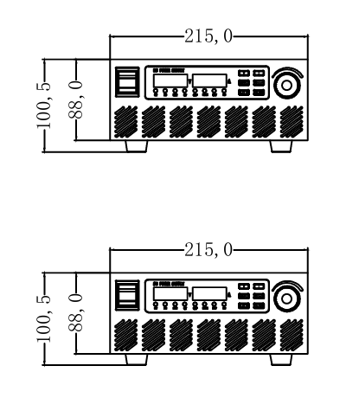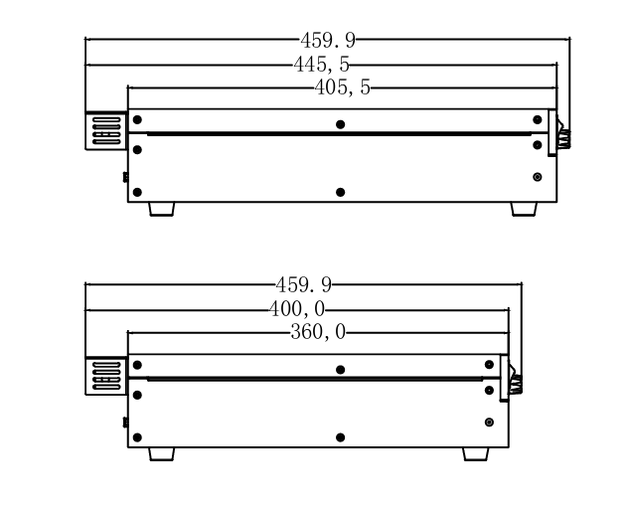

2U-3.6KW model
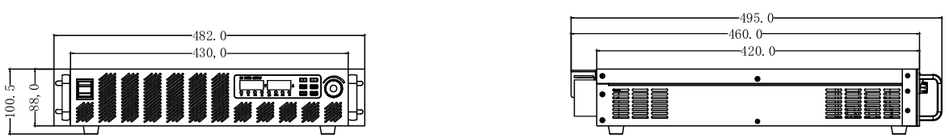

2U-6KW model
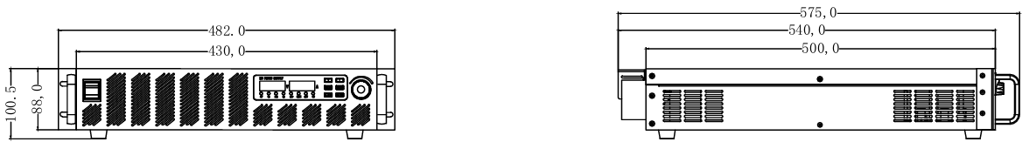

3U model
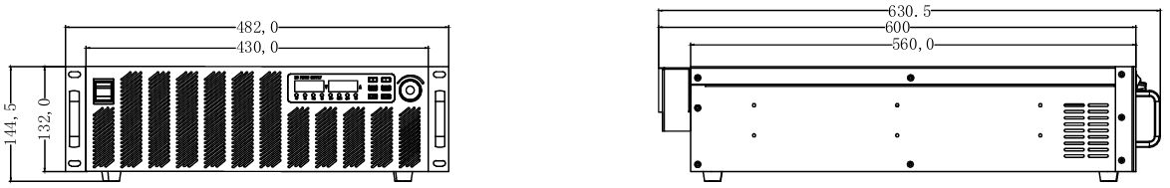

2.5 front panel
2u model
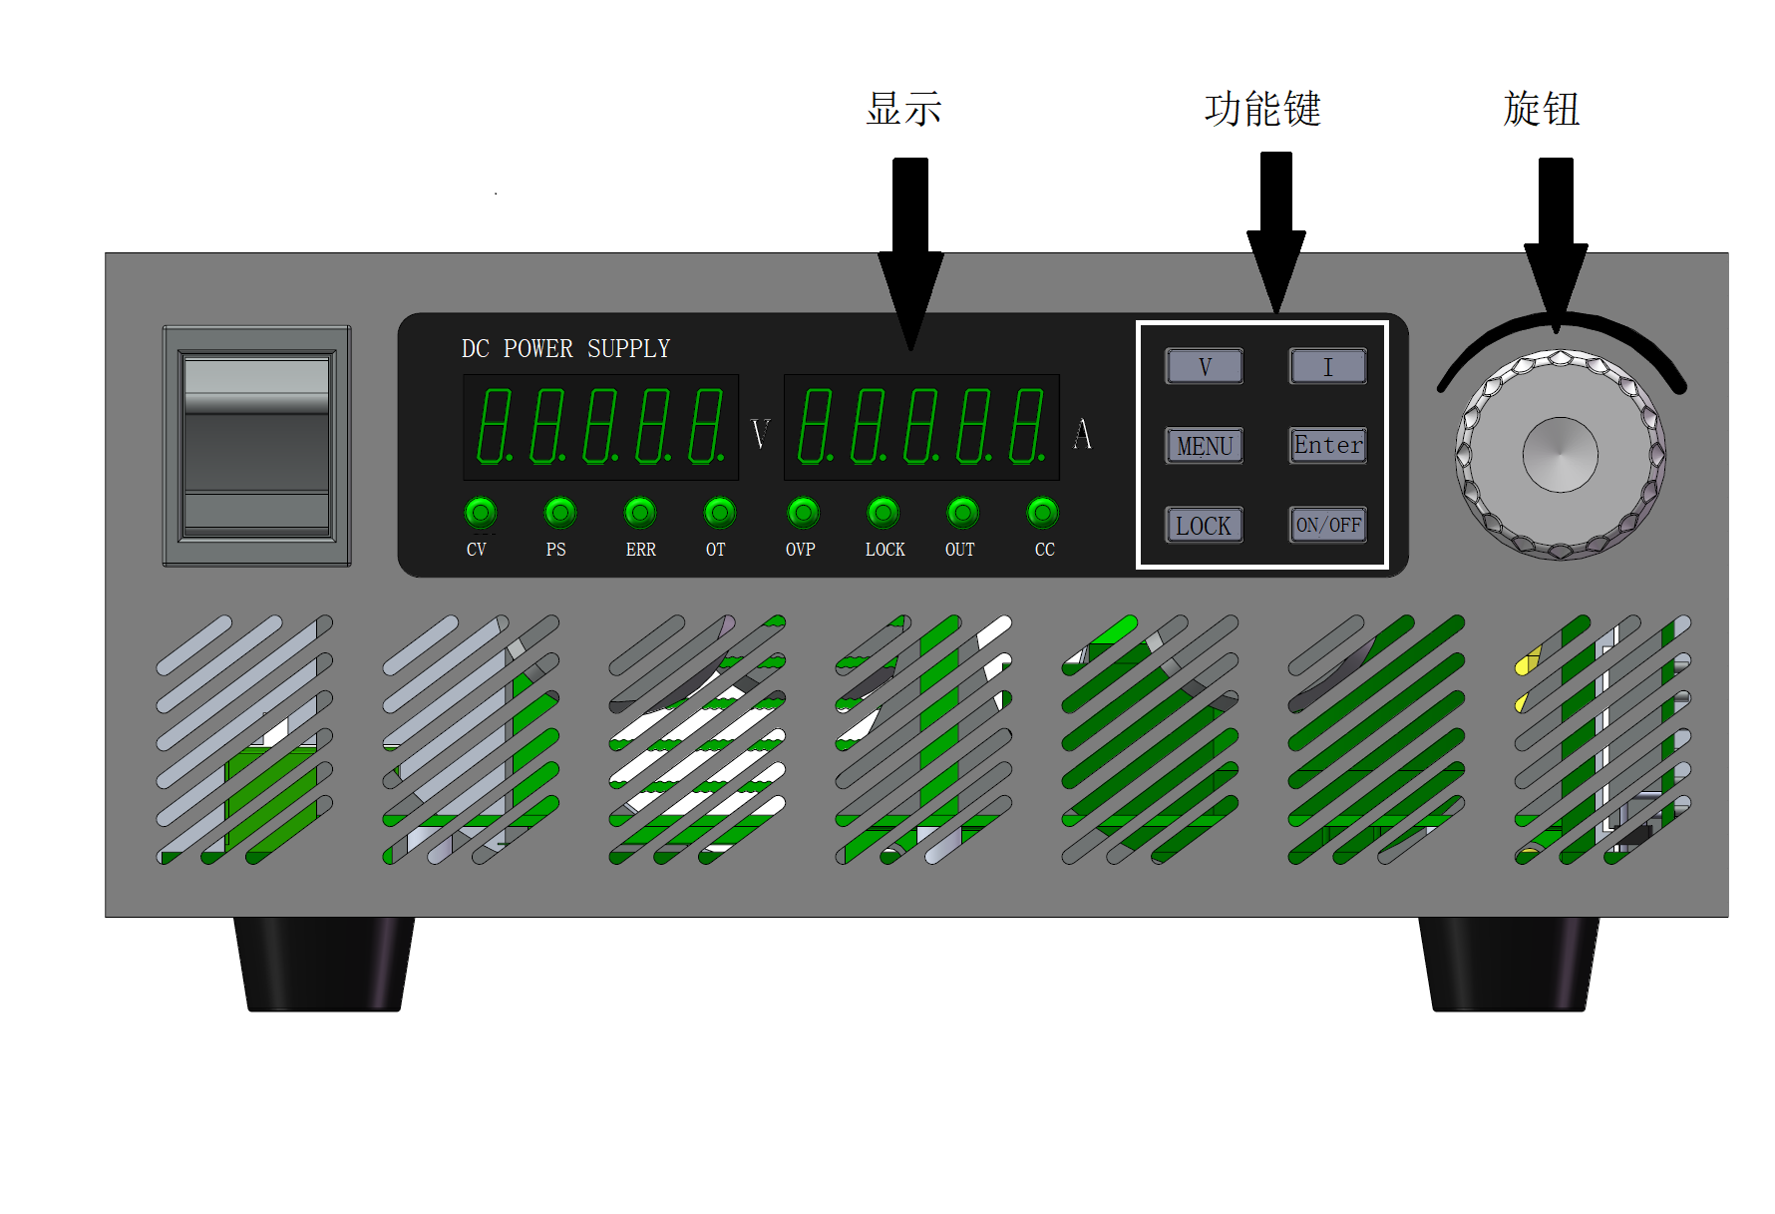
2U model
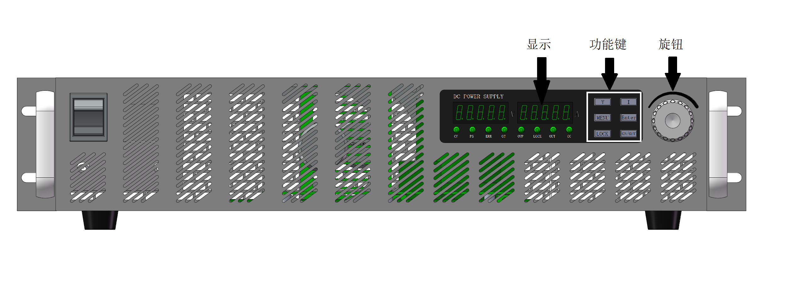

3U model
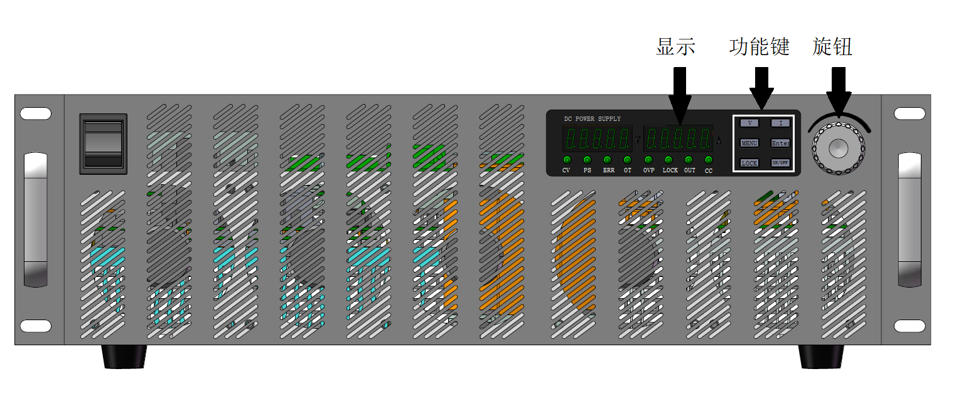

2.6 Introduction of Function Keys
functional key | function
V | Voltage preset value setting
I | Current preset value setting
Menu | Function menu button
Enter | Function determination/save button
LOCK | Local operation lock key; Switch to local mode when exiting remote operation mode.
ON/OFF | Voltage and current output on/off key
Knob left/right adjustment | Digital addition/subtraction, menu interface switching
Button depression | Voltage setting/current setting/over-voltage/over-current interface cursor shift and menu interface confirmation.

2.7 rear panel
2u model
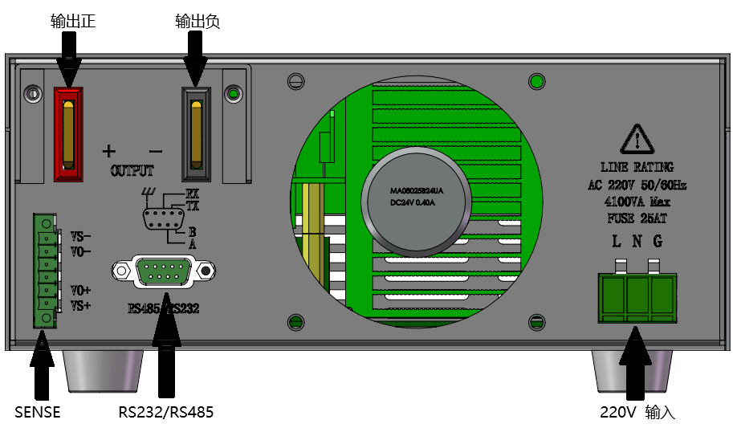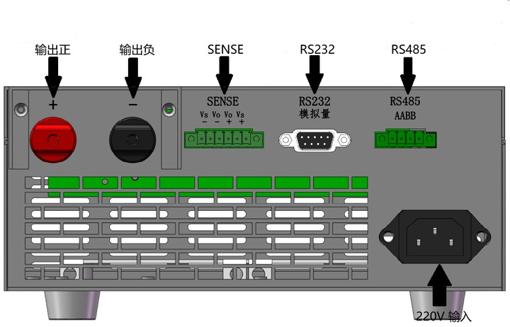

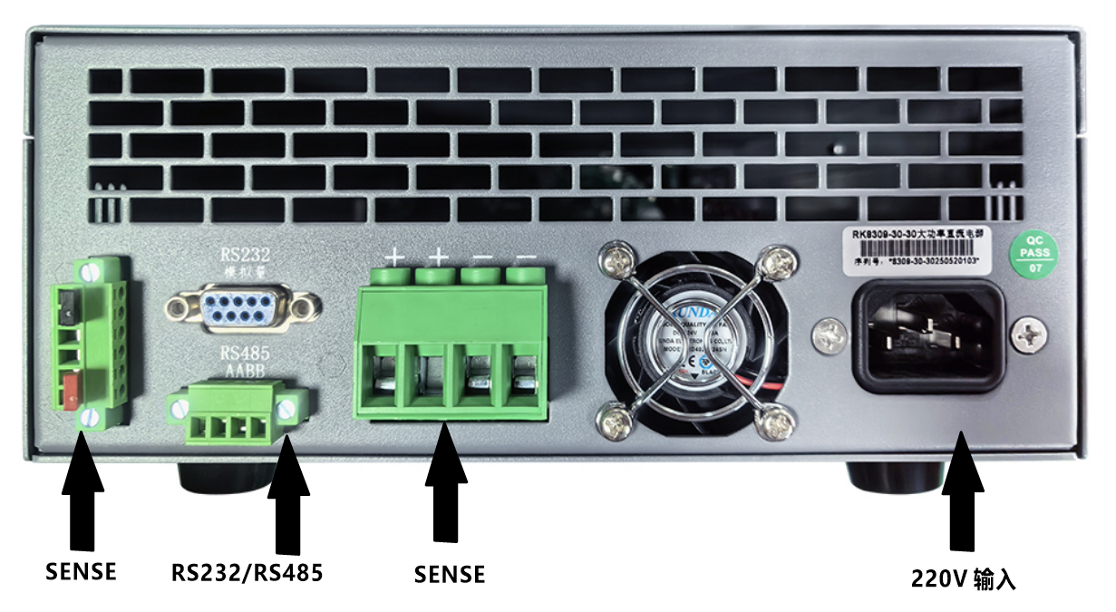

2U low-voltage model
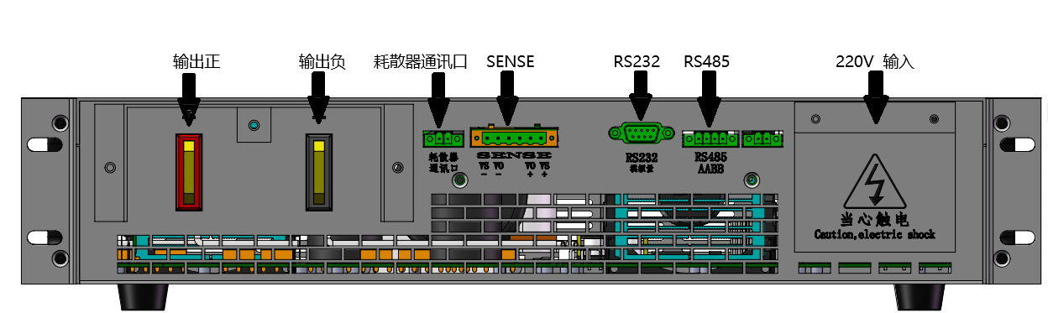

2U high-voltage model
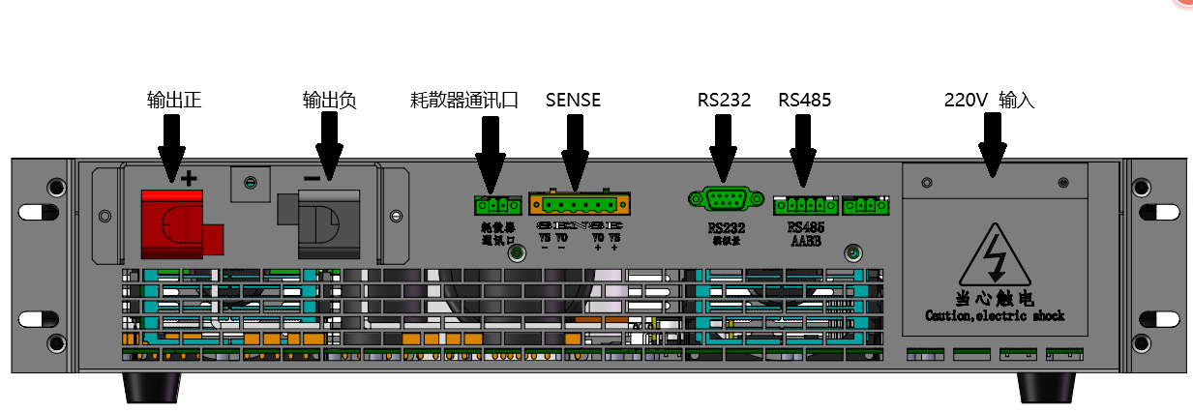

3U model
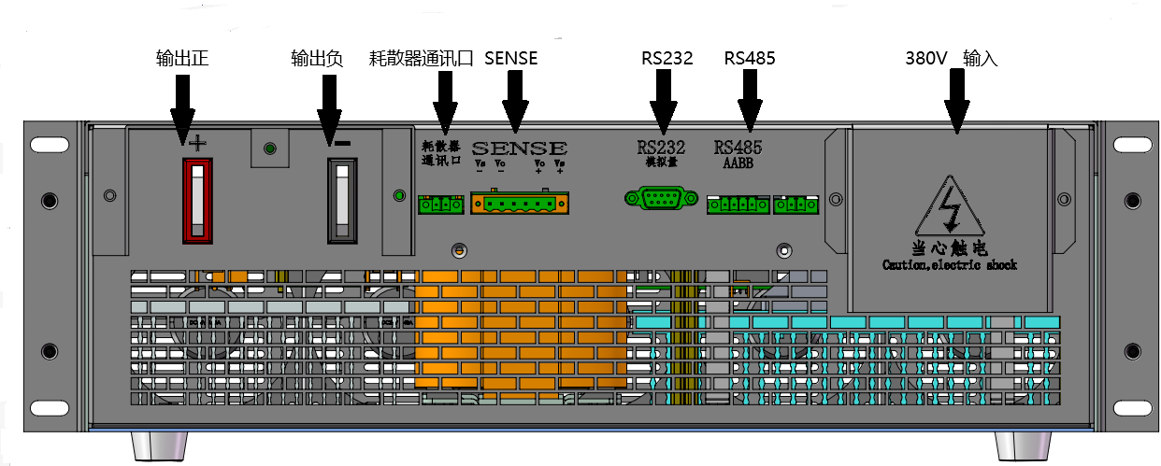

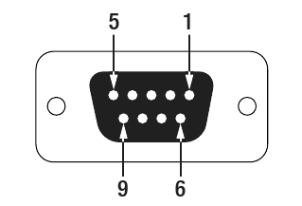
2.8 DB9
The default communication interface of power supply is DB9 bus, and the line sequence is as shown in the right:
It can be configured into RS-485, RS-232 and analog (optional) functions.
See the table below for the description of line sequence:
Pin serial number | RS-485 | RS-232 | analog quantity
one
2 |  | Tx
three |  | Rx | Vset: output voltage setting line
four |  |  | Iset: output current setting line
five |  | GND | Vdisp: output voltage display line.
six | B |  | Idisp: output current display line
seven | A |  | ON: the power supply starts and stops to control the passive signal line. When GND is connected, it means start, and when GND is not connected, it means stop.
eight |  |  | RM: passive signal line for external control of power supply, which is detected when the power supply is started, and the change after startup is invalid. When GND is connected, it means external control, and when GND is not connected, it means internal control of power supply.
nine |  |  | GND: public ground
Remarks: there are three settings of Iset, Vset, Idisp and Vdisp: 4-20mA, 0-5V and 0-10V, which are optional before leaving the factory.
Vset and Iset can be set in three ways: voltage-only, current-only and voltage-current-controlled, which are optional before delivery. Please select the connection mode according to the customization requirements!

2.9 voltage compensation
When the power supply outputs a large current or the conductor is long or thin, a large voltage drop will occur on the connecting line between the load and the power supply output terminal. In order to ensure the normal use of the load, the power supply provides a remote measuring terminal on the back panel, which users can use to measure the output terminal voltage of the load, and the power supply improves the output, so that the terminal voltage of the load reaches the user-set value.
See the figure below for the terminal:

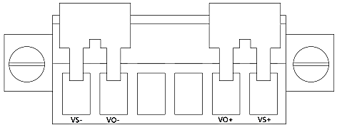

VS+: far-end measuring positive electrode
VO+: output positive pole
VS-: Remote measuring negative electrode
VO-: Output negative electrode

2.10 local measurement
When the local measurement does not need to compensate for the voltage drop of the conductor, use the short-circuit clip provided on the back plate of the instrument, or directly install the conductor between Vo+ and Vs+ and Vo- and Vs-.
The local measurement wiring diagram is as follows:
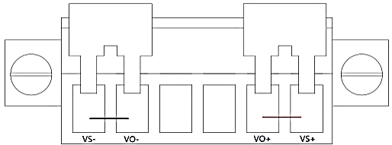

2.11 Remote measurement
The remote measurement function allows compensation for the voltage drop on the wire between the power output terminal and the load. Please use armored twisted pair cable between the remote measurement of power supply and the load. Operating steps:
1. Remove any jumper wires or short circuit clips between Vo+ and Vs+ and between Vo- and Vs- of the terminal board connectors of the rear panel.
2. Connect a pair of induction wires from Vs+ and Vs- to the load end.

Schematic diagram of remote measurement wiring is as follows:
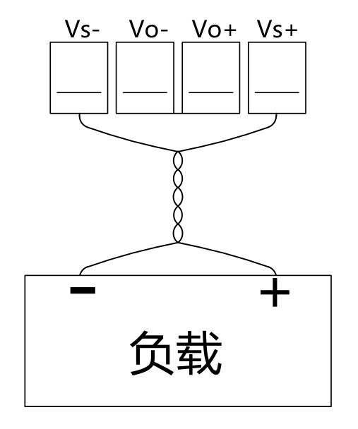
Note: 1. The maximum voltage drop of voltage compensation is 5V.
2. Please pay attention to the positive and negative polarity when wiring, otherwise the instrument will be damaged!
3. Do not suspend the voltage sampling line without using the voltage compensation function.

Installation connection
This product is an economical DC power supply. In order to facilitate the use of the operator, this series of products are only equipped with voltage adjustment and current adjustment knobs, which can meet most users' requirements for DC power supply. The operation of this product is convenient and simple. Please follow the following operating procedures when using it.

3.1 Initial power on
- Carefully check whether the output control line connection of this product is consistent with the requirements, and ensure that the connection is correct.
- Carefully check whether the AC input voltage is consistent with the input voltage of this product, and ensure that the connection is correct.
- Carefully check whether the connection between the load and the output end of this product is consistent, and ensure that the connection is correct.

3.2 Use operation
The machine must be checked for correct connections in all directions, such as input and output, before starting.
- Push the air to open, press the power button to start the power supply.
- Preset state: enter the preset state after the power is started, and the digital tube displays the preset value.

3.3 Operating Instructions for Rotary Encoder
- The rotary encoder has a key switch, and the knob can be pressed as a key to realize related functions.
- Functions of each interface knob:
In the preset state, rotate clockwise, the number will increase, step from low position to high position, and then return to the lowest position when reaching the highest position, with a value of 0-9 cycles; when the voltage and current are adjusted to the rated maximum value, the rotation will not continue; when the voltage and current are adjusted to the minimum value, the number will decrease, step from high position to low position, and then return to the highest position when reaching the lowest position, with a value of 9-0 cycles, and when the voltage and current are adjusted to the minimum value, the rotation will not continue.
The default adjustment is to start from the lower first digit, indicating that the cursor is under this digit. When the knob rotates, adjust this digit. Press the rotary encoder switch, the cursor moves to the next digit, and adjust it by rotating the knob. Thus, the voltage and current are adjusted circularly, and the functions of coarse adjustment and fine adjustment are realized.

Power setting operation
Because the power supply is set for high-brightness digital tube, some letters are not completely displayed, and there will be differences between the display and the actual situation.

4.1 buzzer on
By default, the buzzer is on. Press the "Menu" key, and the first item in the menu is the buzzer option by default. When "BEEP ON" is displayed, the buzzer is on. If the buzzer is turned off, press the "Enter" key to enter the setting. Then rotate the rotary encoder. When the screen shows "BEEP OFF", the buzzer is turned off, and then press "Enter" to save the settings.

4.2 Boot settings again
The voltage and current of the power supply in the default state will be the factory default state when it is turned on again. Press the "Menu" key, rotate the encoder to the right, and the screen will be displayed as "POWER RESET". At this time, the machine will be in the factory default state after restarting. If you need to change the settings to power off and save, you need to press the "Enter" key to enter the settings. Then rotate the rotary encoder. When "POWER LAST" is displayed on the screen, the voltage and current will be the settings before the power is turned off when the power is turned on again, and then press the "Enter" key to save the settings.

4.3 Communication Port Settings
When the output of the machine is stopped, connect the DB-9 connector to the DB-9 seat on the rear panel, press the "Menu" key, and rotate the encoder to the right. When the screen shows "PORT RS232", RS232 communication will be performed. If you want to modify the communication port, you need to press the "Enter" key to enter the setting. Then rotate the rotary encoder to switch, and press the "Enter" key to save the settings. There are RS232(RS232) and RS485(RS485) communication ports to choose from.

4.4 Baud rate setting
After selecting the communication protocol, rotate the encoder to the right. When "BAUD 9.6K" is displayed on the screen, the baud rate is 9600. If you want to modify the baud rate, you need to press the "Enter" key to enter the setting. Then rotate the rotary encoder to switch, and press the "Enter" key to save the settings. The power supply has five baud rates: 9600(9.6K), 19200(19.2K), 38400(38.4K), 57600(57.6K) and 115200(115.2K).

4.5 Address setting
When multiple machines communicate with PC (RS485 communication), it is necessary to number the equipment. When the machine output is off, press the "Menu" key to Enter the menu and then rotate the encoder. When "ADR001" is displayed on the screen, the communication address of the equipment is No.1 machine. If it is necessary to change the communication address, press the "Enter" key to enter the setting. Then rotate the encoder left and right to set the size, and press and shift. Press the "Enter" key after setting to save the setting. Set the maximum number to 247.

4.6 Communication Protocol Settings
When the power supply is in the output state, press the "Menu" key to rotate the encoder. When "COMMU" is displayed on the screen, select the communication protocol, which is "SCPI" by default. If you want to modify the communication protocol, press the "Enter" key to enter the setting. Then rotate the encoder left and right, and there are two options: SCPI(SCPI) and RTU(RTU). Press the "Enter" key after setting to save the setting.

4.7 reset settings
When the power supply is in the output-on or output-off state, rotate the encoder. When "RESET NO" is displayed on the screen, if it is necessary to reset to the factory setting, press the "Enter" key to enter the setting. Then rotate the rotary encoder to "RESET YES", and press "Enter" to save the setting. The machine will return to the interface when it is turned on, the output will be in the OFF state, and the buzzer, voltage setting, current setting, overvoltage protection and overcurrent protection functions will be restored to the factory state.

4.8 View version
When the power supply is off, press the "Menu" key to enter the menu and then rotate the rotary encoder. When "VERSI" is displayed on the left side of the screen, the current software version is displayed on the right side of the screen. Press the "Enter" key and turn around the encoder to view the upgrade date. Press the "Enter" key again to exit viewing the date.

4.9 voltage setting
The voltage setting range is 0V to the maximum output voltage. When the power supply is turned on, it is in voltage setting mode. The cursor will stay at 0.001V/0.01V and blink. When in other interfaces, press the "V" key to preset the voltage, press the rotary encoder to switch the setting number from low to high, then rotate the rotary encoder to set the voltage, and press the "ON/OFF" key to output or turn off the power supply.

4.10 Current setting
The current setting range is 0A to the maximum output current. When power is supplied to other interfaces, press the "I" key interface to jump to the current setting interface. The cursor will stay at 0.001A/0.01A and blink. Press the rotary encoder to switch the setting number from low bit to high bit, then rotate the rotary encoder to set the current, and press the "ON/OFF" key to output or turn off the power supply.

4.11 Overvoltage setting
Set the maximum voltage in the output range of the machine according to different requirements. Press the "Menu" key to enter the menu interface, and rotate the rotary encoder to the left. When the "OVP" logo is displayed on the left part of the interface, the setting value of the highest voltage is displayed on the right part. Press the "Enter" key to enter the setting, then rotate the rotary encoder left and right to set the maximum voltage, and press the rotary encoder to shift. Press the "Enter" key to save the setting after the setting is completed; When the machine is under overvoltage protection, the screen will display "ERROR OVP", and the prompt lights ERR and OVP will light up. To release the overvoltage protection, you need to press the LOCK key to unlock it.

4.12 overcurrent setting
Set the maximum current in the output range of the machine according to different requirements. Press the "Menu" key to enter the menu interface, and rotate the rotary encoder to the left. When the "OCP" logo is displayed on the left part of the interface, the setting value of the maximum current is displayed on the right part. Press the "Enter" key to enter the setting, then rotate the rotary encoder left and right to set the maximum current, and press the rotary encoder to shift. Press the "Enter" key to save the setting after the setting is completed; When the machine is over-current protected, the screen will display "ERROR OCP" and the prompt lamp ERR will light up. To release the over-current protection, you need to press the LOCK key to unlock it.

Menu function display summary
BEEP（BEEP） | ON（ON） | Buzzer on
BEEP（BEEP） | OFF（OFF） | Buzzer off
POWER(POWER) | RESET（RESET） | default setting
POWER(POWER) | LAST（LAST） | Setup before shutdown
PORT(PORT) | RS232（RS232） | RS232 communication
PORT(PORT) | RS485（RS485） | RS485 communication
Baud(BAUD) | 9.6K（9.6K） | Baud rate 9600
Baud(BAUD) | 19.2K（19.2K） | Baud rate 19200
Baud(BAUD) | 38.4K（38.4K） | Baud rate 38400
Baud(BAUD) | 57.6K（57.6K） | Baud rate 57600
Baud(BAUD) | 115.2K（115.2K） | Baud rate 115200
ADDR（ADDR） | ADDR 001 | The address of the machine at the time of communication is 1.
RESET(RESET) | YES（YES） | Parameter reset on
RESET(RESET) | NO（NO） | Parameter reset off
COMMU(COMMU) | SCPI(SCPI) | SCPI instruction
COMMU(COMMU) | RTU(RTU) | MODBUS RTU instruction
VERSI(VERSI) | V1.000 | The machine version is V1.000
VERSI(VERSI) | 5.01.01 | The machine upgrade time is January 1, 2005.
OCP(OCP) | 039.60 | Over-current protection is 39.6A
OVP(OVP) | 110.00 | Overvoltage protection is 110.00A

protocol
Protocol format
- serial port
Data bit: 8 bits, stop bit: 1 bit, check bit: none, baud rate: 9600, default value.
- MODBUS protocol
This equipment uses MODBUS RTU communication format.
This device supports instruction codes: read multiple writable register instructions (0x03), read multiple read-only register instructions (0x04), write multiple register instructions (0x10) and write a single register instruction (0x06).
Reading and writing multiple registers can only read and write registers with continuous addresses at one time. If you need to write a register, you can write multiple register instructions and write the number of registers as 1.
The register address is a number with the length of one word and 16 bits. See the table below for details.
The content of the register is a number with a length of 16 bits per word, and it is unsigned by default.
This device only supports a fixed number of points, and the data related to voltage and current is actually the number of words according to the displayed resolution, which requires customers to transform according to the displayed decimal places. Please check the display on the back panel of the power supply for the decimal places of voltage and current. The decimal places are generated according to the power supply specifications and cannot be changed after leaving the factory.
For example: 50V300A power supply, 4-digit display, 2 decimal points for voltage and 1 decimal point for current. Voltage 5000 represents 50V, and current 3000 represents 300 A; 1000V10A power supply, 5-digit display, 1 decimal point for voltage and 3 decimal points for current. Voltage 500 represents 50V and current 3000 represents 3A.
- MODBUS protocol interpretation
Read multiple registers
Host computer sending |  |  | Power supply response
data frames | length | content | data frames | length | content
Device address | 1 byte | 1 ~ 100 | Device address | 1 byte | 1 ~ 100
Read instruction code | 1 byte | 0x03 or 0x04 | Read instruction code | 1 byte | 0x03 or 0x04
Register address | 2 bytes | 1000 ~ 2022 | Number of data bytes | 1 byte | Number of registers *2
Number of registers | 2 bytes | 1 ~ 20 | data | N bytes
check code | 2 bytes | CRC | check code | 2 bytes | CRC
Example 1: Take 50V300A power supply (voltage is 2 decimal places, current is 1 decimal place, please see decimal places on the display interface for other models of power supply) as an example. Inquire about the actual output voltage and current of the power supply. 0X0ed8 is converted to decimal 3800, and the voltage has two decimal points, which means 38V. 0X0100 is converted into decimal 256, and the current has 1 decimal point, which means 25.6A.
The host computer sends: 01 04 03 e8 00 02 f1 bb
Power supply response: 01 04 04 0e d8 01 00 78 c7
Write multiple registers
Host computer sending |  |  | Power supply response
data frames | length | content | data frames | length | content
Device address | 1 byte | 1 ~ 100 | Device address | 1 byte | 1 ~ 100
Write instruction code | 1 byte | 0x10 | Read instruction code | 1 byte | 0x10
Register address | 2 bytes | 2000 ~ 2022 | Register address | 1 byte | 2000 ~ 2022
Number of registers | 2 bytes | 1 ~ 20 | Number of registers | 2 bytes | 1 ~ 20
Number of data bytes | 1 byte | Number of registers *2 | check code | 2 bytes | CRC
data | N bytes
check code | 2 bytes | CRC
Example 2: Take 50V300A power supply (voltage is 2 decimal places, current is 1 decimal place, please see decimal places on the display interface for other models of power supply) as an example. Set the voltage reference and current reference of the power supply as 38V and 25.6A respectively, the voltage has two decimal points, and 38V is 3800=0X0ed8. The current has one decimal point, and 25.6A is 256=0X0100.
The upper computer sends: 011007d1002040ed8 01009a4c.
Power supply response: 01 10 07 d1 00 02 10 85
Start output
The host computer sends: 011007E000102fff C7 40
Power supply response: 011007E0001014B
5、CRC-16
CRC-16 adopts MODBUS RTU standard CRC algorithm, and the calculation formula is: x^16+x^15+x^2+1.
"Appendix A: CRC-16 calculation code C language version" can be used for reference.
6. Equipment address
The factory default device address of power supply is 0x01, with valid values of 1-247, and 0 is the broadcast address. The change is made by setting the register 2000.
Register address and function list
Register Address (Decimal) | attribute | meaning | annotations
1000 | read only | Output voltage
1001 | read only | output current
1007 | read only | device status | See state mode
2000 | Writable | Device address
2001 | Writable | reference voltage
2002 | Writable | Reference current
2003 | Writable | Overvoltage value
2005 | Writable | Overcurrent value
2007 | Writable | Baud rate | Valid values: 0: 9600, 1: 19200 and 2: 38400.  3:57600,4:115200
2014 | Writable | work pattern | See working mode.
2015 | Writable | reserve
2016 | Writable | outgoing control | 0 is to stop the output, and a non-zero value starts the output.
2017 | Writable | reserve
2020 | Writable | Protocol type | 0:RTU default value; 65:SCPI
2021 | Writable | reference voltage | Power-off saving
2022 | Writable | Reference current | Power-off saving

Status, mode register
1007 | functional mode
digit capacity | 0 meaning | 1 meaning
0 | Output off | Output start
one | Non-constant current mode | Constant current mode
2 | Non-constant pressure mode | Constant pressure mode
three | Internal control mode | External control mode
four | Not overheated | superheat
five | No overcurrent | overflowing
six | Not overpressure | overtension
twelve | reserve | reserve
15 | trouble-free | breakdown
2014 | work pattern
digit capacity | 0 meaning | 1 meaning
0 | Overvoltage protection is prohibited | Allowable overvoltage protection
2 | Overcurrent protection is prohibited. | Allowable overcurrent protection
10 | High range | Low Range (Custom)
11 | Buzzer rings (abnormal state) | The buzzer doesn't ring.
12、13 | reserve | reserve

Instruction list
[SOURce:]OUTPut[:STATe]
This command is used to control the power output on or off.
Command grammar
[SOURce:]OUTPut [:STATe] <bool>
parameter
0|1|ON|OFF
Query grammar
[SOURce:]OUTPut[:STATe]?
Return parameter
0|1

[SOURce:]CURRent
This command is used to set the power supply current value.
Command grammar
[SOURce:]CURRent <NRf>
parameter
<NRf>
unit
A
Query grammar
[SOURce:]CURRent?
parameter
without
Return parameter
<NRf>

[SOURce:]CURRent:PROTection[:LEVel]
This command is used to set the upper limit current value of overcurrent protection OCP. If the peak value of the output current is higher than the OCP upper limit, the output of the power supply will be turned off and an alarm sound will be given.
Command grammar
[SOURce:]CURRent:PROTection[:LEVel]
parameter
<NRf>
unit
A
Query grammar
[SOURce:]CURRent:PROTection[:LEVel]?
Return parameter
<NR2>

[SOURce:]VOLTage
This command is used to set the power supply voltage value.
Command grammar
[SOURce:]VOLTage<NRf>
parameter
<NRf>
unit
V
Query grammar
[SOURce:]VOLTage?
parameter
without
Return parameter
<NRf>

[SOURce:]VOLTage:PROTection[:LEVel]
This command is used to set the software voltage protection value of the power supply.
Command grammar
[SOURce:] VOLTage:PROTection <NRf>
parameter
<NRf>
unit
V mV uV
Query grammar
[SOURce:] VOLTage:PROTection ?
parameter
without
Return parameter
<NRf>

[SOURce:]APPLy {< voltage value > |MIN|MAX}[,{ < current value > |MIN|MAX}]
This command combines VOLTage and CURRent commands. When sending this command to the instrument, as long as the parameters sent are within the previously set range, the output voltage and current values will be output immediately according to the parameters of the current command. The APPLy command only takes effect when the parameters are within the previously set range, and an execution error will occur if they are not within the set range. You can also use MIN or MAX as special parameters of the command: MIN will set both voltage and current to 0; MAX will set the voltage and current to the highest values in the previously set range.
Command grammar
[SOURce:]APPLy <NRf>,<NRf>
parameter
<NRf>
unit
V, A
Query grammar
[SOURce:]APPLy?
Return parameter
<NRf>,<NRf>

MEASure[:SCALar]:CURRent[:DC]?
This command is used to read the input current of the power supply.
Command grammar
MEASure[:SCALar]:CURRent[:DC]?
parameter
without
Return parameter
<NRf>
Returns the parameter unit
A
example
MEAS:CURR?

MEASure[:SCALar]:VOLTage[:DC]?
This command is used to read the input voltage of the power supply.
Command grammar
MEASure[:SCALar]:VOLTage[:DC]?
parameter
without
Return parameter
<NRf>
Returns the parameter unit
V
example
MEAS:VOLT?

MEASure:OUTPut:CONDition?
This command is used to measure the current power state, CV state or CC state.
Command grammar
MEASure:OUTPut:CONDition?
parameter
without
Return parameter
CV | CC

Appendix A: CRC-16 Calculation Code C Language Version
#define u8 unsigned char
#define u16 unsigned int

u16 CRC16(u8 *buf, u8 len)
{
u16 crc = 0xFFFF;
u8 i = 0;
u8 j = 0;
u8 Data = 0;

for (j = 0; j < len; j++)
{
crc=crc^*buf++;
for (i=0; i<8; i++)
{
if((crc&0x0001) > 0)
{
crc=crc>>1;
crc=crc^0xa001;
}
else
{
crc=crc>>1;
}
}
}

return crc;
}

Appendix B: Reference Table for Power Specifications and Conductors
Input wire and power reference table:
Power supply power (KW) | Input electricity | Input Conductor Cross-sectional Area (mm2)
1.5 | AC 220V | 1.0
1.5 - 2 | AC 220V | 2.5
2 - 4 | AC 220V | 4.0
4 - 6 | AC 220V | 6.0
4 - 7.5 | AC 380V | 4.0
7.5 - 15 | AC 380V | 6.0
15 - 25 | AC 380V | 10.0
25 - 35 | AC 380V | 16.0
35- 50 | AC 380V | 25.0
The power supply power listed in the above table is the actual consumption power, power supply efficiency, power factors, etc. Please select the appropriate wire to use according to the actual situation. For reference only.

Output current and wire reference table:
Conductor cross-sectional area (mm2) | 1.5 | 2.5 | four | six | 10 | 16 | 25
Maximum carrying current (a) | 15 | 23 | 32 | 40 | 83 | eighty-five | 100
The above table lists the current carrying capacity of a single GB copper wire at the working temperature of 30 C. Please select the appropriate conductor according to the actual situation. For reference only.

Product warranty, after-sales, maintenance and service commitment
In the spirit of "high quality, excellent service and development" and the concept of "high quality products, reasonable price and caring service", our company solemnly promises to you:

Step 1 serve
1. The product shall be distributed with instruction manual (QR code scanning) and inspection certificate to ensure that users can correctly install and use our products.
2. The products manufactured by the company are produced and inspected according to the manufacturer's standards. Unqualified products will never leave the factory, strictly implement the relevant national regulations on after-sales service of industrial products, and make a warranty commitment for the products within 12 months from the delivery date.
3. Service tenet: efficient, responsible and confusing.
2. Warranty: The warranty period for non-man-made damage is twelve months.
3. Warranty: During the warranty period, the products will be repaired or the accessories will be replaced free of charge. After the warranty period expires, provide paid maintenance service.
During the warranty period of the product, if the product fails, the company is only responsible for the failure and loss of the product, and the company does not bear the load and all other joint losses.
4. Others: customized products are provided with separate instructions, subject to the actual situation.
Guarantee restriction
The above warranty does not apply to damage caused by the following circumstances:
The customer violates the use regulations of this manual;
Customers independently disassemble or repair products;
Unauthorized modification or misuse;
Operate this product outside the specified environment;
Force majeure factors stipulated by relevant laws.

