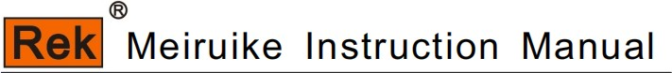

RK9320/9310 Program-controlled AC and DC voltage and insulation tester, manual

SHENZHEN MEIRUIKE ELECTRONIC TECHNOLOGY CO.,LTD

Compound key description

Compound key
Parameter setting: |  | Save: | shift+Ent
New: | shift+← | Delete: | shift+→
Previous page: | shift+↑ | Next item: | shift+↓
0 | shift+↓ | one | shift+Esc
2 | shift+Ent | three | shift+Lock
four | shift+Mode | five | shift+Menu
six | shift+shift | seven | shift+←

Compound key
Parameter setting: |  | Save: | shift+Ent
New: | shift+← | Delete: | shift+→
Previous page: | shift+↑ | Next item: | shift+↓
0 | shift+↓ | one | shift+Esc
2 | shift+Ent | three | shift+Lock
eight  return | shift+OKshift+↑ | nine | shift+→

Compound key | function declaration
shift+ent | Step page: Save the current function parameters to a file.
Shift+ left (NEW) | Step Page: Create a new test step
Shift+ DELETE | Step Page: Delete Test Steps
Shift+ up (PREV) | Step Page: Return to the previous test page.
Shift+ NEXT | Numerical setting page: number "0"
shift+ESC | Numerical setting page: number "1"
shift+ENT | Numerical setting page: number "2"
shift+LOCK | Numerical setting page: number "3"
shift+MODE | Numerical setting page: number "4"
shift+MENU | Numerical setting page: number "5"
shift+shift | Numerical setting page: number "6"
Shift+ left (NEW) | Numerical setting page: number "7"
shift+OK | Numerical setting page: number "8"
Shift+ DELETE | Numerical setting page: number "9"

Safety warning:

Instrument grounding This instrument is a Class I safety instrument. When connecting the power supply, please make sure that the power socket contains grounding wire. If it is not grounded, the casing
Static electricity or induced electricity on the computer may cause personal injury!

Danger of electric shock beware of electric shock during operation, testing and instrument maintenance. Non-professionals are not allowed to open the chassis without authorization. If professionals need more information,
When changing the fuse or carrying out other maintenance, be sure to unplug the power plug first, and do it with others. Even if the power plug has been unplugged, there may still be dangerous voltage on the capacitor, so it should be operated after discharge.

In the process of electric shock damage test, any incorrect removal or addition of the tested part will cause abnormal damage to people, property or instruments.
Harm! ! ! If the instrument is damaged due to abnormal operation, the maintenance cost shall be borne by the customer.

Please use the power supply according to the power supply parameters specified in this instrument, and the power supply input that does not meet the specifications may damage this instrument.

Stay away from the explosion
Sexual gas environment Electronic instruments should not be used in flammable and explosive gas environment or environment containing corrosive gas or smoke, because this may
Bring danger.

Other safety
Please do not apply any voltage source or current source to the test terminal of this instrument.

An important supplement or reminder to the content elaborated.

Instructions for use:
* Please read and understand the contents described in the instruction carefully before operating the tester. After reading, please put the instructions near the operator for reading when necessary. When moving the tester from one workplace to another, please carry the manual with the instrument to avoid losing it.
* With the improvement of instrument function and the upgrade of software, the instruction manual will be improved and upgraded continuously. Please pay attention to the software and manual version of the tester.

Safety warning: 1
Chapter 1 Installation and Use 1
Chapter 2. Operating Specifications and Measures 4
Chapter 3 Overview of Instrument Panel 7
Chapter 4. Operating instructions 16
Chapter 5 Description of Serial Instruction Set 54

Chapter 1 Installation and Use
This chapter describes some checks that you must carry out after receiving the instrument, and the conditions that you must know and have before installing and using the instrument.
This instrument conforms to the standard of GB4793.1-2007/IEC61010-1:2001.

1.1 precautions for use
The following rules must be observed when using the instrument:
■ Do not use this instrument in flammable air.
In order to prevent combustion or explosion, do not use the instrument near alcohol, diluent and other flammable materials, and do not use it in air with high gas concentration.
■ Avoid exposing the instrument to high temperature and direct sunlight.
Don't put the instrument in a place where it is hot or the temperature changes sharply.
Temperature range of the instrument: 5℃ to +35℃
Storage temperature range of instruments; -20℃ to +60℃ ■ Avoid humid environment.
Do not put the instrument in a boiler, humidifier or high humidity environment with water.
Humidity range of the instrument: 20% to 80%RH (dew condensation is not allowed); Less than 90%RH (dew condensation is not allowed)
Condensation may cause the circuit to malfunction. You must wait until the environment is completely dry before using the instrument.
■ Do not put the instrument in an environment with corrosive gas.
Do not use the instrument in an environment with corrosive gases such as sulfuric acid, fog or the like. This may corrode wires and connectors, form hidden dangers or connection defects, and lead to failure, failure and even fire.
■ Do not use this instrument in dusty environment.
Mud and dust can cause short circuit or fire of electronic devices.
■ Do not use this instrument in a place with poor ventilation.
The instrument has a forced air-cooled cooling system. Sufficient space should be provided for the side and rear tuyeres to ensure air circulation.
■ Do not use the instrument on an inclined surface or shaking place.
If the instrument is placed on an uneven surface or shaken place, it may slip and damage the instrument.
■ Do not use this instrument in places with strong magnetic or electric field effects.
When the instrument is used in the place with strong magnetic field or electric field, electromagnetic pulse will cause instrument failure and fire.
■ Do not use this instrument near sensitive test equipment and receiving equipment.
If these devices are used near this instrument, the noise generated by the failure and breakdown of the tested part may affect these devices. When the test voltage exceeds 3kV, the electric field between the test lines will ionize the air and produce corona, which will cause a lot of RF bandwidth interference between the test lines. In order to reduce this influence, ensure that the distance between test lines is far enough.
In addition, keep the test line away from conductive surfaces (especially sharp metal ends).

1.2 Points for attention when moving
Pay attention to the following precautions when moving the instrument or transporting it:
■ Turn off the power switch before moving.
Moving with the power switch on will cause electric shock and damage.
■ Disconnect all connecting wires before moving.
Moving the instrument without disconnecting the cable may cause damage to the connecting cable or drop the instrument during moving.

1.3 Connect the AC power cord

The power cord is provided by our company together with the instrument. Do not use the AC power cord that is not standard on this instrument. Connection sequence
1. Make sure that the power supply is within the line power supply range of the instrument.
2. Determine the nominal value of the instrument fuse, and the fuse box is installed in the correct position (power file). 3. Make sure the power switch of the instrument is turned off.
4. Connect the AC power cord to the AC LINE terminal of the rear panel.
5. Please use the accompanying AC power cord, or the AC power cord selected by sufficient qualified professionals.6. Plug in an AC power outlet.

1.4 electrical grounding
△ Warning: Ensure that the instrument is connected to the electrical ground (safe, earth).
If the output is connected to the peripheral equipment or the nearby commercial wire output transit earth, which is not directly connected to the earth, the shell of the instrument may have a very high voltage and become very dangerous. The instrument is Class I equipment (the equipment is protected from electric shock except for basic insulation). However, there is still a possibility of an electric shock if there is no correct grounding.
To ensure safety, be sure that the instrument is grounded.
Select one of the following two available methods to deground: 1. The power cord is connected to a single-phase three-wire power outlet.(Make sure that the socket ground wire is acceptable To connect with the earth.) 2. Connect the protective terminal of the rear panel to the earth through the grounding row (copper wire or copper row reliably connecting the earth with the production line). Ask specialized engineers to select, make, and install the connection Ground connecting line. To ensure that the ground connection is correct and reliable

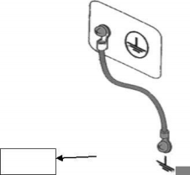
1 . 电源线连接到一个单相三线电源插座上。（请确保插座接地线是可
靠连接大地的）
2 . 把后面板的保护接线端通过接地排（生产线配有的可靠连接大地的 铜线或铜排）接到大地。让专门的工程师选择、制作、并安装该接
地连接线。以确保接地连接正确可靠。

Safely

1.5 operation inspection

△ Warning: When using the instrument normally, make the function interlocking (INTERLOCK) as much as possible to ensure the safety of use. Workspace situations: Make a box-like structure for the piece under test; In the test occasions of large test parts with complex structure: use fences around the test area and other protective structures to prevent electric shock. When the electric shock protection structure is opened, disconnect the (INTERLOCK) signal circuit to ensure the safety of the workplace.

When the power switch is on, the instrument lights all lights on the front panel and starts a self-test, confirming that all indicator lights are on to ensure safety. It is particularly dangerous to damage the DANGER (high pressure hazard at test) lamp. In △ Careful: After cutting off the power switch, it will take a few seconds to power it on again. Repeating the on / off power supply without sufficient time interval is harmful to the instrument.

Check the order 1. Determine that the allowable range of the power supply voltage is consistent with the input voltage range set by the fuse box.2. Determine that the AC power cord is connected to the AC LINE (AC power cord) end of the rear panel.3. Plug the power plug into the AC power socket. 4. Turn on the power switch, determine that the indicator of the front panel is fully on, and the panel shows the boot screen. 5. The next screen displays the AC voltage resistance test (AC) parameters interface in the setting (SETUP) interface.6. Turn off the power switch. Note the boot screen (example):


Meiruike electronic
Shenzhen Meiruike Electronic
Technologyco.,ltd
CPLD OKOK

The model, version, date display shall be subject to the actual model display

1.6 Other characteristics of the instrument
(1) Power consumption: power consumption (RK9320 series) <300VA. (2) Overall dimension (W * H * D): 260mm * 88mm * 398mm (3) Weight: about 7kg

input voltage | frequency range | Fuse (slow melting) | Instrument series | rated power
110V | 47-63Hz | 5A  3A | RK9320 series RK9310 series | 400VA  200VA
220V
220V | 47-63Hz | 3A  1.5A | RK9320 series RK9310 series | 400VA  200VA

Chapter 2. Operating Specifications and Measures
This chapter describes the specifications and measures to be followed during the use of this instrument. When using this instrument, special attention should be paid to ensure safety.
This chapter describes the specifications and measures to be followed during the use of this instrument. When using this instrument, special attention should be paid to ensure safety.

2.1 Prohibited operations

■ Do not continuously switch on the power supply After cutting off the power switch, ensure that the interval is one minute or more before opening the power switch again. Ensure that the circuit drops the power normally and then start again. If the on / off the instrument power supply is repeated frequently, the control circuit of the instrument may cause disorder due to incomplete power failure. At this point, the protection facility may not fully perform the protection function. Unless in special or urgent circumstances. Do not turn off the power switch when the instrument is generating the test voltage.
■ Do not short-circuit the output end to the ground If the high voltage test line of the instrument is connected to the AC LINE (AC power line); or if other nearby equipment (such as delivery equipment) connects to the conductor of the earth. When the grounding end of the instrument is not reliable, the high voltage low end (that is, the shell of the instrument) after the grounding end will be filled with dangerous high voltage. Determine the protective ground end and ground line connection of the instrument. In this way, even if the HIGH VOLTAGE (high voltage power) and ground ends are short circuit, the instrument housing will not be charged with high voltage. Ensure correct and reliability when grounding the protective ground. See "1.4 grounding".

△ pay attention to: The term "AC LINE" refers here to the power cord used by the instrument. It is a wire in which the power supply generated by commercial AC power or power generation is connected to the power supply of the instrument.
■ Do not connect the external voltage to the test end
Do not connect any external voltage to the output end of the instrument. In the non-discharge state, the instrument does not have the external discharge function, and the output end connected to the external voltage may damage the instrument.

2.2 Handling of emergencies In an emergency

(such as electric shock and combustion under test) and when the instrument does not disconnect the high pressure output, perform the following operations. You can do it first To (a) or (b), but both operations must be done.(A) turn off the power switch of the instrument; (B) Unplug the power cord of the instrument from the power cord plug head.
2.3 Preventive measures in the test
■ Wear insulating gloves

When using instruments and wearing insulating gloves, you can protect yourself from touching the high voltage. Even if you have high voltage gloves, it is forbidden to touch the live conductor by hand during the high voltage test.
■ Discontinue and (suspend) the test precautions

If you need to touch the test conductor or change the test connection, please press the STOP switch once first to ensure that the instrument exits the test preparation state.

If you need to rest for a while, or will leave the test place, please turn off the power switch to prevent the safety hazard caused by touching the start switch by mistake.
■ Charged items in high voltage test.
During the test, the high-voltage output terminal, high voltage test line, high-voltage probe, the tested part and the conductors exposed around them all carry dangerous high-voltage electricity. Do not approach or touch these conductors at will even if there are reliable insulation measures during testing.
Warning: The sheath on the crocodile clamp of the test line provided by the instrument is not fully insulated from the test high voltage. Do not touch these parts during the test.

△

■ Matters needing attention after turning off high voltage output
If you have to touch the DUT, test line, probe or output and the surrounding area because of reconnection or other reasons, make sure that
The following two:
(a) Confirm that the working state displayed by the instrument is not a test state.
(b) the HV light goes out.
■ Remote control warning
Because the start and stop of high voltage is controlled remotely, the operator can't know the actual working state of the instrument through the interface, so be especially careful when using the instrument in remote control mode. Please pay special attention to check the reliable connection of remote control.
(c) The "Stop" button must be reliably connected. Press the "STOP" button before replacing the DUT.

2.4 high voltage test warning
△ Warning: In high voltage test, the test line, the test probe and the tested part are all charged with high voltage. The instrument has a discharge circuit, sometimes when the output is
Discharge is still needed after cutting off. There is still the danger of electric shock during discharge. In order to avoid electric shock, it is necessary to ensure that the tested part, test line, probe and output terminal with high voltage do not touch anything other than the test element. If you may come into contact with these, make sure the DANGER light goes out to remove the hidden danger.
Once the test is finished, the discharge circuit of the instrument begins to discharge forcibly. Do not disassemble the DUT during the test and before the discharge is over.
Under normal circumstances, it can be guaranteed that the voltage of the test loop will be within the safe voltage range at the end of discharge. When the capacitance of the tested part is too large or the special structure of the tested part will cause incomplete discharge, technicians must change the test method to ensure complete discharge.

■ Discharge time:
Discharge time calculation formula: t= -ln(30 /U) ×R×C t: discharge time.
30: Discharge residual safe voltage 30U: Test set voltage.
R: the discharge impedance of the measured part, and the discharge impedance of the instrument is about 10k C: the capacitance of the measured part.
Generally, only DC-like high voltage test needs to be discharged, and the length of discharge time depends on the nature of the tested part.
During the test, if it ends normally, the voltage will drop to zero according to the voltage drop time. If the test is unqualified, the measured element is discharged through the secondary side of the transformer (about 10k resistor), and the time for discharging the 1uF capacitor with 6000V high voltage to 30V is about 0.05S. The fixed discharge time of the instrument is 0.2S, which can ensure that the device is discharged completely.

2.5 dangerous state treatment of faulty instruments
The typical possible dangerous state of the instrument is that "high voltage is output and the instrument is out of control". When this happens, 1. Turn off the power switch immediately and unplug the AC power cord from the AC power socket.
2. Please stay away from this instrument immediately, and ask the relevant technicians to check the test circuit to make sure that there is no danger; Or let the instrument stand for more than one hour to confirm that there is no output voltage at the test end.
3. Dismantle the relevant connecting wires and send the instrument back to us for maintenance.
△ Warning: Keep away from this instrument immediately after turning off the power supply, and prevent other people from approaching. Never disassemble the test circuit immediately.
Contact our distributors or agents immediately. There may be high voltage in the instrument, and it is very dangerous for non-professionals to try to repair the instrument.

2.6 Conditions for ensuring trouble-free use for a long time
Due to the volume, weight and actual use of the instrument, the heat dissipation design of the voltage generation module of the instrument is small. Therefore, the instrument is recommended to be used in the following range.

Necessary conditions for withstand voltage test
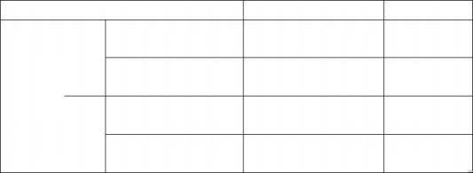
Output time limit
Max. 1 minute
AC

Can output continuously.

Max. 1 minute
DC

Can output continuously.
At least as long as the output time.

There is no requirement

At least as long as the output time.

At least as long as the charging WAIT TIME.
<8mA（RK9320）
<6mA（RK9310）

>6mA（RK9320）
>5mA（RK9310）

the maximum output power
ambient temperature
Time out
t≤40 ℃
>12mA （RK9320）
>10mA （RK9310）

<4mA（RK9320）
<3mA（RK9310）

Note: output time = = (voltage rise time+test time+voltage fall time)
The fan has been working continuously for 30 minutes, so the use of the instrument must be suspended, otherwise the power amplifier output module may be burnt out due to overheating.

2.7 Daily inspection
In order to avoid accidents, at least the following points must be guaranteed before use:
1. The instrument input power supply conforms to the specifications and the instrument power supply configuration is correct.
2. The instrument is reliably connected with the earth.
3. The test line material is in good condition, without fracture, crack and damage.
4. The instrument is not connected to the test line, and the test can be successfully completed by starting the test under the default conditions.
5. When the test line is connected to start the test, the low-voltage end of the test line is in contact with the high-voltage end of the test line, and the instrument can generate a FAIL signal.

Chapter 3 Overview of Instrument Panel
This chapter describes the basic operating characteristics of RK9320/10 series instruments. Please read this chapter carefully before using RK9320/10 series instruments, so that you can learn the operation of RK9320/10 series quickly.

3.1 front panel description
Figure 3-1 briefly describes the RK9320/10 series front panel.
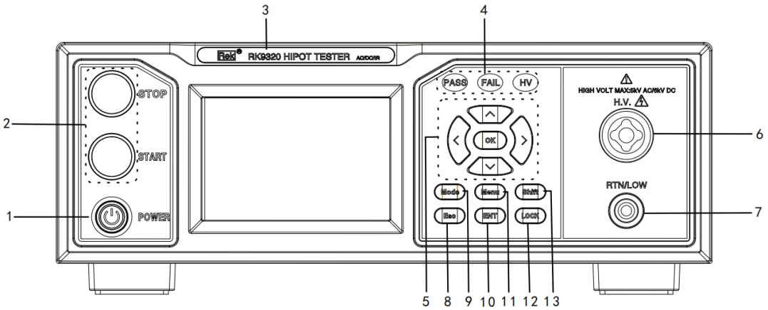

Figure 3- 1 Description of Front Panel

3.1.1 POWER switch (power)
Power switch. Before starting the machine for the first time, the operator should pay attention to check whether the instrument power supply type and test line connection are normal.
3.1.2START key and STOP key
START key (green circle): used to start the test. Once the test starts, the HV indicator will light up.
STOP key (red circle): stop key, used to stop the test; It can also be used to cancel prompt states such as PASS and FAIL.
3.1.3 Trademark and model
Trademark and model of instrument
3.1.4 Indicator light area
● FAIL
In the test, there are test data beyond the set, the instrument judges that the test is unqualified, and the FAIL judgment light is on.
● PASS
After the test, no test data beyond the initial setting was found, the instrument judged that the test was qualified, and the PASS judgment light was on. When the test timing function TIME OFF, the test can only be ended with' ‘STOP' without PASS judgment.
● HV
DANGER ！ ! As long as the test is in progress, this light will light up, indicating that the test is in progress.
3.1.5 Move key
Used for cursor movement on the screen and parameter selection.
3.1.6 High-voltage end of output voltage
High voltage output of high voltage test interface.

3.1.7 Test LOW end and test current RETurn end (low, ret)
Output end of test voltage and current sampling end.
3.1.8.Esc

Return to the superior menu or return to the test page.
3.1.9.Mode
Used to set the operation mode of the equipment.
3.1.10 ENT
Used to adjust and confirm parameters.
3.1.11 Menu
Used for equipment system parameter setting.
3.1.12 LOCK key
Press this key to lock all keys on the operation panel except the STARTT key and the STOP key to prevent misoperation. 3.1.13 Shift
Press (the screen is displayed) to realize the second function of other keys.

3.2 Description of rear panel
RK9320/RK9320A/RK9320B/RK9310 back panel is briefly described.
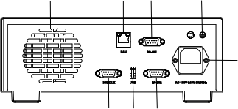
1 2 3 4

5

6 7 8

Figure 3-2 Description of Back Panel

3.2.1 Power amplifier fan radiator
Power amplifier circuit radiator, pay attention to keep the air circulation space.
3.2.2 LAN interface
Interface for LAN communication to realize communication with computer.
3.2.3RS485 serial interface
Serial communication interface to realize communication with computer.
3.2.4 Protective ground terminal
When the three-pin power socket plugged into the instrument power supply cannot ensure reliable connection to the earth, it must be connected to a reliable grounding bar from now on. Note: Do not use this instrument without connecting it to the earth, otherwise the instrument shell may be charged with high voltage and there is a danger of electric shock.

3.2.5 Power socket
For inputting AC power, please use the voltage within the specified input voltage range of the instrument, and use the power cord that comes with the instrument. Built-in power supply fuse, select the fuse corresponding to the input power supply.
3.2.6 HANDLER interface
TEST: the synchronous control signal output by this machine when the instrument starts high-voltage output.
START: input the START signal of this machine, which is used to start the high-voltage output, equivalent to the start signal of the front panel. RESET: Input the reset signal of this machine to STOP the high voltage output, which is equivalent to the stop signal of the front panel.
PASS: the qualified signal output by this machine is equivalent to the PASS indication of the front panel. FAIL: The unqualified signal output by this machine is equivalent to the FAIL indication on the front panel.

3.2.7 USB Device
Realize the U disk mapping of the instrument on the computer side, and directly read the internal storage files.
3.2.8 Rs232 serial interface
Serial communication interface to realize communication with computer.

RK9320AY back panel is briefly described.
3 5
6
2
1ne
4our
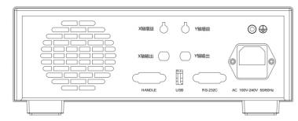

7

8 9 10

Figure 3-3 Description of Back Panel
3.2.1 Power amplifier fan radiator
Power amplifier circuit radiator, pay attention to keep the air circulation space.

3.2.2 X-axis gain adjustment potentiometer
3.2.3 Y-axis gain adjustment potentiometer
3.2.4 X-axis output interface
3.2.5 y-axis output interface
3.2.6 Protective ground terminal
When the three-pin power socket plugged into the instrument power supply cannot ensure reliable connection to the earth, it must be connected to a reliable grounding bar from now on. Note: Do not use this instrument without connecting it to the earth, otherwise the instrument shell may be charged with high voltage and there is a danger of electric shock.

3.2.7 Power socket
For inputting AC power, please use the voltage within the specified input voltage range of the instrument, and use the power cord that comes with the instrument. Built-in power supply fuse, select the fuse corresponding to the input power supply.
3.2.8 HANDLER interface
TEST: the synchronous control signal output by this machine when the instrument starts high-voltage output.
START: input the START signal of this machine, which is used to start the high-voltage output, equivalent to the start signal of the front panel.
RESET: Input the reset signal of this machine to STOP the high voltage output, which is equivalent to the stop signal of the front panel.
MPASS: The qualified signal output by this machine is equivalent to the PASS indication of the front panel. MFAIL: the unqualified signal output by this machine is equivalent to the FAIL indication on the front panel.

3.2.9 USB Device
Realize the U disk mapping of the instrument on the computer side, and directly read the internal storage files.
3.2.10 Rs232 serial interface
Serial communication interface to realize communication with computer.

3.3 Overview of instrument performance

RK9320 can provide 5kVAC/20mA withstand voltage, 6kVDC/10mA withstand voltage and insulation resistance test. RK9320A can provide the voltage withstand test of 5kVAC/20mA and 6kVDC/10mA.
RK9320B can provide 5kVAC/20mA withstand voltage test. RK9320AY can provide 5kVAC/20mA withstand voltage test.
RK9310 can provide 5kVAC/10mA withstand voltage, 6kVDC/5mA withstand voltage and insulation resistance test.

Principle and structure of the instrument:
Because the M C U processor generates signals, the sine wave generated by the signal processing circuit is amplified by the power amplifier, and the high voltage is produced by the 40 ~ 600 Hz high voltage transformer. DA reference signal ensures that the voltage amplitude is controllable. The controllable sine wave can be set at 50 or 60Hz in AC output. In order to solve the problem of power supply ripple in DC and insulation resistance test, the DC output voltage formed after rectification by 600Hz AC power supply is controlled by closed loop to ensure the small load regulation rate.
RK9320 series can be used for AC withstand voltage test, DC withstand voltage test and insulation resistance test.
RK9320 series are equipped with HANDLER, RS-232C, RS 485 and USB, which makes the instrument adapt to many different automatic test systems that need high security and reliability.

Features:

■ Three test functions-AC withstand voltage test, DC withstand voltage test and insulation resistance test. RK9320/RK9310 provides AC and DC withstand voltage test and insulation resistance test.
RK9320A provides AC and DC withstand voltage test. RK9320B provides AC withstand voltage test.
RK9320AY provides AC/DC medical withstand voltage test.

■ Two test power options
The high voltage module of RK9320 series is a class AB power amplifier circuit and a 100VA high voltage transformer, which can realize AC and 5kV/20mA output. Output of DC, 6kV/10mA. The distortion of the waveform is less than 3%.
The high voltage module of RK9310 series is a class AB power amplifier circuit and a 100VA high voltage transformer, which realizes AC, 5kV/10mA output. DC, 6kV/5mA output. The distortion of the waveform is less than 3%.
If the customer has continuous current output, in order to ensure the reliability of the instrument, the maximum output time is 60 seconds when working above 60% of the rated output current. Within 60% ~ 40% of the rated output current, please pay attention to limit the continuous working time. Below 40% rated output current can ensure continuous operation.

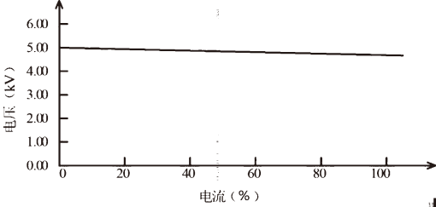
AC voltage load regulation rate

■ DC withstand voltage test 6kV/10mA(RK9320 series)
RK9320 series can provide a wide voltage range (maximum output DC 6kV) for DC withstand voltage test. 600Hz frequency hardware automatic voltage adjustment, voltage load adjustment rate ≤1% +10V.
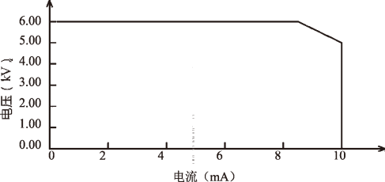
RK9320 DC voltage output range

■ Insulation resistance test is 0.050kV to 5.000kV (1V resolution of 1V) /0.1MΩ to 100.0 GΩ, and the maximum rated current RK9320 is 10mA.

Insulation resistance test range:
When the voltage is less than 500V, the accuracy is 0.1MΩ ~ 1GΩ [10% reading+5 words].
When the voltage is greater than 500V, the accuracy is (5% reading +5 words) in the range of 0.1MΩ ~ 1GΩ, (10% reading +5 words) in the range of 1GΩ ~ 50GΩ, and 15% in the range of 50.0GΩ~100.0GΩ.

■ RS-232C interface as standard.
In addition to power conversion, key lock and other functions, others can be remotely controlled. In DC withstand voltage test, AC withstand voltage test and insulation resistance test, test conditions such as test voltage, judgment function and test time can be controlled remotely. The test results can also be read from the back through remote control. RS-232C and RS485 interfaces provide a stable and unified standard test interface with PC or other devices.

■ HANDLER interface and input signal interface convenient for connection control.
HANDLER interface: START and STOP signals can be input, and TEST, PASS and FAIL signals can be output. It can be conveniently connected with a foot switch for foot control, and connected with a simple test fixture to realize safety interlock, pneumatic control, test indication and the like.

■ USB interface for backup.
The instrument is equipped with USB interface, which can save the test plan and customer measurement documents written by the instrument to an external U disk, or transfer the instrument from the U disk, so as to set the instrument's use parameters and archiving plan in batches.

■ Rise time control function
In AC withstand voltage test, DC withstand voltage test and insulation resistance test, the test voltage can slowly rise to the set value, instead of providing the set voltage to the tested part immediately after the test begins. The voltage rise time is 0.1s to 999.9s, and the resolution is 0.1s.. RK9320
The series conforms to various test standards of UL and withstand voltage test standards of IEC (the initial voltage is less than half of the test voltage and the rising time can be specified when the set test voltage is reached).

■ Falling time control function
In the qualified judgment of AC withstand voltage test, the test voltage can be gradually reduced. The voltage drop time can be set between 0.1s and 999.9s with a resolution of 0.1s..

■ Discharge function
Usually, the measured part is capacitive. At the moment when the DC withstand voltage test and insulation resistance test are cut off, the tested part remains fully charged, so there is a danger of electric shock. RK9320 series has the function of forced rapid discharge of the tested part after the DC withstand voltage test and insulation resistance test are completed.

■ Enhanced security
In order to improve safety, RK9320 series is equipped with many facilities and safety functions, including safety output terminal, discharge function and ground current detection. The so-called ground current detection means that the local high voltage test circuit cuts off the high voltage output when the return current through the shell is greater than 0.45mA.

■ High test accuracy
RK9320 series voltage digital display, the voltage test accuracy is (2% reading +2V) in the withstand voltage test, and the voltage accuracy is (2% reading +2V) in the insulation resistance test. The accuracy in voltage and current withstand test is (2% reading +2 words).

■ Simple operability
RK9320 series is easy to operate, ensuring that users have no difficulty in starting to use it. This instrument lists all the test parameters in the setting interface. Use the arrow keys to select a parameter from the LCD interface, and then modify the parameter with the function button. After the customer sets the data, it can directly measure.

■64M FLASH, each of which can have 50 test items.
You can edit 20 test files, corresponding to various test item combinations required by customers; Each test file can have at most 50 test items, and the test items are AC withstand voltage test, DC withstand voltage test and insulation resistance test, and the test conditions of each item are irrelevant; The stored files of the instrument can be transferred to a computer or another similar instrument through an external USB drive in the file operation interface.

! Warning:
The instrument uses a high voltage of 5kVAC/6kV DC. Therefore, don't touch the tested part and test line at will, which will lead to the danger of electric shock.

Security measures such as fences should be provided to ensure user safety. In addition, to ensure safety, take extreme care to prevent inappropriate connection, operating output of high pressure.

Chapter 4. Operating instructions
4.1 Boot on description and boot screen
Before the power cord plug is connected to the mains, please close the input "power switch", check whether the insurance specification is correct, and connect the safety grounding wire to the "grounding terminal" on the rear panel of the tester.

Meiruike electronic
Shenzhen Meiruike Electronic
Technologyco.,ltd
CPLD OKOK

The basic operations are described as follows:

■ Use the menu buttons ([Menu]) and the soft keys to select the page you want to display.

■ Use the cursor ([] [] [] []) to move the cursor to the domain you want to set up. When the cursor moves to a domain, the domain turns on in blue. A domain is an area where you can set the cursor.

■ The current cursor can set the parameter value by encoding potentiometer or number key. Use the [ENTER] key or tap the enTED potentiometer when ending data entry.

4.2 Operation steps
4.2.1 Set the tester parameters

Please refer to the "Parameter Setting" section to set each parameter.
4.2.2 Connect the tester to the measured object

Plug in the three-wire power supply plug.
Note: The supply voltage shall be maintained operating at 100V-240V AC (50 / 60Hz). The power supply input phase line L, zero line N and ground line E shall be the same as the phase line and zero line on the power supply plug of this instrument. Turn on the power supply, press the power supply switch on the lower left corner of the front panel, turn the instrument on, and display the boot screen. As shown above. Please press the "reset" key once, and determine that the test indicator is not on, the display is working normally and no output, connect the test line, and check whether all wiring is reliable.

4.2.3 Press the "Start" key to start the test.
After pressing the "Start" key, the tester outputs. At this time, the test indicator light on the front panel will light up, the display will display "Being Tested" and the test value will be displayed at the same time. The timer will also start working and the data will be updated continuously.

4.2.4 Determination of qualified products
After the test is completed, the tester will automatically turn off the output, the qualified indicator light on the front panel will light up and make a sound at the same time, and the display will display "PASS" and test data, indicating that the tester determines that the tested object is qualified.
If you want to continue the test, you can press the "Start" button again and the tester will start the test again.
If you want to stop the test, you can press the "Reset" key, and the tester will stop the test immediately, and the display will keep the current test value.

4.2.5 Determination of nonconforming products
If the test fails, the tester will immediately turn off the output, the unqualified light on the front panel will light up, and a warning sound will be issued at the same time. The display will display the test failure prompt and test data, indicating that the tester determines that the tested object is unqualified. Test failure tips include: upper limit failure and over-current protection.
If you want to turn off the alarm sound, you can press the "Reset" key.

4.2.6 START and STOP operation instructions
START key is the key to start the test. Press this key to start the test. The STOP key is the reset STOP key. In the test state, press the stop key once to interrupt the test of the instrument. The running light DANGER turns off and the LOCK light turns on. Press STOP to enter the reset state of the secondary instrument, and the DANGER and LOCK lights go out.
Two ends of the red and black terminal of the instrument are connected with the four-terminal test wire provided by the instrument. When the tested object is not connected, press the START key to start the instrument. At this time, the instrument appears "open circuit failure" and gives an alarm sound (when the grounding resistance function option is selected).

Panel function interface and parameter description

4.3 instrument self-test
4.3.1 Instrument self-check items
When the tester runs POST, the screen displays as follows

Meiruike electronic
Shenzhen Meiruike Electronic
Technologyco.,ltd
CPLD OKOK

The self-inspection items are as follows:
1. Detection of internal crystal oscillator working state: If it is normal, it will display OK; if it is abnormal, it will give an alarm sound and cannot enter the self-inspection of the next project.
2. I/O memory status detection: If it is normal, OK will be displayed; if it is abnormal, an alarm sound will be given, and the next self-check cannot be entered.
3. State detection of complex programmable logic: If it is normal, OK will be displayed; if it is abnormal, an alarm sound will be given, and the self-check of the next project cannot be entered.
4. State detection of serial peripheral interface: If it is normal, OK will be displayed; if it is abnormal, an alarm sound will be given, and the self-check of the next item will not be entered.
5. Keyboard status detection: If it is normal, OK will be displayed; if it is abnormal, an alarm sound will be given, and the next item cannot be self-checked.
6. System status detection: If it is normal, OK will be displayed; if it is abnormal, an alarm sound will be given, and the self-inspection of the next project cannot be entered.
7. Data initialization status detection: If it is normal, OK will be displayed; if it is abnormal, an alarm sound will be given, and the next self-check cannot be entered. If there are no errors in the above self-inspection, the instrument self-inspection is successful. Enter the test interface, as shown below:
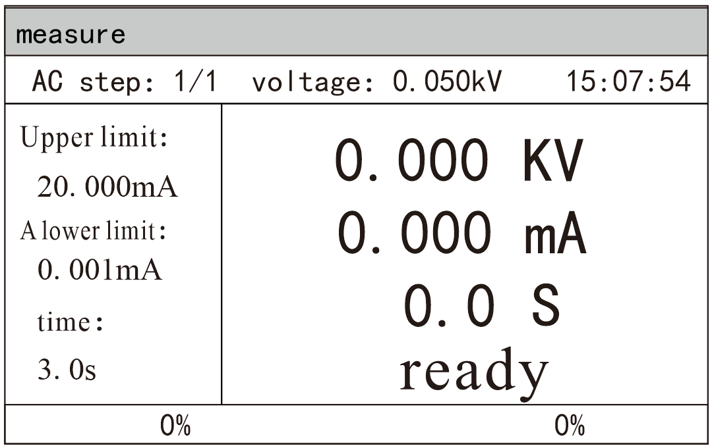

4.4 Parameter setting mode

After starting up, enter the main interface, press the button "Mode" on the instrument panel, enter the mode selection, adjust the mode selection according to the upper and lower buttons. After selecting, press OK to confirm
 | Save  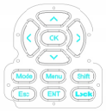  Prev  New Delete  Next
  measure
  AC step: 1/1 voltage: 0.050kV 15:07:54.
  Upper limit:  20.000mA lower limit:  0.001mA time:  3.0s | 0.000 KV  0.000 mA 0.0 S ready
    Press this key.
  0% 0%

The parameter setting interface is shown below：

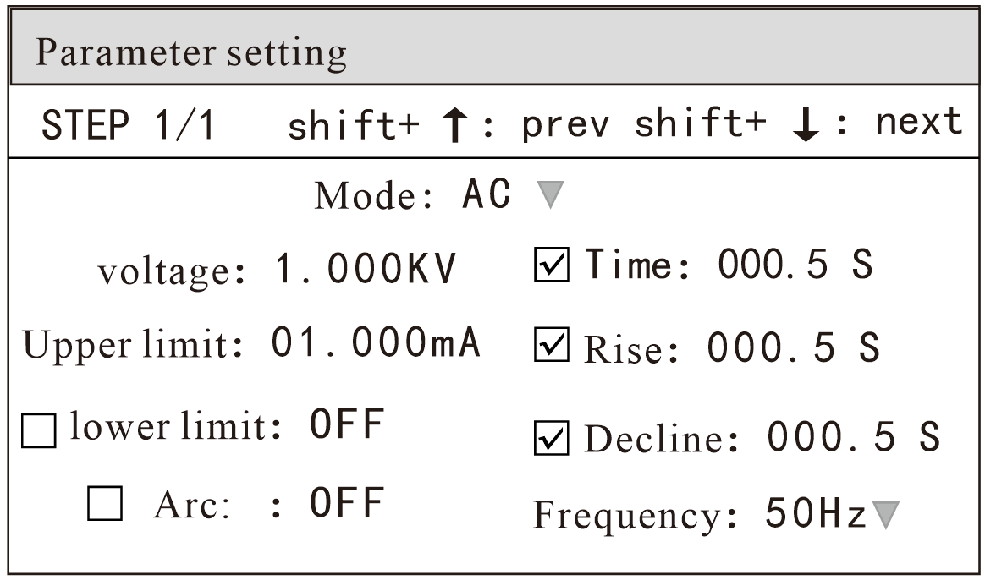

Note: The specific difference varies according to the test mode of the test step。

4.4.1 Parameter setting instructions
Test mode: a parameter in the step details panel is always a test mode parameter. Editing this parameter can change the test mode of the test step. Scope: Test modes supported by the instrument. After pressing the "ENT" key on this parameter, modify the test mode control value according to the selection box control modification method, and then press the "ENT" key again to save the modification. If the test mode of the test step changes, the parameter panel corresponding to the new test mode is automatically updated. In the process of revision, you can press the "ESC" key to cancel all current operations.

4.4.2 Description of test modes supported by steps
The test mode supported by the test step is determined by the following factors: the test mode supported by the tester and the file working mode. For example, suppose the tester supports ACW, DCW and IR test modes.

4.4.3 ACW AC withstand voltage parameter setting
Select "AC" withstand voltage test mode under the parameter panel setting, and the test parameter setting will enter "AC" withstand voltage mode, as shown below.

Figure 4.3.1 Schematic diagram of AC setting interface

Set the parameters as follows:
Test mode: after the cursor moves to the test mode, press the "OK" key to enter the test mode editing, press the "→" or "←" key to change the test mode, set the AC withstand voltage tester to select AC, and then press the "OK" key to save. In this way, all the following parameters are changed to AC withstand voltage parameters.

Description of AC withstand voltage (AC) test parameters:
VOLT ： | voltage | 0.050～5.000kV | AC high voltage test voltage value
UPPER： | upper limit | 0.001～20.00mA  0.001～10.00mA | RK9320 series AC withstand voltage current upper limit value Rk9310 series AC withstand voltage current upper limit value
LOW R ： | lower limit | 0.001～20.00mA  0.001～10.00mA | RK9320 series AC lower limit current value must be less than the UPPER value.  Rk9310 series AC lower limit current value must be less than the UPPER value.
LOW R ： | lower limit | OFF | No requirement for lower limit
ARC ： | electric arc | 1.0 ～ 20.0 mA | Maximum allowable AC arc current
ARC ： | electric arc | OFF | Arc no requirement
TIM E： | time | 0.1～999.9S | Ac withstand voltage test time, when the time is up, end the test RISE ≠OFF.
TIM E： | time | OFF | Test time is not limited.
RISE ： | rise | 0.1～999.9S | Rise time of AC high voltage test voltage
RISE ： | rise | OFF | Default =0.1S and test time > 0.2s..
FALL： | descend | 0.1～999.9S | AC high voltage test voltage drop time
FALL： | descend | OFF | Cut off the voltage output directly after the test. (The tested part may be charged)
FREQ ： | frequency | 50/60 Hz | Ac operating frequency

Output voltage: press the "↓" key to move the cursor to the value after the output voltage, as shown in the following figure:

In this interface, press the "OK" key to edit the output voltage value, and the output voltage range is (0.050-5.000 )KV. To change the output voltage value, press the keys "←" "↓" "→" to adjust. Then press the "OK" key.

Current upper limit: press the "↓" key to move the cursor to the value after the current upper limit, as shown in the following figure:

In this interface, press the "OK" key to edit the upper limit value of current, with the range of (0.001-20.00)mA. To change the current upper limit value, press the keys "←" "↓" "→" to make adjustment, and then press the "OK" key.
Lower current limit: press the "↓" key to move the cursor to the value after the lower current limit, as shown in the following figure:

Note: Turn on or off the lower limit function with the "OK" key. The lower limit range is (0.001-20 )mA.
Press "ENT" key after turning on the lower limit function. To change the current lower limit value, press "←" "→" keys to adjust, and then press "OK" key.
Arc function: press the "↓" key to move the cursor to the arc function item, as shown in the following figure:

Note: Turn on or off the arc function with the "OK" key, and the arc range is (1-20)mA.
Press the "ENT" key after turning on the arc function. To change the arc value, press the "←" "→" keys to adjust, and then press the "OK" key. The smaller the arc value is set, the lighter or flashover phenomenon of the measured object will not be detected by the tester during the test.
Test time: press the "↓" key to move the cursor to the time function item, as shown in the following figure:

Note: Turn on or off the time function with the "OK" key, and the time range is (0.1-999.9) s.
Press the "ENT" key after turning on the time function to edit the time, and the range is (0.1-999.9) s. To change the time value, press the keys "←" "↓" "→" to adjust, and then press the "OK" key.
Rise time: press the "↓" key to move the cursor to the rise time function item, as shown in the following figure:

In this interface, press the "ENT" key to edit the time in the range of (0.1-999.9) s. To change the time value, press the keys "←" "↓" "→" to adjust, and then press the "OK" key

Descent time: press the "↓" key to move the cursor to the function item of descent time, as shown in the following figure:

In this interface, press the "ENT" key to edit the time in the range of (0.1-999.9 )S s. To change the time value, press the keys "←" "↓" "→" to adjust, and then press the "OK" key.
Frequency: press the "↓" key to move the cursor to the frequency function item, as shown in the following figure:

In this interface, press the "ENT" key to edit the frequency with the range of (50/60 )Hz. Press the "↓" and "↑" keys to change the frequency value.

New Step: Press the shift key "New" on the panel in the test interface to create a new test step, and a total of 50 test steps can be created. A new test step is established after the current step, which adopts the default test mode-AC voltage.
Delete step: Press the "shift" key "Delete" on the panel in the test interface to delete the test step. The tester deletes the current step, and the subsequent steps move to the current step.
Previous Page: (Step Forward) In the test interface, press the "Previous Page" key on the panel to move forward the current step, that is, the contents of the current test step and the previous test step are exchanged, which can conveniently realize the sorting function of test steps, but when the current step is the first test step, the moving forward operation is invalid.
Next Page: (Step Move Back) Press the "Next Page" key on the panel in the test interface to move back the current step, that is, the contents of the current test step and the next test step are exchanged, which can conveniently realize the sorting function of test steps. However, when the current step is the last test step, the move back operation is invalid.
Save as file: in the test interface, press the "Mode" key on the panel to the parameter setting interface, press the "Shift" key and then press the "ENT" key to enter the file name interface. After inputting the file name, press the "ENT" key to "Save as file" to save the current test steps, which is convenient to retrieve and use in the form of a file. Storage interface, as shown below:

Please enter a file name |  |  | shift+  ↑  shift+  ok  shift+  ↓  shift+  menu
  ENT
  7STU
  4JKL
  1ABC
  ESC
  9YZ_
  6PQR
  3GHI
  8VWX
  5MNO
  2DEF
  0
Press mode to switch case.

After entering the interface shown above, press the number keys on the panel, and the screen will be displayed as follows:

Please enter a file name |  |  | shift+  ↑  shift+  ok  shift+  ↓  shift+  menu
  1
  a
  b
  c
 |  |  | shift+  ↑  shift+  ok  shift+  ↓  shift+  menu
  ENT
 |  |  | shift+  ↑  shift+  ok  shift+  ↓  shift+  menu
  7STU
  4JKL
  1ABC
  ESC
  9YZ_
  6PQR
  3GHI
  8VW X
  5MNO
  2DEF
  0
Press mode to switch case. |  |  | shift+  ↑  shift+  ok  shift+  ↓  shift+  menu

Type the relevant characters on the screen, press the "ENT" key, and the file will be saved in the memory of the tester.

4.4.4DCW withstand voltage parameter setting of DCW
Select "DC" withstand voltage test mode under the parameter panel setting, and the test parameter setting will enter "DC" withstand voltage mode: the description of DC withstand voltage test parameters is as follows:

voltage | VOLT ： | 0.050～6.000kV | DC high voltage test voltage value
upper limit | UPPER： | 0.1uA～10.00m A  0.1uA～5.00mA | RK9320 series DC withstand voltage current upper limit value  RK9310 series DC withstand voltage current upper limit value
lower limit | LOW ： | 0.1uA ～10.00m A  0.1uA ～5.00mA | The lower limit of RK9320 series DC withstand voltage current is less than the UPPER value.  The lower limit of RK9310 series DC withstand voltage current is less than the UPPER value.
lower limit | LOW ： | OFF | No requirement for lower limit
time | TIM E： | 0.1～999.9S | DC withstand voltage test time, when the time is up, the test will be finished, and RISE ≠OFF.
time | TIM E： | OFF | Test time is not limited.
rise | RISE ： | 0.1～999.9S | DC high voltage test voltage rise time
rise | RISE ： | OFF | Default =0.1S, test time > 0.2s.
descend | FALL ： | 0.1～999.9S | DC high voltage test voltage drop time
descend | FALL ： | OFF | At the end of the test, the voltage output is directly cut off, and the fast discharge is started in 0.2S.
electric arc | ARC ： | 0.1～20.0 m A | Maximum DC arc current
electric arc | ARC ： | OFF | Arc no requirement
Boost judgment | RAM P： | ON | Voltage rise time, current upper limit allowed.
Boost judgment | RAM P： | OFF | When the voltage rises, the current upper limit is not detected, but the current limit is judged.

Set the parameters as follows:
Test mode: after the cursor moves to the test mode, press the "OK" key to enter the test mode editing, press the "↑" or "↓" key to change the test mode, set DC withstand voltage tester to select DC, and then press the "OK" key to save. In this way, all the following parameters are changed to DC withstand voltage parameters.
Output voltage: press the "↓" key to move the cursor to the value after the output voltage, as shown in the following figure:
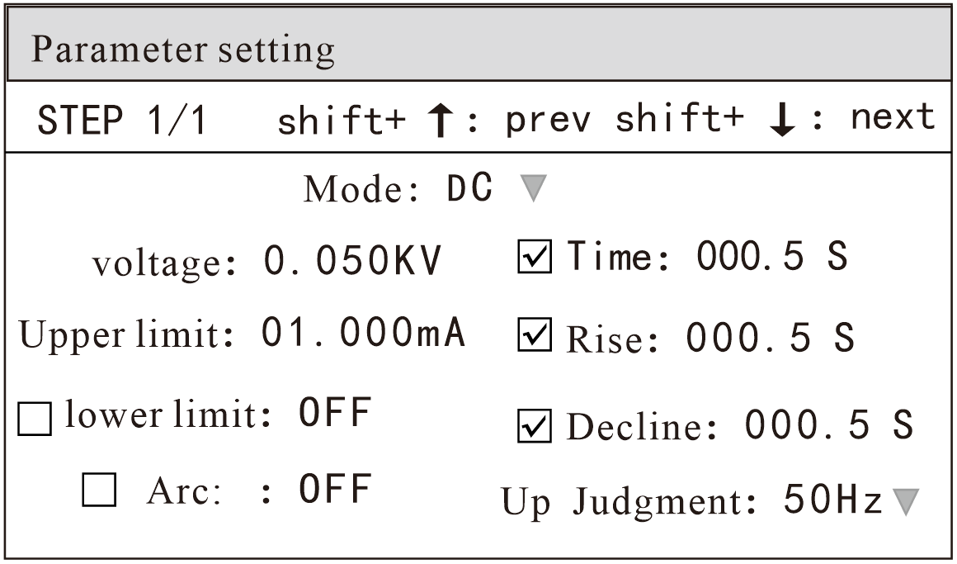

In this interface, press the "OK" key to edit the output voltage value, and the output voltage range is (0.050-6.000)KV. To change the output voltage value, press the keys "←" "↓" "→" to adjust, and then press "OK".

Current upper limit: press the "↓" key to move the cursor to the value after the current upper limit, as shown in the following figure:

In this interface, press the "OK" key to edit the upper limit value of current, with the range of (0.001-10.00)mA. To change the current upper limit, press the keys "←" "↓" "→" to adjust, and then press the "OK" key.

Lower current limit: press the "↓" key to move the cursor to the value after the lower current limit, as shown in the following figure:

Note: Use the "OK" key to turn on or off the lower limit function. The lower limit range is (0.001-10)mA.
After the lower limit function is turned on, press the ENT key to operate the lower limit function. To change the current lower limit value, press the ← ← ← → key to adjust it, and then press the OK key.
Arc function: press the "↓" key to move the cursor to the arc function item, as shown in the following figure:

Note: Turn on or off the arc function with the "OK" key, and the arc range is (1-20 )mA.
Press "ENT" key to operate the arc setting function after turning on the arc function. To change the arc value, press "←" "→" keys to adjust, and then press "OK".
The smaller the arc value is set, the lighter or flashover phenomenon of the measured object will not be detected by the tester during the test. Test time: press the "↓" key to move the cursor to the time function item, as shown in the following figure:

In this interface, press the "ENT" key to edit the time in the range of (0.1-999.9 )S s. To change the time value, press "↑" "↓"
"←" and → "keys to adjust, and then press" OK ".
Rise time: press the "↓" key to move the cursor to the rise time function item, as shown in the following figure:

In this interface, press the "ENT" key to edit the rising time in the range of (0.1-999.9 )S s. To change the rising time, press the keys "←" "←" → "to adjust, and then press" OK ".
Descent time: press the "↓" key to move the cursor to the function item of descent time, as shown in the following figure:

In this interface, press the "ENT" key to edit the descent time, and the range is (0.1-999.9) s. To change the descent time, press the keys "←" "↓" "→" to adjust, and then press "OK".
Ascending judgment: press the "↓" key to move the cursor to the ascending judgment function item, as shown in the following figure:
In this interface, press the "ENTER" key to edit the rising judgment in the range of (ON/OFF). Press "↓" "↑" or rotate the code.

Potentiometer
New Step: Press the shift key "New" on the panel in the test interface to create a new test step, and a total of 50 test steps can be created. A new test step is established after the current step, which adopts the default test mode-AC voltage.
Delete step: Press the "shift" key "Delete" on the panel in the test interface to delete the test step. The tester deletes the current step, and the subsequent steps move to the current step.
Previous Page: (Step Forward) In the test interface, press the "Previous Page" key on the panel to move forward the current step, that is, the contents of the current test step and the previous test step are exchanged, which can conveniently realize the sorting function of test steps, but when the current step is the first test step, the moving forward operation is invalid.
Next Page: (Step Move Back) Press the "Next Page" key on the panel in the test interface to move back the current step, that is, the contents of the current test step and the next test step are exchanged, which can conveniently realize the sorting function of test steps. However, when the current step is the last test step, the move back operation is invalid.
Save as file: in the test interface, press the "Mode" key on the panel to the parameter setting interface, press the "Shift" key and then press the "ENT" key to enter the file name interface. After inputting the file name, press the "ENT" key to "Save as file" to save the current test steps, which is convenient to retrieve and use in the form of a file. Storage interface, as shown below:

Please enter a file name |  |  | shift+  ↑  shift+  ok  shift+  ↓  shift+  menu
  ENT
  7STU
  4JKL
  1ABC
  ESC
  9YZ_
  6PQR
  3GHI
  8VW X
  5MNO
  2DEF
  0
Press mode to switch case.

After entering the interface shown above, press the number keys on the panel, and the screen will be displayed as follows:

Please enter a file name |  |  | shift+  ↑  shift+  ok  shift+  ↓  shift+  menu
  1
  a
  b
  c
 |  |  | shift+  ↑  shift+  ok  shift+  ↓  shift+  menu
  ENT
 |  |  | shift+  ↑  shift+  ok  shift+  ↓  shift+  menu
  7STU
  4J KL
  1ABC
  ESC
  9YZ_
  6PQR
  3GHI
  8VWX
  5MNO
  2DEF
  0
Press mode to switch case. |  |  | shift+  ↑  shift+  ok  shift+  ↓  shift+  menu

Type the relevant characters on the screen, press the "ENT" key, and the file will be saved in the memory of the tester.

4.4.5 IR insulation resistance parameter setting
Select "IR" insulation test mode under the parameter panel setting, and the test parameter setting will enter "IR" withstand voltage mode, as shown below: The setting parameters are as follows:
Test mode: After the cursor moves to the test mode, press the "OK" key to enter the test mode editing, press the "↑" or "↓" key to change the test mode, set the IR insulation test, and then press the "OK" key to save. In this way, all the following parameters are changed to the parameters of insulation resistance.
Output voltage: press the "↓" key to move the cursor to the value after the output voltage, as shown in the following figure:
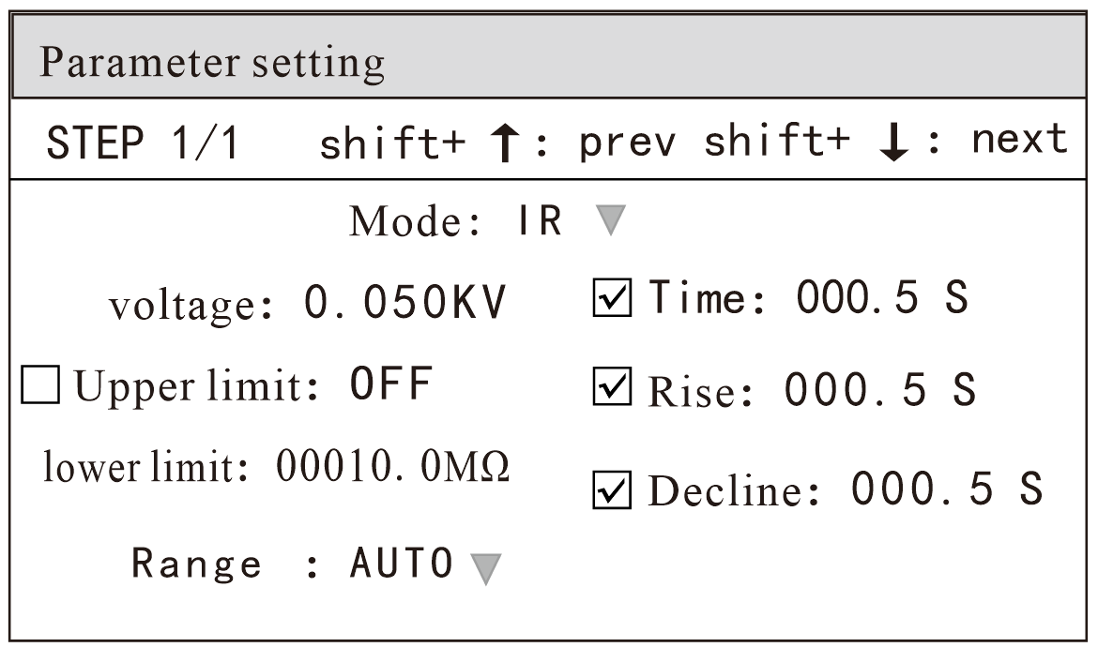

In this interface, press the "OK" key to edit the output voltage value, and the output voltage range is (0.050-5.000)KV. To change the output voltage value, press the keys "←" "↓" "→" to adjust, and then press "OK".
Upper limit of resistance: press the "↓" key to move the cursor to the value after the upper limit of resistance, as shown in the following figure:

Note: Use the "OK" key to turn on or off the upper limit function of resistance. The upper limit range is (0.1-99999.9) mω.
Press the "ENT" key in this interface to edit the current upper limit value, and the range is (0.1-99999.9) mω. To change the current upper limit, press ↑.
, ,
"↓" "←" "→" keys to adjust, and then press "OK".
Lower resistance limit: press the "↓" key to move the cursor to the value after the lower current limit, as shown in the following figure:

In this interface, press the "OK" key to edit the current lower limit value, and to change the current lower limit value, press "←" "→".

Key to adjust, and then press "OK".
Range function: press the "↓" key to move the cursor to the range function item, as shown in the following figure:

The measuring range is divided into: AUTO, 0.5M, 5M, 50M, 500M and 100G.
Test time: press the "↓" key to move the cursor to the time function item, as shown in the following figure:

Note: Use the "OK" key to turn on or off the test time function. The upper limit range is (0.1-999.9) s.
In this interface, press the "ENT" key to edit the time in the range of (0.1-999.9) s. To change the time value, press the keys "←" "↓" "→" to make adjustment, and then press "OK".
Rise time: press the "↓" key to move the cursor to the rise time function item, as shown in the following figure:

Note: Use the "OK" key to turn on or off the rise time function. The upper limit range is (0.1-999.9) s.

In this interface, press the "ENT" key to edit the time in the range of (0.1-999.9) s. To change the time value, press "↑" "↓"

← "→" key to adjust, and then press "OK".
Descent time: press the "↓" key to move the cursor to the function item of descent time, as shown in the following figure:

In this interface, press the "ENT" key to edit the time in the range of (0.1-999.9) s. To change the time value, press the keys "↑" "←" → "to adjust, and then press" OK ".

New Step: Press the shift key "New" on the panel in the test interface to create a new test step, and a total of 50 test steps can be created. A new test step is established after the current step, which adopts the default test mode-AC voltage.
Delete step: Press the "shift" key "Delete" on the panel in the test interface to delete the test step. The tester deletes the current step, and the subsequent steps move to the current step.
Previous Page: (Step Forward) In the test interface, press the "Previous Page" key on the panel to move forward the current step, that is, the contents of the current test step and the previous test step are exchanged, which can conveniently realize the sorting function of test steps, but when the current step is the first test step, the moving forward operation is invalid.
Next Page: (Step Move Back) Press the "Next Page" key on the panel in the test interface to move back the current step, that is, the contents of the current test step and the next test step are exchanged, which can conveniently realize the sorting function of test steps. However, when the current step is the last test step, the move back operation is invalid.
Save as file: in the test interface, press the "Mode" key on the panel to the parameter setting interface, press the "Shift" key and then press the "ENT" key to enter the file name interface. After inputting the file name, press the "ENT" key to "Save as file" to save the current test steps, which is convenient to retrieve and use in the form of a file. Storage interface, as shown below:

Please enter the file name |  |  | shift+  ↑  shift+  ok  shift+  ↓  shift+  menu
  ENT
  7STU
  4J KL
  1ABC
  ESC
  9YZ_
  6PQR
  3GHI
  8VW X
  5MNO
  2DEF
  0
press down

After entering the interface shown above, press the number keys on the panel, and the screen will be displayed as follows:
Please enter the file name |  |  | shift+  ↑  shift+  ok  shift+  ↓  shift+  menu
  1
  a
  b
  c
 |  |  | shift+  ↑  shift+  ok  shift+  ↓  shift+  menu
  ENT
 |  |  | shift+  ↑  shift+  ok  shift+  ↓  shift+  menu
  7STU
  4JKL
  1ABC
  ESC
  8VW X
  5MNO
  2DEF
  9YZ_
  6PQR
  3GHI
  0
press down |  |  | shift+  ↑  shift+  ok  shift+  ↓  shift+  menu

Type the relevant characters on the screen, press the "ENT" key, and the file will be saved in the memory of the tester.

4.5 System Setup Mode

4.5.1 Description of system setting parameters

System Settings
Language setting | Qualified voice
Sound of failure | keying chirps:
System time | System date
Restore system settings | Recovery Test Settings

1 system language
There are two languages in this program, Chinese and English. You can use the [↑] [↓] key to select the function item to be set.
2 failure sound
This optiON has two functions, on and OFF. You can use the [↑] [↓] key to select the function item to be set.
3 system time
This item can set the current time of the instrument. Once the system time is set, the time function will continue regardless of the power-on and power-off state, unless the internal battery fails. You can use the [write] [↓] [←] [→] key to select the value to be set.
4 Restore system settings
This function is to restore system settings, parameter settings and factory settings, and all settings will be reset. Press the [OK] key to pop up [Parareset], and then press the [OK] key to confirm, that is, restore the factory settings and restart the instrument.
5 qualified sound
This optiON has two functions, on and OFF. You can use the [↑] [↓] key to select the function item to be set.

6 key sound
This optiON has two functions, on and OFF. You can use the [↑] [↓] key to select the function item to be set. 7 system date
This item can set the current time of the instrument. Once the system time is set, the time function will continue regardless of the power-on and power-off state, unless the internal battery fails. Use the [write] [↓] [←] [→] cursor to select the time to be set.
8 Restore test settings

4.5.2 Description of communication settings

通讯设置
Communication interface: | RS232
Communication protocol: | Modbus Rtu
Baud rate: | 115200
Mailing address: | 001
IP address: | 192.168.000.088
Subnet mask: | 255.255.255.000
Gateway: | 192.168.000.001
Network protocol: | TCP IP Server | Next page:

1 communication mode
This item has three communication modes, RS232, RS485 and ENTH (default RS232). You can use the [↑] [↓] key to select the item to be set.
2 communication protocol
There are two communication protocols, Scpi and Modbus Rtu (Scpi by default). You can use the [↑] [↓] key to select the item to be set.
3 baud rate
There are four baud rates for this item. 9600/19200/38400/115200 (default 115200) can be used to select the item to be set.
4 mailing address
The mailing address of this item is 0-255, and (001 by default) you can use the [write] [left] key to select the item to be set. This item is only used in RS485 mode.
5 Ip address
default192.168.000.088You can use the [↑] [↓] [←] [→] key to select the item to be set.
6 subnet mask
default255.255.255.000You can use the [↑] [↓] [←] [→] key to select the item to be set.
7 gateway
default192.168.000.001You can use the [↑] [↓] [←] [→] key to select the item to be set.
8 network protocol
There are two network protocols for this item, TCP IP Server and UDP (default TCP IP Server). You can select the item to be set with the [↑] [↓] key.

Communication Settings
Local port: | 05000
The local udp por： | 07000
The local tcp port： | 00050
Remote port： | 05500
DNS： | 114.114.114.114 | On the page：

1 Local interface
The default is 05000. You can use the [↑] [↓] [←] [→] key to select the item to be set.
2 local udp port
The default is 07000. You can use the [↑] [↓] [←] [→] key to select the item to be set.
3 local tcp port
The default is 00050. You can use the [↑] [↓] [←] [→] key to select the item to be set.
4 Remote port
The default is 05500. You can use the [↑] [↓] [←] [→] key to select the item to be set.
5 DNS
default114.114.114.114. You can use the [↑] [↓] [←] [→] key to select the item to be set.

4.5.3 Description of contact inspection function (it is recommended that the voltage of this function is greater than 1.5KV. )
Contact inspection is conducted by a high voltage of 1kV to determine whether it contacts the equipment under test, which is usually used for testing equipment under 100G.
Contact inspection suggests that the high-voltage rod should be used when it is output for testing.

parameter setting
Contact check:
Step mode:
short-circuit protection:
Step wait:
Failure mode:
Electric shock protection:

4.5.4 Description of composite keys

Composite button
parameter setting： |  | preserve: | shift
new ： | shift | delete： | shift
previous page： | shift | next item： | shift
0 | shift | 1 | shift
2 | shift | 3 | shift
4 | shift | 5 | shift
6 | shift+shift | 7 | shift

Composite button
parameter setting： |  |  |  | preserve: |  | shift
new ： | shift |  |  | delete： |  | shift
previous page： | shift |  |  | next item： |  | shift
0 |  | shift | 1 |  | shift
2 |  | shift | 3 |  | shift
8  return |  | shift | 9 |  | shift

Composite button | function declaration
shift+ent | Step page: Save the current function parameters to the file
shift+left（NEW） | Step page: New test step
shift+right（DELETE） | Step page: Delete the test step
shift+up （PREV） | Step page: Return to the previous test page
shift+down（NEXT） | Value setting page:
shift+ESC | Value setting page:
shift+ENT | Value setting page:
shift+LOCK | Value setting page:
shift+MODE | Value setting page:
shift+MENU | Value setting page:
shift+shift | Value setting page:
shift+left（NEW） | Value setting page:
shift+OK | Value setting page:
shift+right（DELETE） | Value setting page:

4.6 Description of file parameters
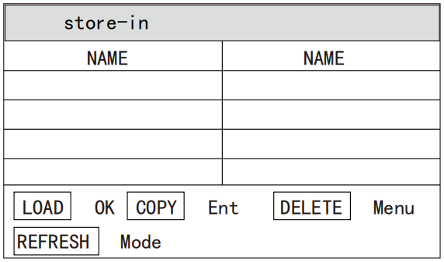

4.7 Test function principle and instructions for use
This section introduces the principle and application of grounding connection, grounding current detection, arc detection and other tests in the order of testing process. Block diagram of test flow of instrument

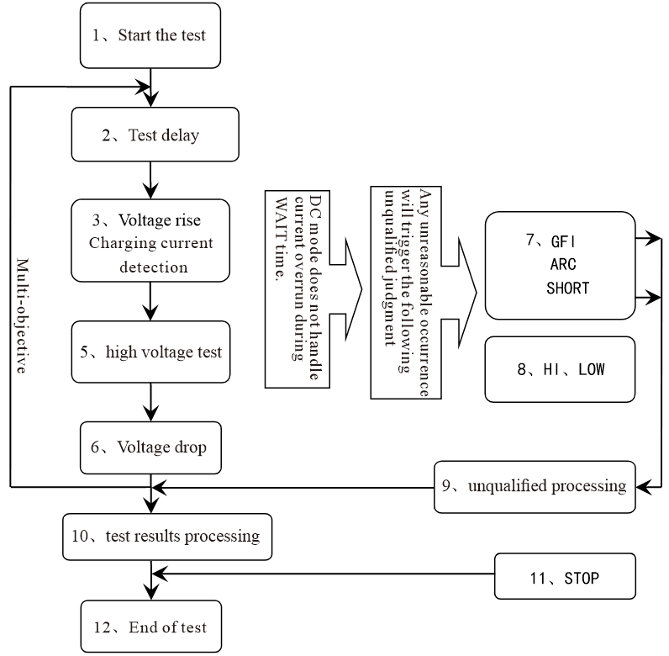

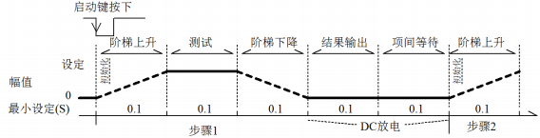
Schematic diagram of instrument test sequence

4.7.1 Start the test
When the instrument is in test mode, after checking the test conditions and the correct connection of the tested part, press the START key to start the test.

4.7.2 Voltage rise
Some characteristics of the tested part are sensitive to the sudden change of voltage, so this function is needed. When the instrument starts to output, the output voltage is zero. When the voltage is output, the instrument will control the output voltage to step up in units of 0.1S The step-up value is determined according to the test voltage and voltage rise time (ΔV = V /(10 * S)). If the default voltage rise RISE OFF 0.1 second is turned off, the test time is automatically added, so that the minimum test time is 0.2S. If this value is too small, it may cause an error in the judgment of ARC or DC boost. Please note.

4.7.3 DC boost judgment
Whether to start the current upper limit judging function switch in the process of voltage rise is mainly used to avoid test misjudgment.
When the distributed capacitor is small, the charging current of the capacitor is relatively small, which will not cause obvious changes in the current. If the boost judgment is turned on, the poor performance of the tested part can be found as early as possible, and the probability of over-current damage of the component can be reduced.
When the step capacitor is large, the capacitor will have a charging process during the voltage rise, and the current at this time may be far greater than the set upper limit of the measured current. If the step-up judgment is turned on, it will cause misjudgment of exceeding the upper limit. If necessary, you can open the short-circuit threshold to lower the short-circuit sensitivity and increase the charging current.

4.7.4 high voltage test
High voltage test is performed on the tested piece. At this time, it should be possible to ensure that the test circuit is correct, and the test results will not be affected by some special attached parameters. The display content is the actual withstand voltage and current required for the test.

4.7.5 Test voltage drop
The rise of the same test voltage is determined by the characteristics of the tested part. When high voltage test finishes the voltage drop, the instrument will control the output voltage drop in units of 0.1S (the DC voltage will not drop with the control voltage), and the step-down value will be determined according to the test voltage and voltage rise time (δ v =-v/(10 * s)). If the voltage drop time (FAIL OFF) is turned off, the default voltage drop time is 0.1 second. At this time, the instrument is judged by comparison without testing, and the data is for reference only. When the voltage drop is over, the instrument will connect the test circuit to AC withstand voltage mode and be tested at this time.
If there is a DC voltage drop, it will be discharged through the AC circuit of the instrument.
4.7.6 Ground wire current detection function

Ground wire current detection is to detect the current flowing through the instrument shell to prevent electric shock. When high voltage is output, there is current flowing back from the voltage output end to the instrument shell through the human body, which may cause very serious consequences.
Description of the response of the ground current detection and judgment circuit of the instrument:

Ground wire current detection is enabled, and if the ground wire current is greater than 0.45mA, it is judged that the ground wire current exceeds the limit.
When electric shock is judged, the instrument will end the high-voltage output within 0.3S and exit the test state. And display (GFI FAIL).
Note: The instantaneous output current of the instrument may be greater than 30mA. If it is really electric shock, it may cause coma or death of the operator. Therefore, it is recommended to turn on the ground wire current detection when the product allows.
4.7.7 Current overrun and arc detection function
Classification of current overrun: current lower limit, current upper limit, current overrun and arc detection.
Current lower limit judgment (LOW): It is generally used for testing low-end disconnection judgment. When the instrument tests the equipment, the equipment will definitely have a certain leakage current. When the leakage current tested by the instrument is less than the lower limit set current value, it is considered that the test failed (no equipment is connected).
This function must be turned off if the leakage current of the tested component itself is very small. When the limit is exceeded, the judgment is displayed (LOWFAIL). This judgment is valid only in the test mode, and the sampling is carried out at regular intervals at a rate of 100mS each time.
Current upper limit judgment (HIGH): the most commonly used judgment of test current exceeding the limit. When the instrument tests the equipment, the equipment will definitely have a certain
Leakage current, when the leakage current tested by the instrument is greater than the upper limit set current value, it is considered that the voltage resistance impedance of the equipment is not enough and the test fails. Over-time judgment display (HI FAIL), sampling regularly, with a rate of 100mS each time.
Current limit judgment: the current sampling judgment is slow, and the current changes rapidly when the insulation collapses, and the sampling circuit cannot reflect it in time, but
If the peak current exceeds the allowable output range of the instrument, this kind of overrun judgment will be triggered, and short failure will be displayed when the overrun occurs. Because the data cannot be collected after the current exceeds the limit, the output result of the system at this time is: the test junction within 100mS before the current exceeds the limit.
Fruit. The current limit is twice the allowable output current of the instrument (1.5 times the peak value of relative AC). The falling time is invalid, and 's judgment cannot be shielded.
ARC detection (ARC): It is a very practical function for measuring coil components. It tests the local current oscillation caused by instantaneous discharge of local circuits in high voltage test loop. Because it is superimposed on the normal test current, the sudden change time is short, so the common current detection circuit on the circuit can not make appropriate judgments in response to the current change. The arc detection circuit filters out the normal current value,
Only deal with high-speed current pulse changes. Because of the randomness of low-pass filtering and arc size itself, this function can only roughly estimate the degree of local ignition. Because the data can't be collected after the current exceeds the limit, the output result at this time is the last test result when it is qualified, and it will be judged and displayed when it exceeds the limit (ARCFAIL). ARC current is a qualitative analysis for testing, and the size of the quantity, the testing environment and the distribution of test lines have great influence on randomness, so pay attention to it when using.

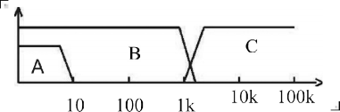
Frequency response comparison between current overrun judgment and arc detection: (see the above figure)
Area A in the figure shows the frequency response of the current sampling display circuit. Because it is necessary to filter the ripple of power frequency →AD sampling → calculate the test results → analyze whether the current exceeds the set limit. Within the test current range, the pulse width is greater than 100mS.
Area B in the figure: current fast response circuit. It only filters out high-frequency interference signals → voltage peak comparison → overcurrent peak signal locking, and only makes limit judgment. It is greater than the allowable output current of the instrument, and the pulse width is greater than 1 ms.
Area C in the figure: arc detection circuit. The arc detection circuit only samples the amplitude of sudden change in current, and the signal Qualcomm filters out low frequency → voltage peak comparison → pulse locking. At the abrupt current edge near the set value, the pulse width is about 1 us-1 ms.
4.7.8 Unqualified judgment
1. When the current exceeds the maximum output current that the instrument can withstand during the test, or the instrument finds that there is a potential safety hazard, the instrument will immediately cut off the voltage of the test loop, and wait for the instrument software to query the cause of the error and judge that it is unqualified.
2. If the test result exceeds the limit set by the test item, the instrument will judge that the tested part is unqualified. And immediately stop the current test, cut off the voltage output, and enter the processing program with unqualified test results.
3, multi-step testing. There is a step of FAIL, and the total test result is FAIL.

4.7.9 Processing of test results
If the test process exceeds the limit, it is judged as (FAIL). FAIL appears in the multi-step test, and the final result is FAIL.
There are many test items, and the failure judgment processing mode is controlled by the failure mode of the system. Otherwise, the instrument will display the FAIL judgment and category (see the figure below, taking HI as an example), waiting for the user to handle it.
After the test, there is no unqualified mark, and the test result is judged as (PASS).
PASS determines that the processing mode is controlled by the PASS HOLD of the SYSTEM, and then prepares to start the next measurement or return to the test waiting state. HANDLER signal output is controlled by control mode. Select FILE mode, so the test will not be output until the whole file test is finished. Result. STEP mode will control the interface to output corresponding signals at each step.
From this state to the next step, customers can use software to query test data and results.

测量
AC
superior limit：  20.000  0.001  3.0s | 0.000  0.000  0.0  READY
0%

4.7.10 STOP (stop measuring)
Press the STOP key in any state during the whole test, and the instrument will automatically end the test and enter the test end state. Press the STOP key again, and the instrument will return to the test waiting state. When the test is stopped, no test result judgment output will be given.
At the end of the test, customers can use the software to query the last test data obtained before STOP.

4.8 Structure and use of the interface circuit of Handler and SIGNAL

4.8.1 Control interface principle
HANDLER and SIGNAL interface instrument internal principle, as follows:
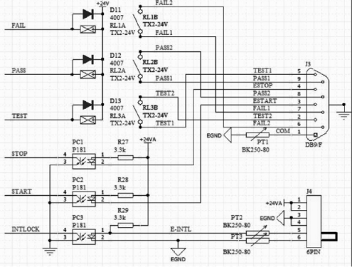
Interface structure and timing of HANDLER and SIGN AL

Description:
1. HANDLER interface: START, STOP and COM signals form remote input control, and the switch input is closed effectively.
2. HANDLER interface: remote output control is composed of TEST, PASS and FAIL signals. The switch output is closed effectively. TEST can be used as a high-voltage start signal or a pulse signal that the instrument works normally.
3. The SIGNAL interface is mainly used to provide the instrument selection signal (INTLOCK) when multiple instruments are tested online. This signal is short-circuited by default on a single machine, and it is forbidden to start high-voltage output when the instrument is open.
4. In addition, the SIGNAL interface provides a power supply with an output voltage of +24V, and the output current is less than 0.5A With the control signal of the HANDLER interface, it can be used to drive indicator lights, photoelectric switches, low-power electromagnetic valves and so on. (see the picture below)

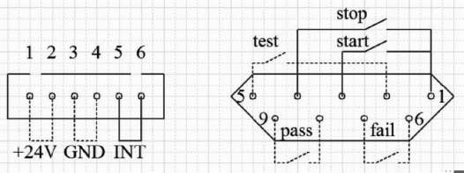

HANDLER SIGNAL interface rear panel view (schematic)

4.8.2 Use of control interface
The control interface is generally used for remote control and test synchronization or indication. The external connection of the interface is as follows:

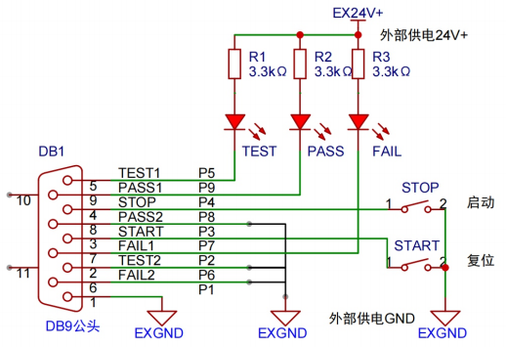

Schematic diagram of external circuit connection

Description:
1. Switches can be replaced by isolated switching elements such as optocoupler secondary side, and the current direction refers to the principle shown above (COM terminal is low-end).
2. The indicator light here can be replaced by other drive control components, and the current direction depends on the power supply.
3, the instrument internal power performance
A) The output is rectified and filtered by AC power supply, and the output without voltage regulation is about 24V. Please confirm it before use.
B) The instantaneous maximum current shall not be greater than 0.5A, and the long-term working current shall be less than 0.2a. Please bring your own power supply if you need more current.
C) The external control signal needs a voltage greater than 220V or a current of 2A, so the internal relay of the instrument can't bear it. Please transfer it by yourself.

4.9 Other interfaces and functions of the instrument
1. The USB HOST on the front panel is used to connect a USB flash drive and export and import the customer profile.
2. The USB DEV on the back panel maps the internal FLASH to the computer as a USB flash drive.
3. RS232 is used to connect with the computer. See the system settings for baud rate, and the data format is 8. n.1.. Compatible with software format IEE485.

4.10 instrument communication protocol (modbus-RTU, supporting SCPI)
This instrument uses RS-232c RS-485 standard asynchronous serial communication bus interface to communicate with external control equipment, and the transmission baud rate can be preset in the instrument (9600, 19200, 38400 and 115200 are optional). 8 data bits, 1 stop bit, no check bit.
The logic level of the signal is ±12V, and the maximum transmission distance is 15m.
The serial interface adopts direct communication, using only three signal lines of TXD (transmission), RXD (reception) and GND (ground), and using a nine-core calibration interface socket.
1. Read instruction (function code is 03H)
Send format (7 bits of data in total):

Address | function code | Address high | Address low | High data volume | Low data volume | CRC low | CRC high
Return format:

Address | function code | Data volume (Byte) | Data byte | CRC low | CRC high
Data Byte: when the data type is U16, the data byte is 2 bytes, with the highest bit before, and the data amount is 1.
When the data type is float, the data 4byte is 4 bytes, and the high bit comes first, and the data amount is 2.
Example: Send 01 03 00 01 00 01 D5 CA to inquire about the current selection steps of No.01 instrument.
Return to 01 03 02 00 01 79 84
Different address bits return different data and different register lists.
serial number |  | Register address |  | Slave actual address |  | Register name | data type |  | Number of register bytes |  | explain |  |  | Data range |  | Read-write type | serviceable range
1 |  | 0002H |  | 0001H |  | Sel Step | U16 |  | 2 |  | Current Steps/Selected Steps |  |  |  |  | RW
2 |  | 0003H |  | 0002H |  | To l Step | U16 |  | 2 |  | Total steps |  |  |  |  | R
3 |  | 0004H |  | 0003H |  | New Step | U16 |  | 2 |  | New steps |  |  |  |  | W
4 |  | 0005H |  | 0004H |  | Del Step | U16 |  | 2 |  | Delete steps |  |  |  |  | W
5 |  | 0006H |  | 0005H |  | Mode | U16 |  | 2 |  | model |  |  | 1-3 |  | RW | complete
6 |  | 0007H |  | 0006H |  | Volt | float |  | 4 |  | voltage |  |  | AC 0.05-5.0  Dc 0.05-6.0 (none for RK9320b) and IR 0.05-5.0 (RK9320 only) |  | RW | AC DC IR
7 |  | 0009H |  | 0008H |  | Cur rUp lim | float |  | 4 |  | Current upper limit |  |  | AC 0.001-20  Dc 0.001-10 (none for rk 9320b)  RK9310 :AC 0.001-10 DC 0.001-5 |  | RW | AC DC
8 |  | 000BH |  | 000AH |  | Cur rUp lim | float |  | 4 |  | Current lower limit |  |  | AC 0.001-19.999  DC 0.001-9.999 (RK9320B)  RK9310 :AC 0.001-9.999 DC 0.001-4.999 |  | RW | AC DC
9 |  | 000DH |  | 000CH |  | Arc | float |  | 4 |  | Arc setting |  |  | 0-20 |  | RW | AC DC
10 |  | 000FH |  | 000EH |  | T ime | float |  | 4 |  | timeset |  |  | 0. 1-999.9 0 (unlimited) |  | RW | AC DC IR
11 |  | 0011H |  | 0010H |  | R ise T ime | float |  | 4 |  | Rise time setting |  |  | 0-999.9 |  | RW | AC DC IR
12 |  | 0013H |  | 0012H |  | FallT ime | float |  | 4 |  | Descent time setting |  |  | 0-999.9 |  | RW | AC DC IR
13 |  | 0015H |  | 0014H |  | Freq | U16 |  | 2 |  | Frequency setting |  |  | 5060 |  | RW | AC
serial number | Register address |  | Slave actual  address |  | Register name |  |  | data type |  | Number of register  bytes |  | Length | explain |  | Data range |  | Read-write type | serviceable range
14 | 0016H |  | 0015H |  | Ramp |  |  | U16 |  | 2 |  | 1 | Upward  determinat i on |  | 0 1 |  | RW | DC
15 | 0017H |  | 0016H |  | ResUp lim |  |  | float |  | 4 |  | 2 | Resistance limit |  | 0.1-99999.9 |  | RW | IR
16 | 0019H |  | 0018H |  | ResDn lim |  |  | float |  | 4 |  | 2 | Lower limit of  resistance |  | 0.1-99999.8 0 (no lower  limit) |  | RW | IR
17 | 001BH |  | 001AH |  | Range |  |  | U16 |  | 2 |  | 1 | range |  | 0 1 2 3 4 5 |  | RW | IR
18 | 0x49H |  | 0x48H |  | bias current |  |  | float |  | 4 |  | 2 | Pressure bias  current |  | 0-20.0 |  | RW | AC DC
19 | 63H |  | 62H |  | fetch one mode |  |  | u8 |  | 2 |  | 1 | Get the pattern of the current step |  |  |  | R
20 | 64H |  | 63H |  | fetch one status |  |  | u8 |  | 2 |  | 1 | Test status/results of the current step |  |  |  | R
21 | 65H |  | 64H |  | fetch one Voltage |  |  | float |  | 4 |  | 2 | The test voltage of the current step |  |  |  | R | AC DC IR
22 | 67H |  | 66H |  | fetch one Current/ RES |  |  | float |  | 4 |  | 2 | The test current for the current step |  |  |  | R | AC DC IR
23 | 0071H |  | 0070H |  | fetch one all |  |  |  |  | 16 |  | 8 | mode(u16) status(u16) voltage(float) current(float)  reserve(float) |  |  |  | R
24 | 0089H |  | 0088H |  | fetch speical step mode |  |  | u8 |  | 2 |  | 1 | Get a pattern for the specified step |  |  |  | R
25 | 008AH |  | 0089H |  | fetch speical step status |  |  | u8 |  | 2 |  | 1 | Specify the test  status/results of the steps |  |  |  | R
26 | 008BH |  | 008AH |  | fetch speical step Voltage |  |  | float |  | 4 |  | 2 | Specify the test voltage for the step |  |  |  | R
27 | 8DH |  | 008CH |  | fetch spe ical stepCurrent/RES |  |  | float |  | 4 |  | 2 | The test current for the specified step |  |  |  | R
28 | 91H |  | 0090H |  | fetch special step all |  |  |  |  | 16 |  | 8 | mode (u16) status(u16) voltage(float) current(float)  reserve(float)
29 | 135H |  | 134H |  | fetch step 4 Current/ RES |  |  | float |  | 4 |  | 2 | Test current for step 4 |  |  |  | R | AC DC IR
30 | 139H |  | 138H |  | fetch step 4 step all |  |  | u16 u16 float float |  | 16 |  | 8 | mode (u16) status(u16) voltage(float) current(float)  reserve(float)
31 | 141H |  | 140H |  | fetch step 5 mode |  |  | u8 |  | 2 |  | 1 | Get the pattern for step 5 |  |  |  | R
32 | 142H |  | 141H |  | fetch step 5 status |  |  | u8 |  | 2 |  | 1 | Test status/results for step 5 |  |  |  | R
33 | 143H |  | 142H |  | fetch step 5 Voltage |  |  | float |  | 4 |  | 2 | Test voltage for step 5 |  |  |  | R | AC DC IR
34 | 145H |  | 144H |  | fetch step 5 Current/ RES |  |  | float |  | 4 |  | 2 | Test current for step 5 |  |  |  | R | AC DC IR
35 | 149H |  | 148H |  | fetch step 5 step all |  |  | u16 u16 float float |  | 16 |  | 8 | mode (u16) status(u16) voltage(float) current(float)  reserve(float)
36 | 151H |  | 150H |  | fetch step 6 mode |  |  | u8 |  | 2 |  | 1 | Get the pattern for step 6 |  |  |  | R
37 | 152H |  | 151H |  | fetch step 6 status |  |  | u8 |  | 2 |  | 1 | Test status/results for step 6 |  |  |  | R
38 | 153H |  | 152H |  | fetch step 6 Voltage |  |  | float |  | 4 |  | 2 | Test voltage for step 6 |  |  |  | R | AC DC IR
serial number | Register address |  | Slave actual  address |  | Register name |  |  | data type |  | Number of register  bytes |  | Length | explain |  | Data range |  | Read-write type | serviceable range
39 | 155H |  | 154H |  | fetch step 6 Current/ RES |  |  | float |  | 4 |  | 2 | Test current for step 6 |  |  |  | R | AC DC IR
40 | 159H |  | 158H |  | fetch step 6 step all |  |  | u16 u16 float float |  | 16 |  | 8 | mode(u16) status(u16) voltage(float) current(float)  reserve(float)
41 | 161H |  | 160H |  | fetch step 7 mode |  |  | u8 |  | 2 |  | 1 | Get the pattern for step 7 |  |  |  | R
42 | 162H |  | 161H |  | fetch step 7 status |  |  | u8 |  | 2 |  | 1 | Test status/results for step 7 |  |  |  | R
43 | 163H |  | 162H |  | fetch step 7 Voltage |  |  | float |  | 4 |  | 2 | Test voltage for step 7 |  |  |  | R | AC DC IR
44 | 155H |  | 164H |  | fetch step 7 Current/ RES |  |  | float |  | 4 |  | 2 | Test current for step 7 |  |  |  | R | AC DC IR
45 | 169H |  | 168H |  | fetch step 7 step all |  |  | u16 u16 float float |  | 16 |  | 8 | mode (u16) status(u16) voltage(float) current(float)  reserve(float)
46 | 171H |  | 170H |  | fetch step 8 mode |  |  | u8 |  | 2 |  | 1 | Get step 8 mode |  |  |  | R
47 | 172H |  | 171H |  | fetch step 8 status |  |  | u8 |  | 2 |  | 1 | Test status/results for step 8 |  |  |  | R
48 | 173H |  | 172H |  | fetch step 8 Voltage |  |  | float |  | 4 |  | 2 | Test voltage for step 8 |  |  |  | R | AC DC IR
49 | 175H |  | 174H |  | fetch step 8 Current/ RES |  |  | float |  | 4 |  | 2 | Test current for step 8 |  |  |  | R | AC DC IR
50 | 179H |  | 178H |  | fetch step 8 step all |  |  | u16 u16 float float |  | 16 |  | 8 | mode (u16) status(u16) voltage(float) current(float)  reserve(float)
51 | 181H |  | 180H |  | fetch step 9 mode |  |  | u8 |  | 2 |  | 1 | Get the pattern for step 9 |  |  |  | R
52 | 182H |  | 181H |  | fetch step 9 status |  |  | u8 |  | 2 |  | 1 | Test status/results for step 9 |  |  |  | R
53 | 183H |  | 182H |  | fetch step 9 Voltage |  |  | float |  | 4 |  | 2 | Test voltage for step 9 |  |  |  | R | AC DC IR
54 | 185H |  | 184H |  | fetch step 9 Current/ RES |  |  | float |  | 4 |  | 2 | Test current for step 9 |  |  |  | R | AC DC IR
55 | 189H |  | 188H |  | fetch step 9 step all |  |  | u16 u16 float float |  | 16 |  | 8 | mode (u16) status(u16) voltage(float) current(float)  reserve(float)
56 | 191H |  | 190H |  | fetch step 10 mode |  |  | u8 |  | 2 |  | 1 | Get the pattern for step 10 |  |  |  | R
57 | 192H |  | 191H |  | fetch step 10 status |  |  | u8 |  | 2 |  | 1 | Test status/results for step 10 |  |  |  | R
58 | 193H |  | 192H |  | fetch step 10 Voltage |  |  | float |  | 4 |  | 2 | Test voltage for step 10 |  |  |  | R | AC DC IR
59 | 195H |  | 194H |  | fetch step 10 Current/ RES |  |  | float |  | 4 |  | 2 | Test current for step 10 |  |  |  | R | AC DC IR
60 | 199H |  | 198H |  | fetch step 10 step all |  |  | u16 u16 float float |  | 16 |  | 8 | mode (u16) status(u16) voltage(float) current(float)  reserve(float)
61 | 1A1H |  | 1A0H |  | fetch step 11 mode |  |  | u8 |  | 2 |  | 1 | Get the pattern for step 11 |  |  |  | R
62 | 1A2H |  | 1A1H |  | fetch step 11 status |  |  | u8 |  | 2 |  | 1 | Test status/results for step 11 |  |  |  | R
63 | 1A3H |  | 1A2H |  | fetch step 11 Voltage |  |  | float |  | 4 |  | 2 | Test voltage for step 11 |  |  |  | R | AC DC IR
64 | 1A5H |  | 1A4H |  | fetch step 11 Current/ RES |  |  | float |  | 4 |  | 2 | Test current for step 11 |  |  |  | R | AC DC IR
serial number | Register address |  | Slave actual  address |  | Register name |  |  | data type |  | Number of register  bytes |  | Length | explain |  | Data range |  | Read-write type | serviceable range
65 | 1A9H |  | 1A8H |  | fetch step 11 step all |  |  | u16 u16 float float |  | 16 |  | 8 | mode (u16) status(u16) voltage(float) current(float)  reserve(float)
66 | 1B1H |  | 1B0H |  | fetch step 12 mode |  |  | u8 |  | 2 |  | 1 | Get the pattern of step 12 |  |  |  | R
67 | 1B2H |  | 1B1H |  | fetch step 12 status |  |  | u8 |  | 2 |  | 1 | Test status/results for step 12 |  |  |  | R
68 | 1B3H |  | 1B2H |  | fetch step 12 Voltage |  |  | float |  | 4 |  | 2 | Test voltage for step 12 |  |  |  | R | AC DC IR
69 | 1B5H |  | 1B4H |  | fetch step 12 Current/ RES |  |  | float |  | 4 |  | 2 | Test current for step 12 |  |  |  | R | AC DC IR
70 | 1B9H |  | 1B8H |  | fetch step 12 step all |  |  | u16 u16 float float |  | 16 |  | 8 | mode (u16) status(u16) voltage(float) current(float)  reserve(float)
71 | 1C1H |  | 1C0H |  | fetch step 13 mode |  |  | u8 |  | 2 |  | 1 | Get the pattern for step 13 |  |  |  | R
72 | 1C2H |  | 1C1H |  | fetch step 13 status |  |  | u8 |  | 2 |  | 1 | Test status/results for step 13 |  |  |  | R
73 | 1C3H |  | 1C2H |  | fetch step 13 Voltage |  |  | float |  | 4 |  | 2 | Test voltage for step 13 |  |  |  | R | AC DC IR
74 | 1C5H |  | 1C4H |  | fetch step 13 Current/ RES |  |  | float |  | 4 |  | 2 | Test current for step 13 |  |  |  | R | AC DC IR
75 | 1C9H |  | 1C8H |  | fetch step 13 step all |  |  | u16 u16 float float |  | 16 |  | 8 | mode (u16) status(u16) voltage(float) current(float)  reserve(float))
76 | 1D1H |  | 1D0H |  | fetch step 14 mode |  |  | u8 |  | 2 |  | 1 | Get the pattern for step 14 |  |  |  | R
77 | 1D2H |  | 1D1H |  | fetch step 14 status |  |  | u8 |  | 2 |  | 1 | Test status/results for step 14 |  |  |  | R
78 | 1D3H |  | 1D2H |  | fetch step 14 Voltage |  |  | float |  | 4 |  | 2 | Test voltage for step 14 |  |  |  | R | AC DC IR
79 | 1D5H |  | 1D4H |  | fetch step 14 Current/ RES |  |  | float |  | 4 |  | 2 | Test current for step 14 |  |  |  | R | AC DC IR
80 | 1D9H |  | 1D8H |  | fetch step 14 step all |  |  | u16 u16 float float |  | 16 |  | 8 | mode (u16) status(u16) voltage(float) current(float)  reserve(float)
81 | 1E1H |  | 1E0H |  | fetch step 15 mode |  |  | u8 |  | 2 |  | 1 | Get the pattern for step 15 |  |  |  | R
82 | 1E2H |  | 1E1H |  | fetch step 15 status |  |  | u8 |  | 2 |  | 1 | Test status/results for step 15 |  |  |  | R
83 | 1E3H |  | 1E2H |  | fetch step 15 Voltage |  |  | float |  | 4 |  | 2 | Test voltage for step 15 |  |  |  | R | AC DC IR
84 | 1E5H |  | 1E4H |  | fetch step 15 Current/ RES |  |  | float |  | 4 |  | 2 | Test current for step 15 |  |  |  | R | AC DC IR
85 | 1E9H |  | 1E8H |  | fetch step 15 step all |  |  | u16 u16 float float |  | 16 |  | 8 | mode (u16) status(u16) voltage(float) current(float)  reserve(float)
86 | 1F1H |  | 1F0H |  | fetch step 16 mode |  |  | u8 |  | 2 |  | 1 | Get the pattern for step 16 |  |  |  | R
87 | 1F2H |  | 1F1H |  | fetch step 16 status |  |  | u8 |  | 2 |  | 1 | Test status/results forstep 16 |  |  |  | R
88 | 1F3H |  | 1F2H |  | fetch step 16 Voltage |  |  | float |  | 4 |  | 2 | Test voltage for step 16 |  |  |  | R | AC DC IR
89 | 1F5H |  | 1F4H |  | fetch step 16 Current/ RES |  |  | float |  | 4 |  | 2 | Test current for step 16 |  |  |  | R | AC DC IR
90 | 1F9H |  | 1F8H |  | fetch step 16 step all |  |  | u16 u16 float float |  | 16 |  | 8 | mode (u16) status(u16) voltage(float) current(float)  reserve(float))
serial number | Register address |  | Slave actual  address |  | Register name |  |  | data type |  | Number of register  bytes |  | Length | explain |  | Data range |  | Read-write type | serviceable range
91 | 201H |  | 200H |  | fetch step 17 mode |  |  | u8 |  | 2 |  | 1 | Get the pattern for step 17 |  |  |  | R
92 | 202H |  | 201H |  | fetch step 17 status |  |  | u8 |  | 2 |  | 1 | Test status/results for step 17 |  |  |  | R
93 | 203H |  | 202H |  | fetch step 17 Voltage |  |  | float |  | 4 |  | 2 | Test voltage for step 17 |  |  |  | R | AC DC IR
94 | 205H |  | 204H |  | fetch step 17 Current/ RES |  |  | float |  | 4 |  | 2 | Test current for step 17 |  |  |  | R | AC DC IR
95 | 209H |  | 208H |  | fetch step 17 step all |  |  | u16 u16 float float |  | 16 |  | 8 | mode (u16) status  (u16) voltage(float) current(float)  reserve(float)
96 | 211H |  | 210H |  | fetch step 18 mode |  |  | u8 |  | 2 |  | 1 | Get the pattern for step 18 |  |  |  | R
97 | 212H |  | 211H |  | fetch step 18 status |  |  | u8 |  | 2 |  | 1 | Test status/result of step 18 |  |  |  | R
98 | 213H |  | 212H |  | fetch step 18 Voltage |  |  | float |  | 4 |  | 2 | Test voltage for step 18 |  |  |  | R | AC DC IR
99 | 215H |  | 214H |  | fetch step 18 Current/ RES |  |  | float |  | 4 |  | 2 | Test current for step 18 |  |  |  | R | AC DC IR
100 | 219H |  | 218H |  | fetch step 18 step all |  |  | u16 u16 float float |  | 16 |  | 8 | mode (u16) status  (u16) voltage(float) current(float)  reserve(float)
101 | 221H |  | 220H |  | fetch step 19 mode |  |  | u8 |  | 2 |  | 1 | Get step 19 pattern |  |  |  | R
102 | 222H |  | 221H |  | fetch step 19 status |  |  | u8 |  | 2 |  | 1 | Test status/results of step 19 |  |  |  | R
103 | 223H |  | 222H |  | fetch step 19 Voltage |  |  | float |  | 4 |  | 2 | Test voltage for step 19 |  |  |  | R | AC DC IR
104 | 225H |  | 224H |  | fetch step 19 Current/ RES |  |  | float |  | 4 |  | 2 | Test current for step 19 |  |  |  | R | AC DC IR
105 | 229H |  | 228H |  | fetch step 19 step all |  |  | u16 u16 float float |  | 16 |  | 8 | mode (u16) status  (u16) voltage(float) current(float)  reserve(float)
106 | 231H |  | 230H |  | fetch step 20 mode |  |  | u8 |  | 2 |  | 1 | Get step 20 mode |  |  |  | R
107 | 232H |  | 231H |  | fetch step 20 status |  |  | u8 |  | 2 |  | 1 | Test status/results for step 20 |  |  |  | R
108 | 233H |  | 232H |  | fetch step 20 Voltage |  |  | float |  | 4 |  | 2 | Test voltage of step 20 |  |  |  | R | AC DC IR
109 | 235H |  | 234H |  | fetch step 20 Current/ RES |  |  | float |  | 4 |  | 2 | Test current for step 20 |  |  |  | R | AC DC IR
110 | 239H |  | 238H |  | fetch step 20 step all |  |  | u16 u16 float float |  | 16 |  | 8 | mode (u16) status  (u16) voltage(float) current(float)  reserve(float)
111 | 241H |  | 240H |  | fetch step 21 mode |  |  | u8 |  | 2 |  | 1 | Get the pattern for step 21 |  |  |  | R
112 | 242H |  | 241H |  | fetch step 21 status |  |  | u8 |  | 2 |  | 1 | Test status/results for step 21 |  |  |  | R
113 | 243H |  | 242H |  | fetch step 21 Voltage |  |  | float |  | 4 |  | 2 | Test voltage for step 21 |  |  |  | R | AC DC IR
114 | 245H |  | 244H |  | fetch step 21 Current/ RES |  |  | float |  | 4 |  | 2 | Test current for step 21 |  |  |  | R | AC DC IR
115 | 249H |  | 248H |  | fetch step 21 step all |  |  | u16 u16 float float |  | 16 |  | 8 | mode (u16) status  (u16) voltage(float) current(float)  reserve(float)
116 | 251H |  | 250H |  | fetch step 22 mode |  |  | u8 |  | 2 |  | 1 | Get the pattern for step 22 |  |  |  | R
serial number | Register address |  | Slave actual  address |  | Register name |  |  | data type |  | Number of register  bytes |  | Length | explain |  | Data range |  | Read-write type | serviceable range
117 | 252H |  | 251H |  | fetch step 22 status |  |  | u8 |  | 2 |  | 1 | Test status/results for step 22 |  |  |  | R
118 | 253H |  | 252H |  | fetch step 22 Voltage |  |  | float |  | 4 |  | 2 | Test voltage for step 22 |  |  |  | R | AC DC IR
119 | 255H |  | 254H |  | fetch step 22 Current/ RES |  |  | float |  | 4 |  | 2 | Test current for step 22 |  |  |  | R | AC DC IR
120 | 259H |  | 258H |  | fetch step 22 step all |  |  | u16 u16 float float |  | 16 |  | 8 | mode (u16) status  (u16) voltage(float) current(float)  reserve(float)
121 | 261H |  | 260H |  | fetch step 23 mode |  |  | u8 |  | 2 |  | 1 | Get the pattern for step 23 |  |  |  | R
122 | 262H |  | 261H |  | fetch step 23 status |  |  | u8 |  | 2 |  | 1 | Test status/results of step 23 |  |  |  | R
123 | 263H |  | 262H |  | fetch step 23 Voltage |  |  | float |  | 4 |  | 2 | Test voltage for step 23 |  |  |  | R | AC DC IR
124 | 265H |  | 264H |  | fetch step 23 Current/ RES |  |  | float |  | 4 |  | 2 | Test current for step 23 |  |  |  | R | AC DC IR
125 | 269H |  | 268H |  | fetch step 23 step all |  |  | u16 u16 float float |  | 16 |  | 8 | mode (u16) status  (u16) voltage(float) current(float)  reserve(float)
126 | 271H |  | 270H |  | fetch step 24 mode |  |  | u8 |  | 2 |  | 1 | Get the pattern of step 24 |  |  |  | R
127 | 272H |  | 271H |  | fetch step 24 status |  |  | u8 |  | 2 |  | 1 | Test status/results of step 24 |  |  |  | R
128 | 273H |  | 272H |  | fetch step 24 Voltage |  |  | float |  | 4 |  | 2 | Test voltage for step 24 |  |  |  | R | AC DC IR
129 | 275H |  | 274H |  | fetch step 24 Current/ RES |  |  | float |  | 4 |  | 2 | Test current for step 24 |  |  |  | R | AC DC IR

Description of return value:
Mode mode: 1 AC withstand voltage 2 DC withstand voltage 3 insulation resistance Range range: AUTO 0.5M 5M 50M 500M 100G

Fetch one-Au/Fefch/Special/

model | Data byte
Alternating current (AC) and direct current (DC) | Mode (byte) voltage (float) current (float) retention (float)
Insulation (IR) | Mode (byte) state (byte) voltage (float) resistance (float) retention (float)
Mode byte: 00AC01DC02IR
Status:
00H Untested 01H Test 02H Test Qualified 03H Exceeded Upper Limit 04H Below Lower Limit 07H Short Circuit Failure 08H Arc Failure 09H Human Protection Failure O BH Contact Inspection Failure.
2. Write instruction (function code is 10H)
The sending format is:

address | function code | Address high position | Low address | Data volume high bit (word) | Low data volume (word) | Data volume (Byte) | Data words 1-n | CRC low | CRC high

The return format is:

address | function code | Address high position | Low address | Data volume high bit (word) | Low data volume (word) | CRC low | CRC high

The following explains the meaning of each parameter in detail for you:

2.1 address
Mailing address. The range is decimal 1-247. If the local address in the instrument system settings is 99, this bit is 63H.
2.2 function code
Write one or more bytes of data to the instrument. The function code is 10H.
2.3 high address+low address
The storage address of each parameter of the instrument. See the table below for details.

2.4. Data volume (word)
How many groups of data are written to the storage address of instrument parameters? U16 is 1 and float is 2.
2.5 data volume (Byte)
How many bytes of data to write to the instrument parameter storage address.
2.6 data bytes 1-n. See the table below for details.

serial number | Register address | Slave actual address | Register name | data type | Number of register bytes | explain | Data range | Read-write type | serviceable range
1 | 0002H | 0001H | Sel Step | U16 | 2 | Current Steps/Selected Steps |  | RW
2 | 0003H | 0002H | To l Step | U16 | 2 | Total steps |  | R
3 | 0004H | 0003H | New Step | U16 | 2 | New steps |  | W
4 | 0005H | 0004H | Del Step | U16 | 2 | Delete steps |  | W
5 | 0006H | 0005H | Mode | U16 | 2 | model | 1-3 | RW | complete
6 | 0007H | 0006H | Volt | float | 4 | voltage | AC 0.05-5.0  Dc 0.05-6.0 (none for RK9320b) and IR 0.05-5.0 (RK9320 only) | RW | AC DC IR
7 | 0009H | 0008H | Cur rUp lim | float | 4 | Current upper limit | AC 0.001-20  Dc 0.001-10 (none for rk 9320b)  RK9310 :AC 0.001-10 DC 0.001-5 | RW | A CDC
8 | 000BH | 000AH | Cur rUp lim | float | 4 | Current lower limit | AC 0.001-19.999  DC 0.001-9.999 (RK9320B)  RK9310 :AC 0.001-9.999 DC 0.001-4.999 | RW | A CDC
9 | 000DH | 000CH | Arc | float | 4 | Arc setting | 0-20 | RW | A CDC
10 | 000FH | 000EH | T ime | float | 4 | timeset | 0. 1-999.9 0 (unlimited) | RW | AC DC IR
11 | 0011H | 0010H | R ise T ime | float | 4 | Rise time setting | 0-999.9 | RW | AC DC IR
12 | 0013H | 0012H | FallT ime | float | 4 | Descent time setting | 0-999.9 | RW | AC DC IR
13 | 0015H | 0014H | Freq | U16 | 2 | Frequency setting | 5060 | RW | AC
14 | 0016H | 0015H | Ramp | U16 | 2 | Ascending judgment | 01 | RW | DC
15 | 0017H | 0016H | Res Up lim | float | 4 | Upper resistance limit | 0. 1-99999.9 | RW | IR
16 | 0019H | 0018H | Res Dn lim | float | 4 | Lower resistance limit | 0. 1-99999.8 0 (no lower limit) | RW | IR
17 | 001BH | 001AH | Range | U16 | 2 | measuring range | 0 1 2 3 4 5 | RW | IR

For example, send 01h, 10h, 00h, 06h, 00h, 02h, 04h, 40h, 00h, 00h, 66h, 45h.
Address function code address data amount length float data CRC
Represents setting the voltage value of Unit 01 to 2KV.

The code of a reference float conversion is float a = 0; byte [] ft = new byte [4] ;
Console.Write L ine ( "Hello, World! " ) ;
ft [0] = 0x00 ;
ft [1] = 0x00 ;
ft [2] = 0x00 ;
ft [3] = 0x40 ;
a = System.B it Converter.To S ing le (ft, 0) ;
Console.Write L ine ( "ft {0} ",a) ;

float a = 0 ;
byte [] ft = new byte [4] ;
ft [0] = 0x00 ;
ft [1] = 0x00 ;
ft [2] = 0x00 ;
ft [3] = 0x40 ;
a = System.B it Converter.To S ing le (ft, 0) ;
Console.Write L ine ( "ft {0} ",a) ;
This is a float data. When the real world is 2.0, the 4-digit byte is 40 00 00 00, and the real world memory is 00 000 40 2.0, which means 2kV. The above code, A, is actually 2.0.

2.716 bit CRC check
1. First, define two 256-byte check tables.
const BYTE chCRCHTalbe[]
= // CRC high byte
Value table
{
0x00, 0xC1, 0x81, 0x40, 0x01, 0xC0, 0x80, 0x41, 0x01, 0xC0, 0x80, 0x41,
0x00, 0xC1, 0x81, 0x40, 0x01, 0xC0, 0x80, 0x41, 0x00, 0xC1, 0x81, 0x40,
0x00, 0xC1, 0x81, 0x40, 0x01, 0xC0, 0x80, 0x41, 0x01, 0xC0, 0x80, 0x41,
0x00, 0xC1, 0x81, 0x40, 0x00, 0xC1, 0x81, 0x40, 0x01, 0xC0, 0x80, 0x41,
0x00, 0xC1, 0x81, 0x40, 0x01, 0xC0, 0x80, 0x41, 0x01, 0xC0, 0x80, 0x41,
0x00, 0xC1, 0x81, 0x40, 0x01, 0xC0, 0x80, 0x41, 0x00, 0xC1, 0x81, 0x40,
0x00, 0xC1, 0x81, 0x40, 0x01, 0xC0, 0x80, 0x41, 0x00, 0xC1, 0x81, 0x40,
0x01, 0xC0, 0x80, 0x41, 0x01, 0xC0, 0x80, 0x41, 0x00, 0xC1, 0x81, 0x40,
0x00, 0xC1, 0x81, 0x40, 0x01, 0xC0, 0x80, 0x41, 0x01, 0xC0, 0x80, 0x41,
0x00, 0xC1, 0x81, 0x40, 0x01, 0xC0, 0x80, 0x41, 0x00, 0xC1, 0x81, 0x40,
0x00, 0xC1, 0x81, 0x40, 0x01, 0xC0, 0x80, 0x41, 0x01, 0xC0, 0x80, 0x41,
0x00, 0xC1, 0x81, 0x40, 0x00, 0xC1, 0x81, 0x40, 0x01, 0xC0, 0x80, 0x41,
0x00, 0xC1, 0x81, 0x40, 0x01, 0xC0, 0x80, 0x41, 0x01, 0xC0, 0x80, 0x41,
0x00, 0xC1, 0x81, 0x40, 0x00, 0xC1, 0x81, 0x40, 0x01, 0xC0, 0x80, 0x41,
0x01, 0xC0, 0x80, 0x41, 0x00, 0xC1, 0x81, 0x40, 0x01, 0xC0, 0x80, 0x41,
0x00, 0xC1, 0x81, 0x40, 0x00, 0xC1, 0x81, 0x40, 0x01, 0xC0, 0x80, 0x41,
0x00, 0xC1, 0x81, 0x40, 0x01, 0xC0, 0x80, 0x41, 0x01, 0xC0, 0x80, 0x41,
0x00, 0xC1, 0x81, 0x40, 0x01, 0xC0, 0x80, 0x41, 0x00, 0xC1, 0x81, 0x40,
0x00, 0xC1, 0x81, 0x40, 0x01, 0xC0, 0x80, 0x41, 0x01, 0xC0, 0x80, 0x41,
0x00, 0xC1, 0x81, 0x40, 0x00, 0xC1, 0x81, 0x40, 0x01, 0xC0, 0x80, 0x41,
0x00, 0xC1, 0x81, 0x40, 0x01, 0xC0, 0x80, 0x41, 0x01, 0xC0, 0x80, 0x41,
0x00, 0xC1, 0x81, 0x40
};

//CRC low byte value table
const BYTE chCRCLTalbe[]
=
{
0x00, 0xC0, 0xC1, 0x01, 0xC3, 0x03, 0x02, 0xC2, 0xC6, 0x06, 0x07, 0xC7,
0x05, 0xC5, 0xC4, 0x04, 0xCC, 0x0C, 0x0D, 0xCD, 0x0F, 0xCF, 0xCE, 0x0E,
0x0A, 0xCA, 0xCB, 0x0B, 0xC9, 0x09, 0x08, 0xC8, 0xD8, 0x18, 0x19, 0xD9,
0x1B, 0xDB, 0xDA, 0x1A, 0x1E, 0xDE, 0xDF, 0x1F, 0xDD, 0x1D, 0x1C, 0xDC,

0x14, 0xD4, 0xD5, 0x15, 0xD7, 0x17, 0x16, 0xD6, 0xD2, 0x12, 0x13, 0xD3,
0x11, 0xD1, 0xD0, 0x10, 0xF0, 0x30, 0x31, 0xF1, 0x33, 0xF3, 0xF2, 0x32, 0x36, 0xF6, 0xF7, 0x37, 0xF5, 0x35, 0x34, 0xF4, 0x3C, 0xFC, 0xFD, 0x3D, 0xFF, 0x3F, 0x3E, 0xFE, 0xFA, 0x3A, 0x3B, 0xFB, 0x39, 0xF9, 0xF8, 0x38, 0x28, 0xE8, 0xE9, 0x29, 0xEB, 0x2B, 0x2A, 0xEA, 0xEE, 0x2E, 0x2F, 0xEF, 0x2D, 0xED, 0xEC, 0x2C, 0xE4, 0x24, 0x25, 0xE5, 0x27, 0xE7, 0xE6, 0x26, 0x22, 0xE2, 0xE3, 0x23, 0xE1, 0x21, 0x20, 0xE0, 0xA0, 0x60, 0x61, 0xA1, 0x63, 0xA3, 0xA2, 0x62, 0x66, 0xA6, 0xA7, 0x67, 0xA5, 0x65, 0x64, 0xA4, 0x6C, 0xAC, 0xAD, 0x6D, 0xAF, 0x6F, 0x6E, 0xAE, 0xAA, 0x6A, 0x6B, 0xAB, 0x69, 0xA9, 0xA8, 0x68, 0x78, 0xB8, 0xB9, 0x79, 0xBB, 0x7B, 0x7A, 0xBA, 0xBE, 0x7E, 0x7F, 0xBF, 0x7D, 0xBD, 0xBC, 0x7C, 0xB4, 0x74, 0x75, 0xB5, 0x77, 0xB7, 0xB6, 0x76, 0x72, 0xB2, 0xB3, 0x73, 0xB1, 0x71, 0x70, 0xB0, 0x50, 0x90, 0x91, 0x51, 0x93, 0x53, 0x52, 0x92, 0x96, 0x56, 0x57, 0x97, 0x55, 0x95, 0x94, 0x54, 0x9C, 0x5C, 0x5D, 0x9D, 0x5F, 0x9F, 0x9E, 0x5E, 0x5A, 0x9A, 0x9B, 0x5B, 0x99, 0x59, 0x58, 0x98, 0x88, 0x48, 0x49, 0x89, 0x4B, 0x8B, 0x8A, 0x4A, 0x4E, 0x8E, 0x8F, 0x4F, 0x8D, 0x4D, 0x4C, 0x8C, 0x44, 0x84, 0x85, 0x45, 0x87, 0x47, 0x46, 0x86, 0x82, 0x42, 0x43, 0x83, 0x41, 0x81, 0x80, 0x40
};
2. Then calculate.
WORD CRC16(BYTE* pchMsg, WORD wDataLen)
{
BYTE chCRCHi = 0xFF; //high CRC byte initialization
BYTE chCRCLo = 0xFF; //low CRC byte initialization
WORD wIndex; //Index in CRC loop
while (wDataLen--)
{
//Calculate CRC
wIndex = chCRCLo ^ *pchMsg++ ;
chCRCLo = chCRCHi ^ chCRCHTalbe[wIndex];
chCRCHi = chCRCLTalbe[wIndex] ;
}
return ((chCRCHi << 8) | chCRCLo) ;

Chapter 5 Description of Serial Instruction Set

Brief description of instruction format:
1. The instrument instruction set only describes the actual characters accepted or sent by the instrument.
2. Instruction characters are all ASCII characters.
3, the instruction data "<? ? ? > "are all ASCII strings. The default format of the system is integer or floating-point number, and the unit of data is the default value, which does not appear in the instruction.
4. At the end of an instruction, there must be an instruction end mark: the identifier of the end of an instruction, without which the instrument will not parse the instruction.
A) The default closing marks are: carriage return (NL), print control character (\n), decimal number (10) and hexadecimal number (0x0A).
B) End marks of IEEE-488 bus: keyword (end) and signal (EO I).

5.1 SC PI instruction set

RK9320
● DISPlay
● SYSTem

Instrument subsystem command of
● FUNCtion
●MMEM●FETC

5.2 D ISPLAY subsystem command set
The command set of DISPlay subsystem is mainly used to set the display page and characters of the instrument. You can query the current page. DISPlay ：PAGE
Command syntax: DISPlay：PAGE space < page name > Note: pagename is represented by numbers, as follows:

1----TEST
2----TESTSET
3----SYSSET
4----FILE

Set display page to: Measurement display page
Set the display page to: Measurement Settings page.
Set Display Page to: System Settings Page
Set the display page to: (internal) document list

Characters? You can query the current page. -example:
Set display page to: Measurement display page. Setting instruction: DISP ：PAGE1
Query instruction: DISPlay：PAGE? Return value: 1

5.3 FUNCtion subsystem command set
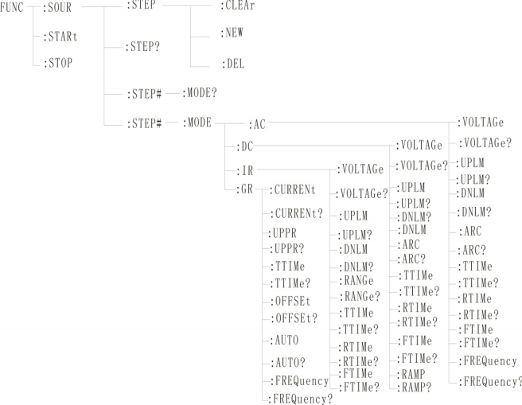
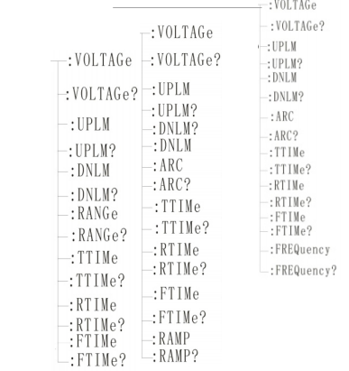
5.3.1FUN Ction subsystem command set is mainly used to set the test parameters of instrument test function. Command tree:

5.3.2 PROG function command set
FUNC：STARt the test when the instrument is testing the interface.
FUNC：STOP the test when the instrument is testing the interface.
Func: STEP: < num >: ins adds a new test item to the existing test plan (step).
Func: STEP: < num >: del in the existing test plan (step), delete the current test project.
Func: step: < num >: new Create an empty test plan to write a brand-new test plan.
Func: step: < num >: edit the < num > step of the current test scheme, < num > = 1~50.

5.3.3AC Setup function command set

Func: source: step #: mode: AC: voltage Set/query the voltage of AC.
-format
Setting format: func: source: step #: mode: AC: voltage < voltage value >.
Query format: func: source: step #: mode: AC: voltage?
-data < voltage value >:
Data type: floating-point number setting format: func: step: < num >: AC: volt < voltage value >
Data range: 0.050-5.000
Data accuracy: 0.001 Data unit: KV
Example: Set the voltage value of AC in STEP1 to 1000V in this way.
Setting command: func: source: step 1: mode: AC: voltage 1.000.
Query command: func: source: step 1: mode: AC: voltage?
Func: source: step #: mode: AC: uplm Set/query the upper limit current of AC.
-format
Setting format: func: source: step #: mode: AC: uplm < current value >
Query format: func: source: step #: mode: AC: uplm?
-data < current value >
Data type: floating point number
Data range: 0.001-20.00mA(RK9320) Data range: 0.001-10.00mA(RK9310) Data accuracy: 0.001.
Data unit: mA
Example: set the current value of AC in STEP1 to 1mA.
Setting command: func: source: step 1: mode: AC: uplm1.000.
Query command: func: source: step 1: mode: AC: uplm?
Return value: 1
Func: source: step #: mode: AC: dnlm Set/query the lower limit current of AC.
-format
Setting format: func: source: step #: mode: AC: dnlm < current value >
Query format: func: source: step #: mode: AC: dnlm?
-data < current value >
Data type: floating point number
Data range: 0.001-20.00mA(RK9320) Data range: 0.001-20.00mA(RK9310)

Data accuracy: 0.001
Data unit: mA
Example: set the current value of AC in STEP1 to 1mA.
Setting command: func: source: step 1: mode: AC: uplm1.000.
Query command: func: source: step 1: mode: AC: uplm?
Return value: 1
Func: source: step #: mode: AC: arc set/query arc value.
-format
Setting format: func: source: step #: mode: AC: arc < arc value >.
Query format: func: source: step #: mode: AC: arc?
-data < arc value >:
Data type: floating point number
Data range: 0.001-20.00mA Data accuracy: 0.001.
Data unit: mA
Example: set the current value of AC in STEP1 to 1mA.
Setting command: func: source: step 1: mode: AC: arc1.000.
Query command: func: source: step 1: mode: AC: arc?
Return value: 1
Func: source: step #: mode: AC: ttime Set/query the test time of AC.
-format
Set the format: func: source: step #: mode: AC: ttime < time >
Query format: func: source: step #: mode: AC: ttime?
-data < time value >
Data type: Integer
Data range: 0-999.9 Data accuracy: 0.1
Data unit: s
Example: Set the time value of AC in STEP1 to 1S.

Set the command：FUNC ：SOURce:STEP1：MODE:AC:TTIMe 1
Query command：FUNC ：SOURce:STEP1: MODE:AC:TTIMe ？
returned value ：1
Func: source: step #: mode: AC: rtime Set/query the rising time of AC.

-format
Set the format: func: source: query format: func: source:

STEP#:MODE:AC:RTIMe < time > STEP#:MODE:AC:RTIMe?

-data < time value >
Data type: Integer
Data range: 0-999.9 Data accuracy: 0.1
Data unit: s
example：Set the time value of AC in STEP1 to 1S
Set the command： FUNC ：SOURce:STEP1:MODE:AC:RTIMe1
Query command： FUNC ：SOURce:STEP1:MODE:AC:RTIMe ？
returned value ： 1
Func: source: step #: mode: AC: ftime Set/query the falling time of AC.
-format
Set the format: func: source: step #: mode: AC: ftime < time >
Query format: func: source: step #: mode: AC: ftime?
-data < time value >
Data type: Integer
Data range: 0-999.9 Data accuracy: 0.1
Data unit: s
example：Set the time value of AC in STEP1 to 1S
Set the command： FUNC ：SOURce:STEP1:MODE:AC:FTIMe 1
Query command： FUNC ：SOURce:STEP1:MODE:AC:FTIMe ？
returned value ： 1
Func: source: step #: mode: AC: frequency Set/query the test frequency of AC.
-format
Set the format: func: source: step #: mode: AC: frequency < frequency >.
Query format: func: source: step #: mode: AC: frequency?
-data < frequency value >
Data Type: Integer Data Range: 50/60 Data Precision: 0.1
Data unit: Hz
Example: set the frequency value of AC in STEP1 to 50Hz.
Setting command: func: source: step 1: mode: AC: frequency 50 query command: func: source: step 1: mode: AC: frequency?

5.3.4DC Setup function command set
Func: source: step #: mode: DC: voltage Set/query DC voltage.
-format
Setting format: func: source: step #: mode: DC: voltage < voltage value >.
Query format: func: source: step #: mode: DC: voltage?
-data < voltage value >:
Data type: floating point number
Data range: 0.050-6.000 Data accuracy: 0.001
Data unit: KV
Example: Set the voltage value of DC in STEP1 to 1000V in this way.
Setting command: func: source: step 1: mode: DC: voltage 1.000.
Query command: func: source: step 1: mode: DC: voltage?
Func: source: step #: mode: DC: uplm Set/query the upper limit current of DC.
-format
Setting format: func: source: step #: mode: DC: uplm < current value >
Query format: func: source: step #: mode: DC: uplm?
-data < current value >
Data type: floating point number
Data range: 0.001-10.00mA(RK9320) Data range: 0.001-5.00mA(RK9310) Data accuracy: 0.001.
Data unit: mA
Example: set the current value of DC in STEP1 to 1mA.
Setting command: func: source: step 1: mode: DC: uplm1.000.
Query command: func: source: step 1: mode: DC: uplm?
Return value: 1
Func: source: step #: mode: DC: dnlm sets/inquires the lower limit current of DC.
-format

Setting format: func: source: step #: mode: DC: dnlm < current value >
Query format: func: source: step #: mode: DC: dnlm?
-data < current value >
Data type: floating point number
Data range: 0.001-10.00mA(RK9320) Data range: 0.001-5.00mA(RK9310).
Data accuracy: 0.001 Data unit: mA
Example: set the current value of DC in STEP1 to 1mA.
Setting command: func: source: step 1: mode: DC: uplm1.000.
Query command: func: source: step 1: mode: DC: uplm?
Return value: 1
Func: source: step #: mode: DC: arc set/query arc value.
-format
Setting format: func: source: step #: mode: DC: arc < arc value >.
Query format: func: source: step #: mode: DC: arc?
-data < arc value >:
Data type: floating point number
Data range: 0.001-10.00mA
Data accuracy: 0.001 Data unit: mA
Example: set the current value of DC in STEP1 to 1mA.
Setting command: func: source: step 1: mode: DC: arc1.000.
Query command: func: source: step 1: mode: DC: arc?
Return value: 1
Func: source: step #: mode: DC: ttime Set/query the test time of DC.
-format
Setting format: func: source: step #: mode: DC: ttime < time > query format: func: source: step #: mode: DC: ttime? -data < time value >
Data type: Integer
Data range: 0-999.9 Data accuracy: 0.1
Data unit: s

Example: Set the time value of DC in STEP1 to 1S.
Setting command: func: source: step 1: mode: AC: ttime1.
Query command: func: source: step 1: mode: AC: ttime?
Return value: 1
Func: source: step #: mode: DC: rtime Set/query the rising time of DC.
-format
Set the format: func: source: step #: mode: DC: rtime < time >
Query format: func: source: step #: mode: DC: rtime?
-data < time value >
Data type: Integer
Data range: 0-999.9 Data accuracy: 0.1
Data unit: s
example：Set the time value of DC in STEP1 to 1S
Set the command： FUNC ：SOURce: STEP1:MODE:DC:RTIMe1
Query command： FUNC ：SOURce: STEP1:MODE:DC:RTIMe ？
returned value ： 1
Func: source: step #: mode: DC: ftime Set/query the falling time of DC.
-format
Set the format: func: source: step #: mode: DC: ftime < time >.
Query format: func: source: step #: mode: DC: ftime?
-data < time value >
Data type: Integer
Data range: 0-999.9 Data accuracy: 0.1
Data unit: s
example：Set the time value of DC in STEP1 to 1S
Set the command： FUNC ：SOURce: STEP1:MODE:DC:FTIMe 1
Query command： FUNC ：SOURce: STEP1:MODE:DC:FTIMe ？
returned value ： 1
Func: source: step #: mode: DC: ramp Set/query DC boost status.
-format
Setting format: func: source: step #: mode: DC: ramp < boost judgment >

Query format: func: source: step #: mode: DC: ramp?
-data < boost judgment >
Data type: Integer
Data range: 0/1(OFF/ON) Data precision: None.
Data unit: None
Example: set the frequency value of DC in STEP1 to 0(OFF) in this way.
Setting command: func: source: step 1: mode: DC: ramp0 query command: func: source: step 1: mode: DC: ramp?
Return value: 0(OFF)

5.3.5 IR SETUP function command set
Func: source: step #: mode: IR: voltage Set/query the voltage of IR.
-format
Setting format: func: source: step #: mode: IR: voltage < voltage value >.
Query format: func: source: step #: mode: IR: voltage?
-data < voltage value >:
Data type: floating point number
Data range: 0.050-5.000 Data accuracy: 0.001
Data unit: KV
Example: Set the voltage value of IR in STEP1 to 1000V in this way.
Setting command: func: source: step 1: mode: IR: voltage 1.000.
Query command: func: source: step 1: mode: IR: voltage? Return value: 1
Func: source: step #: mode: IR: uplm Set/query the upper limit of IR.
-format
Setting format: func: source: step #: mode: IR: uplm < resistance value >
Query format: func: source: step #: mode: IR: uplm?
-data < current value >
Data type: floating point number
Data range: 0.1M -100GΩ(0 is OFF) Data accuracy: 0.1MΩ
Data unit: mω

Example: Set the upper resistance limit of IR in STEP1 to 100 mω.
Set the command：FUNC ：SOURce:STEP1:MODE:IR:UPLM 100
Query command：FUNC ：SOURce:STEP1:MODE:IR:UPLM ？
returned value ：100
Func: source: step #: mode: IR: dnlm Set/query the lower limit of IR.
-format
Setting format: func: source: step #: mode: IR: dnlm < resistance value >
Query format: func: source: step #: mode: IR: dnlm?
-data < current value >
Data type: floating point number
Data range: 0.1M -1GΩ Data accuracy: 0.1MΩ
Data unit: 0.1MΩ
Example: Set the resistance value of IR in STEP1 to 10M Ω
Set the command：FUNC ：SOURce: STEP1:MODE:IR:UPLM 10
Query command：FUNC ：SOURce: STEP1:MODE:IR:UPLM ？
returned value ：10
Func: source: step #: mode: IR: range Set/query the resistance range.
-format
Set the format: func: source: step #: mode: IR: range < range value >.
Query format: func: source: step #: mode: IR: range?
-data < a range value >: data type: integer.
Data range: 0.5M 5M 50M 500M 100G m, 100 g Data accuracy: None.
Data unit: mω
Example: Set the resistance range of IR in STEP1 to 100 mω.
Setting command: func: source: step 1: mode: IR: range 100.
Query command: func: source: step 1: mode: IR: range?
Return value: 100
Func: source: step #: mode: IR: ttime Set/query the test time of IR.
-format
Set the format: func: source: step #: mode: IR: ttime < time >

Query format: func: source: step #: mode: IR: ttime?
-data < time value >
Data type: Integer
Data range: 0-999.9 Data accuracy: 0.1
Data unit: s
Example: Set the time value of IR in STEP1 to 1S

Set the command：FUNC ：SOURce: STEP1:MODE:IR:TTIMe1
Query command：FUNC ：SOURce: STEP1:MODE:IR:TTIMe？
returned value ： 1
Func: source: step #: mode: IR: rtime Set/query the rising time of IR.
-format
Set the format: func: source: step #: mode: IR: rtime < time >
Query format: func: source: step #: mode: IR: rtime?
-data < time value >
Data type: Integer
Data range: 0-999.9 Data accuracy: 0.1
Data unit: s
Example: Set the time value of IR in STEP1 to 1S

Set the command： FUNC ：SOURce: STEP1:MODE:IR:RTIMe1
Query command：FUNC ：SOURce: STEP1:MODE:IR:RTIMe？
returned value： 1
Func: source: step #: mode: IR: ftime Set/query the falling time of IR.
-format
Set the format: func: source: step #: mode: IR: ftime < time >
Query format: func: source: step #: mode: IR: ftime?
-data < time value >
Data type: Integer
Data range: 0-999.9 Data accuracy: 0.1
Data unit: s
Example: Set the time value of IR in STEP1 to 1S.

Set the command： FUNC ：SOURce: STEP#:MODE:IR:FTIMe 1
Query command：FUNC ：SOURce: STEP#:MODE:IR:FTIMe？
returned value： 1

5.4SYSTEM subsystem command set
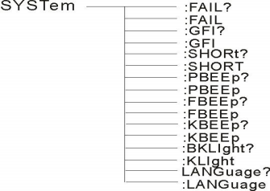
Command tree

SYSTem ：PBEE/FBEE/KBEE
Set/Query Test Passed/Failed/Button Buzzer Status-Format
Setting format: syst: pbee < on/off > or < 1/0 >
Query format: SYST ：PBEE? -data: < ON/OFF >
Data type: character
Data range: 0(OFF ),1(ON) Example:
Set BEEP to 1.
Setup command: syst: beep1-return information.
Query command: SYST:BEEP? , return value: buzzer status, such as 1.
SYSTem ：REset restores all default states-format:
Set format: SYST ：RES

5.5MMEM subsystem command set
MMEM：SAVE Saves the current file to the file number.
-format:
Set the format: MMEM ：SAVE < file name >-data < file name >
Data type: string
MMEMLOAD exports the file specified by the file number to the current
-format:
Set the format: MMEM ：LOAD < file name >
-data < file name >
Data Type: String 57

5.6 FETCH subsystem command set
FETCH is used to obtain the measurement results of the instrument-format:
Set the format: FETCh：AUTO Query format: FETCh:AUTO? -data < ON/OFF>or <1/0 >
Data type: character
Data range: 0(OFF), 1 (on)-Example:
Automatically return the test data to ON.
Command: FETCh：AUTOON or fetch: auto 1.
-return information
Query command: FETCh? , returns the current measurement result of the instrument. Command syntax: FETCh?
Is string information, untested = (uint8 _ t) 0, onprogress, testok,
OverUp lim,// over the upper limit
BelowDn lim,// is lower than the lower limit OverGRVolt,///overvoltage.
OpenCircuit,// open circuit ShortFail,// short circuit
ArcFail,// Arc fail GFIFail,// Leakage fail.

5.7 Other Control Command Sets

*IDN query instrument model, version information
The query returns: < manufacturer >, < model >, < firmware > < nl end >
Here: < manufacturer > gives the name of the manufacturer (i.e. REK).
< model > gives the machine model (such as RK9320).
< firmware > gives the software version number (such as Version1.0.0).
For example: WrtCmd(“ *IDN? " );

5.8, technical parameters

parameter | type | RK9320 | RK9320A | RK9320B | RK9320AY
Ac withstand voltage test | voltage range | 0.050kV ~ 5.000kV | 0.050kV ~ 5.000kV | 0.050kV ~ 5.000kV | 0.050kV ~ 5.000kV
Ac withstand voltage test | Voltage accuracy | ±（2%+5V） | ±（2%+5V） | ±（2%+5V） | ±（2%+5V）
Ac withstand voltage test | resolution ratio | 1V | 1V | 1V | 1V
Ac withstand voltage test | Maximum output power | 100VA( 5.000kV/20mA) | 100VA( 5.000kV/20mA) | 100VA( 5.000kV/20mA) | 100VA( 5.000kV/20mA)
Ac withstand voltage test | Maximum rated current | 20mA | 20mA | 20mA | 20mA
Ac withstand voltage test | Lower limit current range | 0 ~ 20mA,0= no judgment lower limit. | 0 ~ 20mA,0= no judgment lower limit. | 0 ~ 20mA,0= no judgment lower limit. | 0 ~ 20mA,0= no judgment lower limit.
Ac withstand voltage test | Output waveform | sine wave | sine wave | sine wave | sine wave
Ac withstand voltage test | Output waveform distortion | ≤ 5% (no-load or pure resistive load) | ≤ 5% (no-load or pure resistive load) | ≤ 5% (no-load or pure resistive load) | ≤ 5% (no-load or pure resistive load)
Ac withstand voltage test | degree  Output signal type | DDS linear power amplifier | DDS linear power amplifier | DDS linear power amplifier | DDS linear power amplifier
Ac withstand voltage test | Voltage rise time | 0.1s ~ 999.9s ，  OFF= voltage rise time off | 0.1s ~ 999.9s ，  OFF= voltage rise time off | 0.1s ~ 999.9s ，  OFF= voltage rise time off | 0.1s ~ 999.9s ，  OFF= voltage rise time off
Ac withstand voltage test | testTime | 0.3s ~ 999.9s, OFF= continuous test. | 0.3s ~ 999.9s, OFF= continuous test. | 0.3s ~ 999.9s, OFF= continuous test. | 0.3s ~ 999.9s, OFF= continuous test.
Ac withstand voltage test | Voltage drop time | 0.1s  OFF | 0.1s  OFF | 0.1s  OFF | 0.1s  OFF
DC | voltage range | 0.050 | 0.050 |  | 0.050
DC | voltage accuracy | ±（2%+5V） | ±（2%+5V） |  | ±（2%+5V）
DC | resolution ratio | 1V | 1V |  | 1V
DC | maximum(power)output | 60W | 60W |  | 60W
DC | Maximum rated current | 0 | 0 |  | 0
DC | Lower limit current range | 0 | 0 |  | 0
DC | ripple factor | ≤ | ≤ |  | ≤
DC | discharge time | ≤ | ≤ |  | ≤
DC | Voltage up time | 0.1s  OFF | 0.1s  OFF |  | 0.1s  OFF
DC | testing time | 0.3s | 0.3s |  | 0.3s
DC | Voltage drop time | 0.1s  OFF | 0.1s  OFF |  | 0.1s  OFF
insulation | Output voltage setting | 0.050
insulation | The resistance upper limit is set | scope:
insulation | The lower limit of resistance is set | scope:
insulation | Voltage up time | 0.1s  OFF
insulation | testing time | 0.3s
insulation | Voltage drop time | 0.1s  OFF
insulation | ohmmeter | ≥500v  ±5%  50.0  <500V  No precision requirements
ammeter | measuring range | AC 0~20mA  DC 0~10mA | AC 0~20mA  DC 0~10mA | AC 0~20mA | AC 0~20mA  DC 0~10mA
ammeter | measurement accuracy | ± (2% + 5 words) | ± (2% + 5 words) | ± (2% + 5 words) | ± (2% + 5 words)
type |  | horizontal | horizontal | horizontal | horizontal
Arc detection |  | 1mA-20mA | 1 | 1 | 1mA-20mA
input characteristics |  | 100V~240V | 100V~240V | 100V~240V | 100V~240V
Test alarm |  | Buzzer, LCD display, | Buzzer, LCD display, | Buzzer, LCD display, | Buzzer, LCD display,
screen size |  | 3.5 Inch | 3.5 Inch | 3.5 Inch | 3.5 Inch
communication interface |  | HANDLER  USBDRV | HANDLER  USBDRV (computer interface), USBHOST(U disk interface), LAN. | HANDLER、RS232、RS485、  USBDRV (computer interface), USBHOST(U disk interface), LAN. | HANDLER、RS232、RS485、  USBDRV (computer interface), USBHOST(U disk interface), LAN.
storage |  | 64M flash can store 50 test steps per file. | 64M flash can store 50 test steps per file. | 64M flash can store 50 test steps per file. | Each file of 64M flash can store 50 test steps.
External volume  (W × D × H) |  | 260*400*100mm | 260*400*100mm | 260*400*100mm | 260*400*100mm
Weight (KG) |  | 7KG | 7KG | 7KG | 7KG
Optional standard accessories |  | Power line RK00001 and RS232 communication  Cable RK00002, test line RK26003A, test line RK00048 | Power line RK00001, RS232 communication cable RK00002 and test line RK00048.  Test line RK26003A | Power supply line RK00001, RS232 communication cable RK0002, test line RK00048 and test line RK26003A. | Power supply line RK00001, RS232 communication cable RK0002, test line Rk00048, test line RK26003A, RK8N+ high voltage bar.  BNC double-ended line RK00016
Optional parts |  | RK00031 USB to Rs485 bus serial line industrial grade  RK8N+ high voltage rod  RK00003 RS232 to USB cable | RK00031 USB to Rs485 bus serial line industrial grade  RK8N+ high voltage rod  RK00003 RS232 to USB cable | RK00031 USB to Rs485 bus serial line industrial grade  RK8N+ high voltage rod  RK00003 RS232 to USB cable | RK00031 USB to Rs485 bus serial line industrial grade  RK00003 RS232 to USB cable
Contact inspection |  | Optional on or off. | Optional on or off. | Optional on or off. | Optional on or off.

parameter | type | RK9310
Ac withstand voltage test | voltage range | 0.050kV ~ 5.000kV
Ac withstand voltage test | Voltage accuracy | ±（2%+5V）
Ac withstand voltage test | resolution ratio | 1V
Ac withstand voltage test | Maximum output power | 100VA( 5.000kV/10mA)
Ac withstand voltage test | Maximum rated current | 10mA
Ac withstand voltage test | Lower limit current range | 0 ~ 10mA,OFF= lower limit of no judgment.
Ac withstand voltage test | Output waveform | sine wave
Ac withstand voltage test | Output waveform distortion | ≤ 5% (no-load or pure resistive load)
Ac withstand voltage test | Output signal type | DDS linear power amplifier
Ac withstand voltage test | Voltage rise time | 0.1s ~ 999.9s, OFF= voltage rise time off.
Ac withstand voltage test | testTime | 0.1s ~ 999.9s, OFF= continuous test.
Ac withstand voltage test | Voltage drop time | 0.1s ~ 999.9s, OFF= voltage drop time off.
Dc withstand voltage test | voltage range | 0.050kV ~ 6.000kV
Dc withstand voltage test | Voltage accuracy | ±（2%+5V）
Dc withstand voltage test | resolution ratio | 1V
Dc withstand voltage test | Maximum output power | 60W( 6.000kV/5mA)
Dc withstand voltage test | Maximum rated current | 0 ~ 5mA
Dc withstand voltage test | Lower limit current range | 0 ~ 5mA
Dc withstand voltage test | ripple coefficient | ≤ 5%(6kV/5mA)
Dc withstand voltage test | discharge time | ≤ 200ms
Dc withstand voltage test | Voltage rise time | 0.1s ~ 999.9s, OFF= voltage rise time off.
Dc withstand voltage test | testTime | 0.1s ~ 999.9s, OFF= continuous test.
Dc withstand voltage test | Voltage drop time | 0.1s ~ 999.9s, OFF= voltage drop time off.
Insulation test | Output voltage setting | 0.050kV ~5. 000kV Resolution: 1Volts/step
Insulation test | Resistance upper limit setting | Range: (0.2m ~ 100g) ω
Insulation test | Lower resistance setting | Range: (0.1m ~ 100) gω
Insulation test | Voltage rise time | 0.1s ~ 999.9s, OFF= voltage rise time off.
Insulation test | testTime | 0.1s ~ 999.9s, OFF= continuous test.
Insulation test | Voltage drop time | 0.1s ~ 999.9s, OFF= voltage drop time off.
Insulation test | Resistance meter | ≥500v0.10M Ω-1.0G Ω ±5% 1.0G-50.0 GΩ ± 10%  50.0 GΩ-100.0 GΩ±15%  <500V 0.20M Ω-1.0G Ω ±10% 1.0GΩ-10.0G Ω  No precision requirement
ammeter | measuring range | AC 0~10mA DC 0~5mA
ammeter | measurement accuracy | ± (2% + 5 words)
type |  | horizontal
Arc detection |  | 1mA-10mA
Input characteristics |  | 100V~240V 50Hz/60Hz
Test alarm |  | Buzzer, LCD display, FAIL indicator
screen size |  | 3.5-inch TFT LCD screen
communication interface |  | HANDLER, RS232, RS485, USB interface, LAN
storage |  | 64M flash can store 50 test steps per file.
External volume (W × D × H) |  | 260*400*100MM
Weight (KG) |  | 7KG
Optional standard accessories |  | Power cord RK00001, RS232 communication cable RK00002, instruction manual (electronic version)  Test line RK00048, test line RK26003A and MODBUS test host computer (downloaded from official website).
Optional parts |  | RK00031 USB to RS485 bus serial line industrial grade, RS232 to USB RK00003, high voltage rod RK8N+
Contact inspection |  | Optional on or off.

5.9 Instructions for upgrading instrument system:
1. Connect the instrument USB to the computer, and the computer resource manager will display the USB flash drive. Copy the upgrade file to the root directory, and then restart the instrument to complete the upgrade. If there is any error in the upgrade, please contact us in time.
2. Press and hold STOP+STAR to restart the power supply, clear the data error caused by version change, and restore the set data to the default factory data.

5.10 Warranties and Accessories
5.10.1 Warranty
If the user purchases instruments from our company, it shall be counted from the delivery date of our company, and if the user purchases instruments from the distribution department, it shall be counted from the delivery date of the distribution unit, and the mainframe shall be guaranteed for one year. The warranty card of the instrument should be presented when the warranty is issued. The company provides lifelong maintenance service for all outgoing instruments. During the warranty period, if the instrument is damaged due to improper operation by the user, the maintenance cost shall be borne by the user.
5.10.2 Attachment

RK26003A high voltage test clamp | Article 1
RK00048 test line | Article 1
RK00001 power cord | Article 1
RS232 serial connector | Article 1
RK8N+ High Voltage Rod (RK9320AY only) | Article 1
BNC double-ended wire (RK9320AY only) | Article 2
certificate | 1 copy
Calibration certificate | 1 copy

After receiving the instrument, the user should unpack and check the above contents. If there is a shortage, please contact our company or distributor.

Instructions for user manual:
The company reserves the right to change the specifications of the user manual without prior notice.
With the improvement of the tester and the upgrade of software and hardware, the user manual will be constantly updated and improved. Please pay attention to the version of the tester and instructions. If there is anything unknown in the manual, please contact us directly. Merrick's products are protected by China patents that have been approved and are under examinatio



Use the browser to scan.
Pay attention to the official website of Shenzhen Meiruike Electronic Technology Co., Ltd. and experience more benefits and services.

Shenzhen meiruike electronic technology co., ltd
Address: No.31 Bulan Road, Nanwan Street, Longgang District, Shenzhen
Building 12, Building B7, Li Lang International Jewelry Industrial Park (West No.7 Special Ladder)
Technology Department: (0) 13924600220
Tel: 0755 -28604516 (after-sales special line) 0755 -83806889
Http: // Www. chinarek. com national service hotline: 400 -876 -9388.

